Contents

1 Welcome 2

Software Installation Directions 2

Installation 2

Setup Using Docker 2

Installing Docker 2

Pulling the Docker image 2

Running Docker Images 2

Setup From Scratch 2

2 Map-Reduce and Spark 3

2.1 The Memory Hierarchy 3

2.1.1 Memory Latency 3

2.1.2 Cache 3

2.1.3 Memory Access locality 4

2.1.4 Row-wise vs Column-wise Scanning 4

2.1.5 Measuring Latency 6

2.1.6 Memory Hierarchy 6

2.1.7 History of Large Scale Computing 6

2.2 Spark Basics 7

2.2.1 Map Reduce 7

2.2.2 Short History of Map Reduce 8

2.2.3 Spark Architecture 9

2.2.4 Manipulating Plain RDD 10

2.2.5 Manipulating KeyVal RDD 10

2.3 Assignment 1: Collinear Points 11

Programming Assignment 1: Collinear Points 11

2.4 Pyspark and RDDs 13

2.4.1 Spark Notebook Basics pt. 1 13

2.4.2 Changing Number of Workers 14

2.4.3 Execution Plans Lazy Eval and Caching 14

2.4.4 Partition and Gloming 16

2.4.5 Spark Basics pt. 2 17

2.4.6 Word Count 18

2.4.7 Finding Most Common Words 19

2.4.8 Operations on KeyVal RDDs 20

2.4.9 Parsing Large Files 22

2.5 Spark SQL and DataFrames 22

2.5.1 Dataframes 22

2.5.2 Dataframe Operations 24

2.5.3 Loading and Using Parquet 27

2.6 Preparing for Data Analysis 29

2.6.1 Where is the Data Dense 29

2.6.2 Moving and Deserialization 29

2.6.3 Deserialization 29

2.6.4 Transform RDD into Spark 30

2.7 Programming Assignment 2 30

3 PCA and Weather Analysis 30

3.1 Covariance and PCA 30

3.1.1 High Dimensional Vectors 30

3.1.2 Computing PCA Using RDD 31

3.1.3 Loading the Data 32

3.2 Visualizing PCA Coefficients 32

3.2.1 Weather Data Visualization 32

3.2.2 Variance Explained by Eigenvectors 33

3.3 Programming Assignment 3 33

3.4 Vizualizing PCA Residuals I 33

3.4.1 Spectral Analysis of Snow Depth in NY Part 1 33

3.4.2 Spectral Analysis of Snow Depth in NY Part 2 33

3.4.3 Spectral Analysis of Snow Depth in NY Part 3 33

3.5 Vizualizing PCA Residuals II 33

3.5.1 Spectral Analysis of Snow Depth in NY Part 4 33

3.5.2 Snow Changes from Yr to Yr 33

3.6 Programming Assignment 4 33

4 K-Means and Intrinsic Dimensions 33

4.1 K-Means Clustering 33

4.1.1 K-Means Animation 33

4.1.2 K-Means Theory 33

4.1.3 K-Means Measure of Performance - Part 1 33

4.1.4 K-Means Measure of Performance - Part 2 33

4.1.5 Clustering and K-means 33

4.1.6 Initialization of K-means 33

4.1.7 Data in High Dimensions 33

4.2 Intrinsic Dimension 33

4.2.1 Intrinsic Dimensions 33

4.2.2 Examples of Intrinsic Dimensions 33

4.2.3 Fractional Dimensions 33

4.2.4 Recognizing Facial Gestures 33

4.4 Programming Assignment 5 33

5 Decision Trees, Random Forests, Boosting 34

5.1 Decision Trees 34

5.1.1 Decision Tree 34

5.1.2 The Splitting Step 34

5.1.3 Pruning Trees 34

5.1.4 Generative and Discriminative Models 34

5.2 Boosting 34

5.2.1 Boosting I 34

5.2.2 Boosting II 34

5.2.3 Boosting as a Gradient Descent 34

5.2.4 Weak Learner Styles 34

5.2.5 Boosting and Overfitting 34

5.2.6 Boosting and Overfitting II 34

5.2.7 Applications of Boosting 34

5.2.8 Face Detection 34

5.3 Ensemble 34

5.4 Real-World Aplication 34

5.4.1 Whale Classification 34

5.4.2 Classification with XGBoost 34

5.5 Programming Assignment 6 34

5.6 Programming Assignment 7 34

6 Neural Networks and TensorFlow 34

6.1 Neural Networks 34

6.1.1 Historical Perspective 34

6.1.2 Skeptical View 34

6.2 NN Basics 34

6.2.1 Back Prop 34

6.2.2 TensorFlow Linear Regression 34

6.3 TensorFlow Base API 34

6.3.1 TensorFlow Logistic Regression 34

6.3.2 TensorFlow base API 34

6.4 TensorFlow Estimator API 34

6.4.1 TensorFlow Pre-defined Estimator 34

6.4.2 TensorFlow Custom Estimator 34

6.4.3 Convolutional Neural Network 34

6.5 Programming Assignment 8 34

Appendix 1 Jupyter Nbextensions Configurator 36

Usage 36

base_url 36

tree tab 36

edit menu item 36

YAML file format 36

APPENDIX 2 Spark Install Instructions - Windows 37

Install and Setup 37

First Spark Application 37

APPENDIX 3 Gow - The lightweight alternative to Cygwin 38

Introduction 38

Features and Benefits 38

Win32 Utilities Overview 38

Big Data Analytics using SPARK

Yoav Freund, Professor Computer Science & Engineering UC San Diego

[**LINK**](https://courses.edx.org/courses/course-v1:UCSanDiegoX+DSE230x+1T2019a/course/#block-v1:UCSanDiegoX+DSE230x+1T2019a+type@chapter+block@b341cd4498054fa089cc99dcadd5875a)

# 1 Welcome

Welcome to Big Data Analytics using Spark! This course teaches you how to perform statistical analysis of very large datasets that do not fit on a single computer. You will learn some of the most popular tools for performing this type of analysis: apache spark, XGBoost and TensorFlow. You will learn how to use these tools through Jupyter Notebooks and experience the power of combining narrative, code and graphics to create convincing analytical documents.

* Memory Hierarchy, Latency vs. Throughput
* Spark Basics
* Dataframes and SQL
* PCA and Weather Analysis
* K-Means and Intrinsic Dimensions
* Neural Networks and TensorFlow.

## Software Installation Directions

### Installation

* This class will use python3
* The easiest way to install everything is to use the Docker instance that we provide. If for whatever reason, you cannot install Docker then we also provide instructions to download and install the required Python implementation and associated libaries.
* If you're a verified learner, then it's up to you to decide if you want to have a local development environment. We will provide you with a cloud hosted jupyter notebook interface for some of the Programming Assignments where you can code directly. We still recommend verified learners to setup the local environment anyhow.
* If you're auditing the course, then you should follow the instructions below. We highly recommend setting up using docker.

### Setup Using Docker

The purpose of this part is to ensure you have a working and compatible Python and PySpark installation. In order to avoid potential compatibility issues generated from students using different versions than the expected, we provide a Docker image with Ubuntu 16.04 and a clean Anaconda 4.3 with python 3.6, jupyter 5.4, spark 2.2 installation. We also provide a script to run the docker image and get Jupyter running on it so that you can program on it directly. In this guide, we provide instructions on how to install Docker and pull the Docker image. In case you are not able to use Docker, you will have to install Python and Pyspark manually.

* Using the provided Docker container requires installing Docker, 6-7 GB of free space and root access on the host machine (admin rights for windows).
* If you are not able to use the provided container, you can install Python and Pyspark on your own. Make sure you follow the instructions given below. We will expect your results to match ours.
* Docker containers are not intended to store data. We highly recommend you develop your solutions locally and only use docker to compile and run. The following guides show you how to do that. Obtained results should be stored locally as well. If you develop within the container you are at risk of losing your work. You have been warned.
* When you work within the provided container (interactively or not) you are automatically logged in as a user named ucsddse230. Your homework notebook is mounted in the directory /home/ucsddse230/work. If you delete the mounted directory containing your work it will be deleted from the host system. Make sure your work is secure at all times. We recommend you use some sort of version control such as git.

### Installing Docker

Installing Docker should be straightforward for Windows and Mac OS users. Mac and Windows users can download it from from the [Docker website](https://store.docker.com/search?type=edition&offering=community). Linux users will have to use this [guide](https://docs.docker.com/install/linux/docker-ce/ubuntu/). The linux guides essentially try to upgrade your system to a compatible version (for example upgrading to Ubuntu 16.04). Be careful not to break your current system. If you are working with linux, having a Ubuntu 16.04 system should result in an easier docker installation. For Windows users, Docker will require you enable Hyper-V and restart your computer. Some Windows 10 versions do not have Hyper-V. If you face any issues with installing Docker on Windows, installing Docker Toolbox instead of Docker should be the easiest way out.

### Pulling the Docker image

After successful installation of Docker, open a command prompt or shell and execute the following command (Windows users should skip the “sudo” part): Linux/Mac:

$ sudo docker pull ucsddse230/cse255-dse230

Windows (Powershell prefered):

$ docker pull ucsddse230/cse255-dse230

Docker should automatically start downloading and extracting the provided image. If you skip this step the image will automatically be downloaded the first time you attempt to start it. Once finished you can verify you have it by typing Linux/Mac:

$ sudo docker images

Windows:

$ docker images

Students using Docker Toolbox for their Windows OS that does not support Hyper-V would now need to execute an additional command to identify their Docker IP address.

$ docker-machine ip

Note down the IP address that is returned as the output. You will need to use this in the next section.

### Running Docker Images

Next, download the required content (for example, Programming assignment or Section Notebooks) files from EdX directory to some location on your computer. ex: /local/path/to/pa1. An an illustration, let's use Programming Assignment 1. You may open the [Programming Assignment 1 section](https://courses.edx.org/courses/course-v1:UCSanDiegoX+DSE230x+1T2019a/jump_to_id/2cb4714117c04c50a41e5d97b3af2e0c) on EdX which has the link to the necessary started code. Let's say after unpacking the files pa1 files are present in  /local/path/to/pa1

NOTE: This path should be the absolute path.

Then run the following following line of code in your terminal (first time might take a while).

$ docker run -it -p 8889:8888 -v /local/path/to/pa1:/home/ucsddse230/work ucsddse230/cse255-dse230 /bin/bash

This command will:

1. Start the docker container

2. mount the local directory "/local/path/to/pa1" inside the container at the location "/home/ucsddse230/work"

3. Forward requests to port 8889 on the local system from port 8888 inside the docker container.

Notice the terminal has changed, you are now inside a virtual machine. Run the following commands to start jupyter at http://localhost:8889 by issuing the command

$ jupyter notebook

This will start jupyter at port 8888 inside the docker container, which will be accessible outside the docker at port 8889.

Now you can view notebooks and work on homework at the localhost:8889 port. Go ahead open your web browser and put "localhost:8889" in the address bar. You should now be able to see the Jupyter Notebook webpage.

Students using Docker Toolbox can access the Jupyter notebook running in their Docker container at the DockerIP:8888 port, where DockerIP is the IP address returned in the previous section.

Whatever changes you make will also happen to /local/path/to/pa1.

### Setup From Scratch

First install the Python 3.6 version using the [anaconda](https://www.continuum.io/Downloads) distribution.

#### Install jupyter

If you install Anaconda, jupyter and all the necessary packages are installed for you.

#### Install notebook extensions

This step is not required, but extensions can make your work on notebooks significantly easier. To install a bunch of useful extensions, together with a configurator for managing thses extensions, follow the directions on:

<https://github.com/Jupyter-contrib/jupyter_nbextensions_configurator>

#### Install python packages

Make sure to install the python package [findspark](https://github.com/minrk/findspark). The typing the following command in the terminal installs the package:

Anaconda: conda install -c conda-forge findspark=1.0.0[1]

pip: sudo pip install findspark

If you are using pip instead of anaconda, you also must install the following packages:

* numpy
* matplotlib
* pandas

Some notebooks require additional packages, or packages of a later version. If an import command in a notebook fails, use pip or conda to install the missing package. Install Spark on your computer

* [Install on Linux or Mac OS X](https://mas-dse.github.io/DSE230/installation/linux/)
* [Install on Windows](https://mas-dse.github.io/DSE230/installation/windows/)

# 2 Map-Reduce and Spark

## 2.1 The Memory Hierarchy

### 2.1.1 Memory Latency

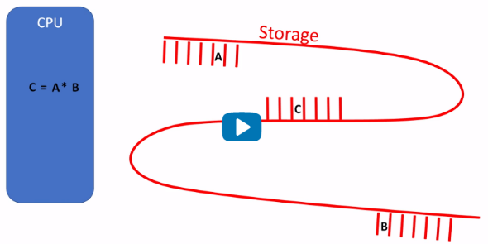

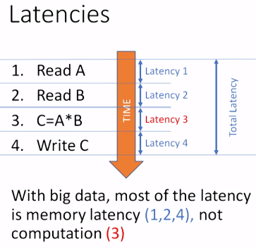

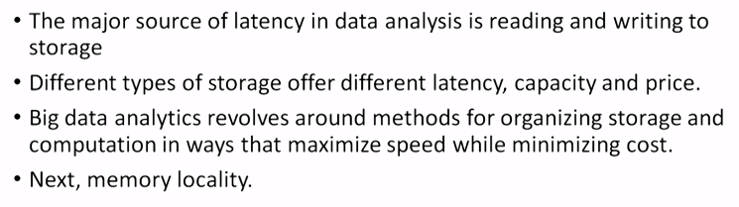

### 2.1.2 Cache

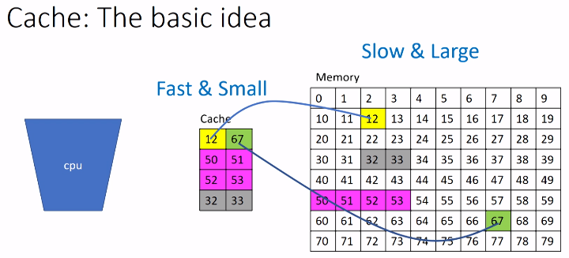

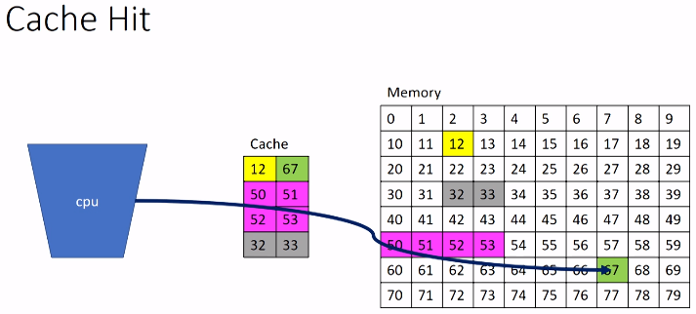

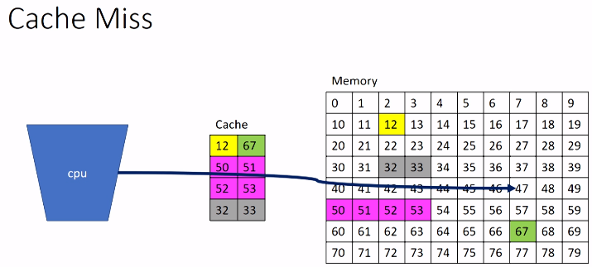

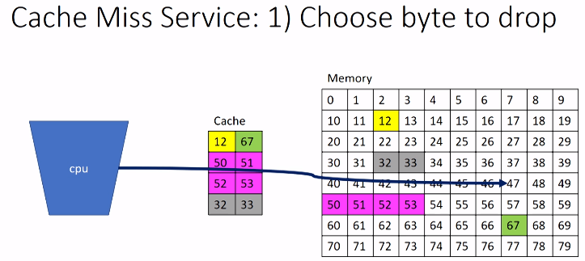

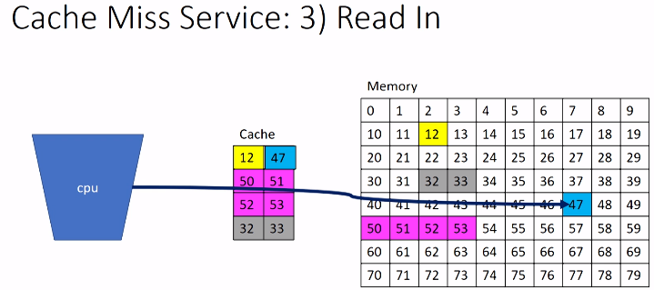

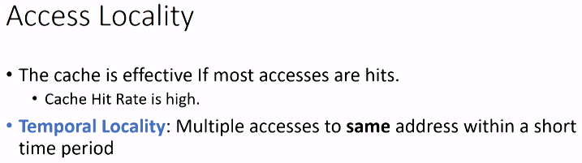

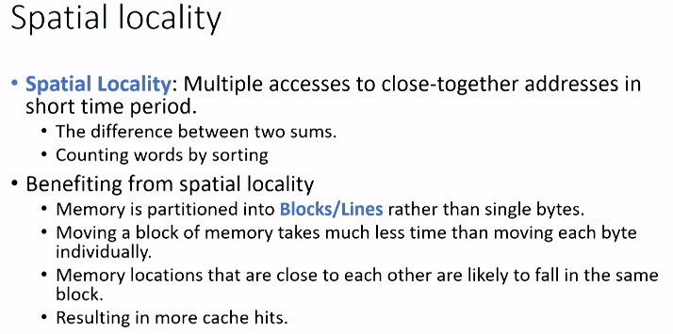

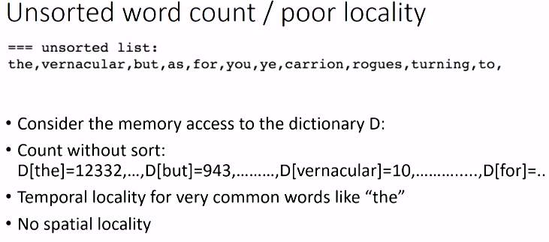

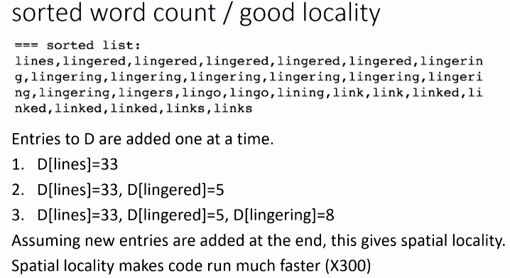

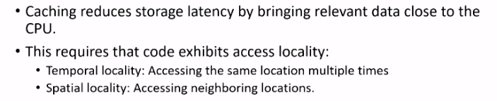

### 2.1.3 Memory Access locality

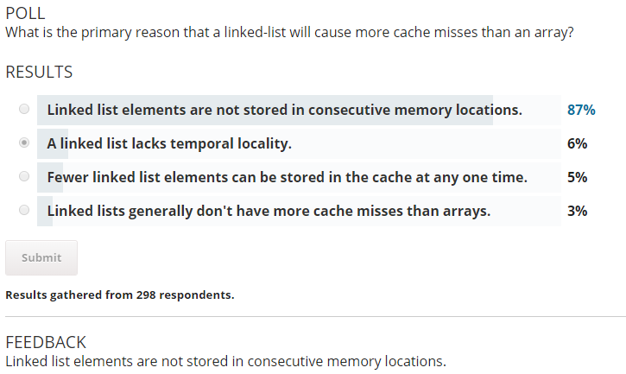

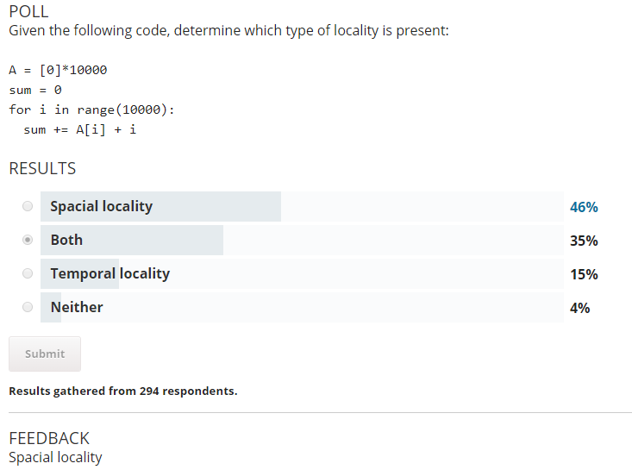

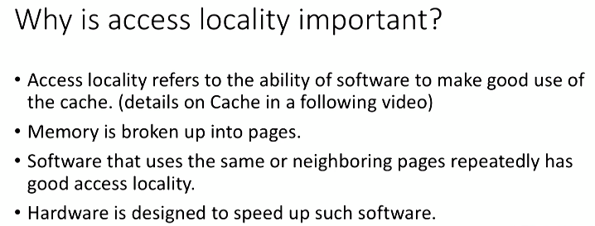

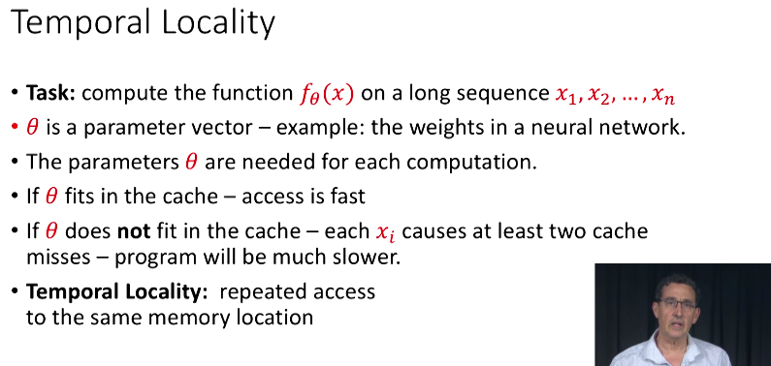

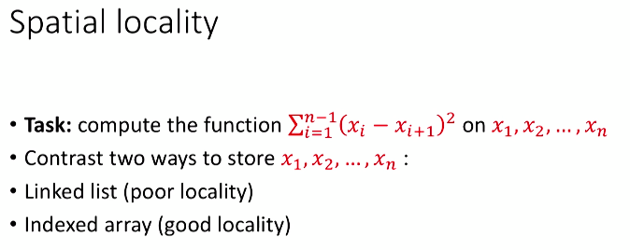

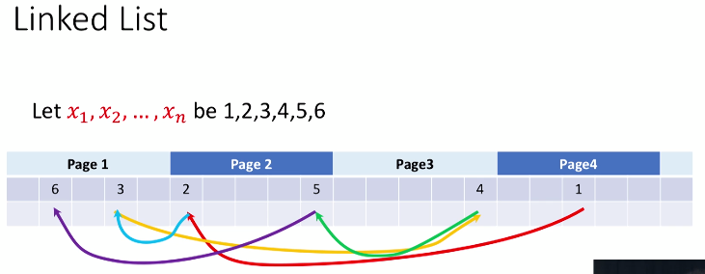



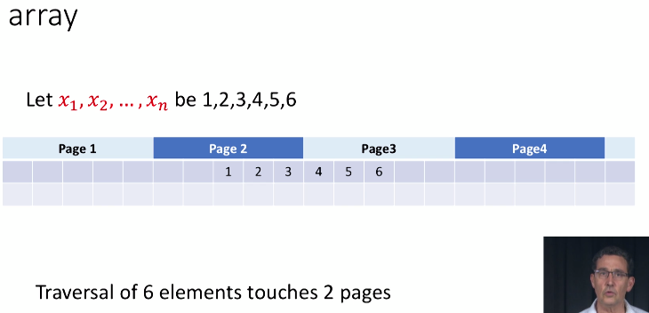

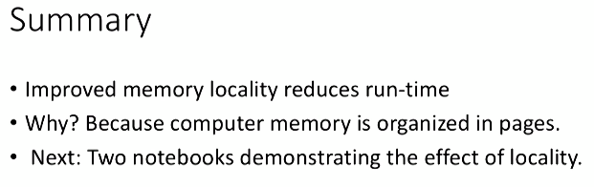

### 2.1.4 Row-wise vs Column-wise Scanning

#### Memory locality, Rows vs. Columns

Effect of row vs column major layout: The way you traverse a 2D array effects speed.

* [numpy arrays](https://docs.scipy.org/doc/numpy/reference/generated/numpy.array.html#numpy-array) are, by default, organized in a row-major order.

a=array([range(1,31)]).reshape([3,10])

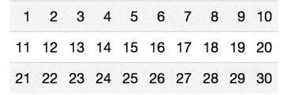

* a[i,j] and a[i,j+1] are placed in consecutive places in memory.
* a[i,j] and a[i+1,j] are 10 memory locations apart.
* This implies that scanning the array row by row is more local than scanning column by column.
* locality implies speed.

In [1]:

%**pylab** inline

**from** **time** **import** time

*# create an n by n array*

n=1000

a=ones([n,n])

Populating the interactive namespace from numpy and matplotlib

In [2]:

%%time

*# Scan column by column*

s=0;

**for** i **in** range(n): s+=sum(a[:,i])

CPU times: user 12.7 ms, sys: 1.66 ms, total: 14.3 ms

Wall time: 12.8 ms

In [3]:

%%time

*## Scan row by row*

s=0;

**for** i **in** range(n): s+=sum(a[i,:])

CPU times: user 7.53 ms, sys: 4 ms, total: 11.5 ms

Wall time: 7.89 ms

#### Some experiments with row vs column scanning

We want to see how the run time of these two code snippets varies as n, the size of the array, is changed.

In [4]:

**def** sample_run_times(T,k=10):

*""" compare time to sum array row by row vs column by column*

*T: the sizes of the matrix, [10**e for e in T]*

*k: the number of repetitions of each experiment*

*"""*

all_times=[]

**for** e **in** T:

n=int(10**e)

*#print('\r',n)*

a=np.ones([n,n])

times=[]

**for** i **in** range(k):

t0=time()

s=0;

**for** i **in** range(n):

s+=sum(a[:,i])

t1=time()

s=0;

**for** i **in** range(n):

s+=sum(a[i,:])

t2=time()

times.append({'row minor':t1-t0,'row major':t2-t1})

all_times.append({'n':n,'times':times})

**return** all_times

In [5]:

*#example run*

sample_run_times([1,2],k=1)

Out[5]:

[{'n': 10,

'times': [{'row major': 3.1948089599609375e-05,

'row minor': 5.698204040527344e-05}]},

{'n': 100,

'times': [{'row major': 0.0005230903625488281,

'row minor': 0.00038886070251464844}]}]

#### Plot the ratio between run times as function of n

Here we have small steps between consecutive values of n and only one measurement for each (k=1)

In [6]:

all_times=sample_run_times(np.arange(1.5,3.01,0.001),k=1)

n_list=[a['n'] **for** a **in** all_times]

ratios=[a['times'][0]['row minor']/a['times'][0]['row major'] **for** a **in** all_times]

figure(figsize=(15,10))

plot(n_list,ratios)

grid()

xlabel('size of matrix')

ylabel('ratio or running times')

title('time ratio as a function of size of array');

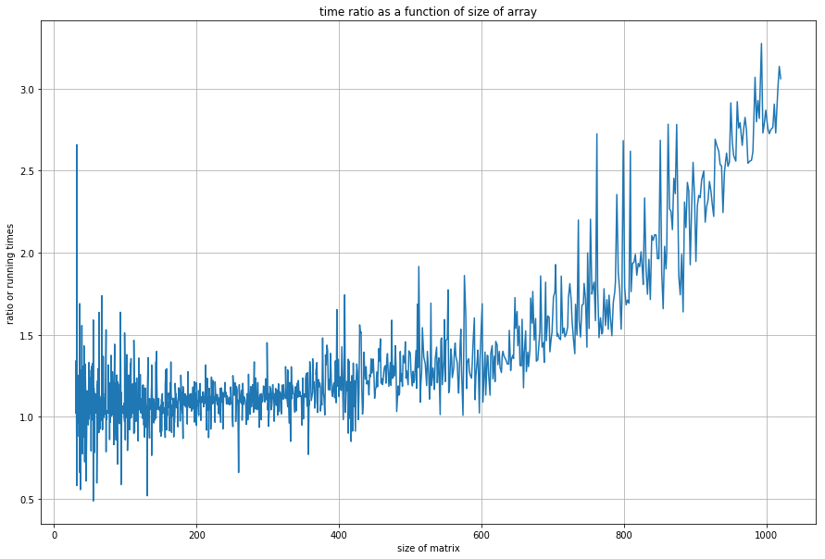

#### Conclusions

* Traversing a numpy array column by column takes more than row by row.
* The effect increasese proportionally to the number of elements in the array (square of the number of rows or columns).
* Run time has large fluctuations.
* See you next time.

#### Next, we want to quantify the random fluctuations

and see what is their source

In [7]:

k=100

all_times=sample_run_times(np.arange(1,3.001,0.01),k=k)

_n=[]

_row_major_mean=[]

_row_major_std=[]

_row_major_std=[]

_row_minor_mean=[]

_row_minor_std=[]

_row_minor_min=[]

_row_minor_max=[]

_row_major_min=[]

_row_major_max=[]

**for** times **in** all_times:

_n.append(times['n'])

row_major=[a['row major'] **for** a **in** times['times']]

row_minor=[a['row minor'] **for** a **in** times['times']]

_row_major_mean.append(np.mean(row_major))

_row_major_std.append(np.std(row_major))

_row_major_min.append(np.min(row_major))

_row_major_max.append(np.max(row_major))

_row_minor_mean.append(np.mean(row_minor))

_row_minor_std.append(np.std(row_minor))

_row_minor_min.append(np.min(row_minor))

_row_minor_max.append(np.max(row_minor))

_row_major_mean=np.array(_row_major_mean)

_row_major_std=np.array(_row_major_std)

_row_minor_mean=np.array(_row_minor_mean)

_row_minor_std=np.array(_row_minor_std)

In [8]:

figure(figsize=(20,13))

plot(_n,_row_major_mean,'o',label='row major mean')

plot(_n,_row_major_mean-_row_major_std,'x',label='row major mean-std')

plot(_n,_row_major_mean+_row_major_std,'x',label='row major mean+std')

plot(_n,_row_major_min,label='row major min among **%d**'%**k**)

plot(_n,_row_major_max,label='row major max among **%d**'%**k**)

plot(_n,_row_minor_mean,'o',label='row minor mean')

plot(_n,_row_minor_mean-_row_minor_std,'x',label='row minor mean-std')

plot(_n,_row_minor_mean+_row_minor_std,'x',label='row minor mean+std')

plot(_n,_row_minor_min,label='row minor min among **%d**'%**k**)

plot(_n,_row_minor_max,label='row minor max among **%d**'%**k**)

xlabel('size of matrix')

ylabel('running time')

legend()

grid()

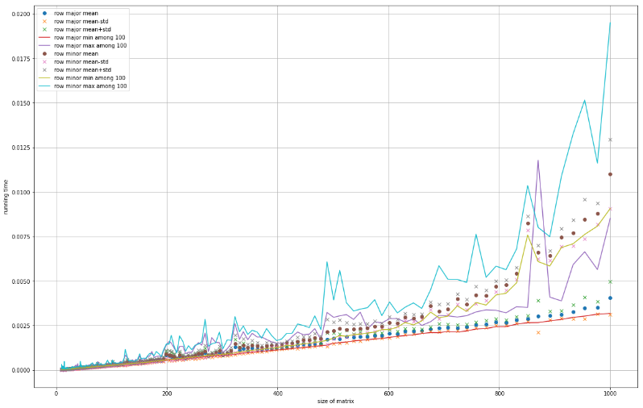

#### Summary

1. Scan by column slower than scan by row and the difference increases with the size.
2. Scan by row increases linearly and has very little random fluctuations.
3. Scan by column increases linearly with one constant until about n=430 and then increases with a higher constant.
4. Scan by column has large fluctuations around the mean

### 2.1.5 Measuring Latency

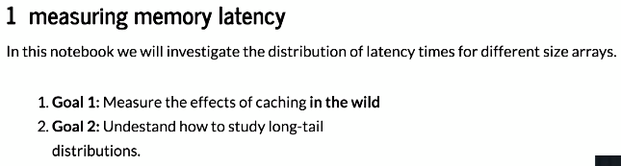

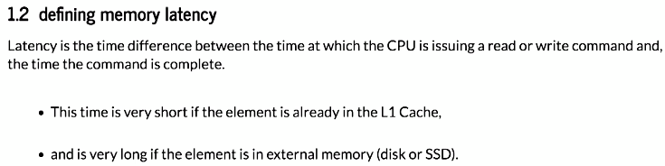

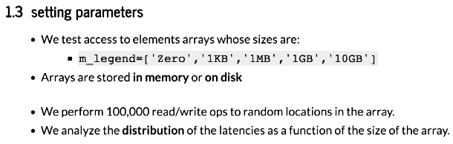

### 2.1.6 Memory Hierarchy

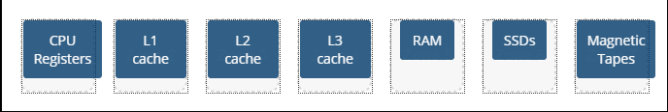

Why do we use caching?

* to transfer data between the different levels of the memory hierarchy 62%
* to ensure we stay in the top of the memory hierarchy 35%
* to ensure the bottom of the memory hierarchy does not lose data 2%

How is memory abstracted to the programmer?

* as a large, single array 72%
* memory is not abstracted to the programmer 15%
* as a high-dimensional matrix 13%

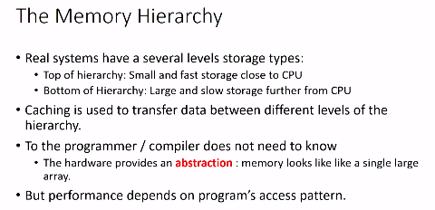

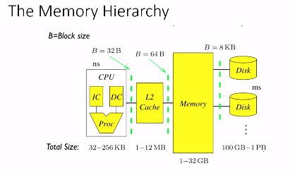

4 levels of storage: trade-off speed vs size

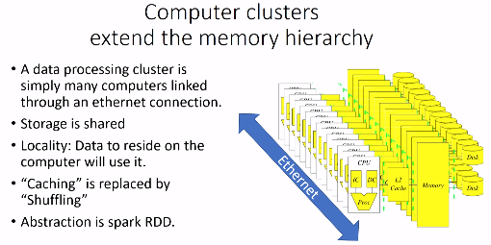

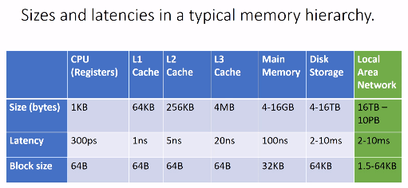

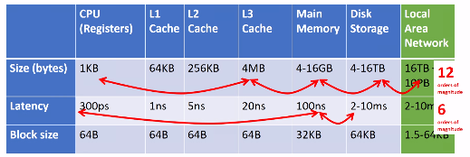

### 2.1.7 History of Large Scale Computing



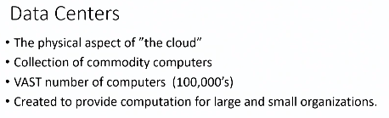

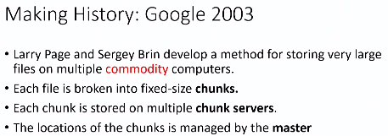

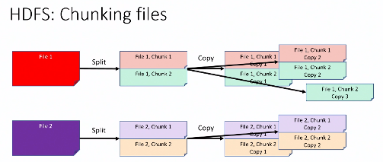

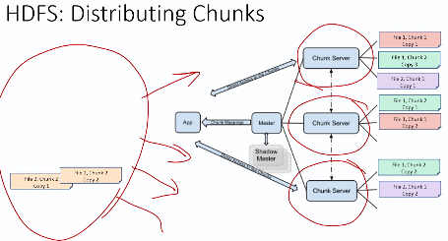

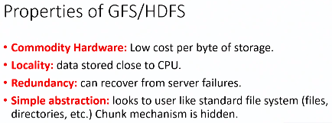

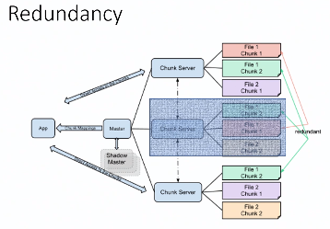

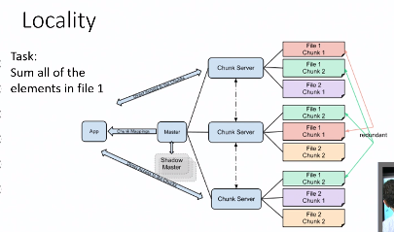

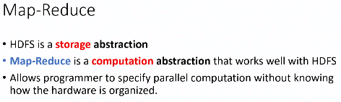

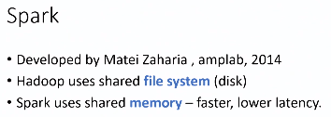

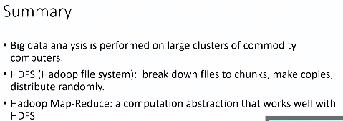

You are given a cluster of 5 servers, each with 500GB of storage. You run HDFS on these 5 servers with a redundancy factor of 4. What is the effective amount of total storage space available on the HDFS cluster?

* 625GB 55%
* 2500GB 16%
* 125GB 15%
* 500GB 14%

Which of the following are NOT properties of HDFS?

* Provides computational abstraction 67%
* Locality of data to CPU 16%
* Abstracts filesystem from user 13%
* Redundancy 2%
* Files divided into chunks 2%

## 2.2 Spark Basics

### 2.2.1 Map Reduce

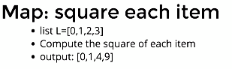

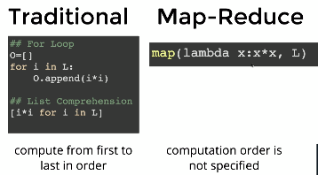

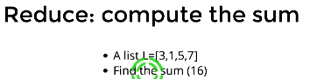

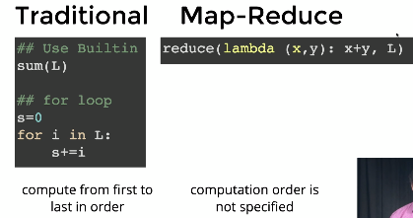

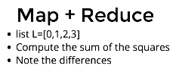

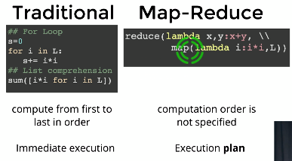

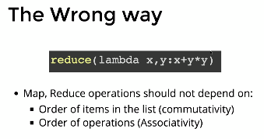

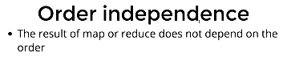

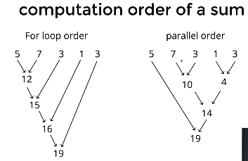

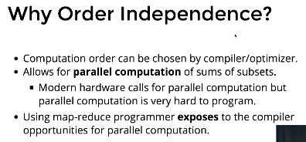

### 2.2.2 Short History of Map Reduce

Which of the following is not a characteristic of the collect() function of an RDD?

* It returns a subset of the distributed data 66%
* Parallelism is lost after collect() is performed 15%
* It brings all the distributed data to a single node 10%
* It is too slow for large data 9%

Which of the following operations on an RDD also returns an RDD? Check all that apply

* map()
* reduce()
* collect()
* sample()
* take()
* first()

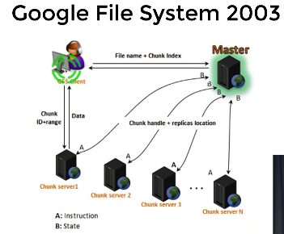

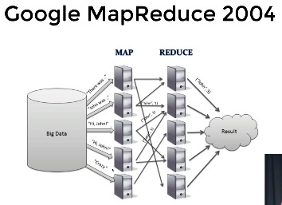

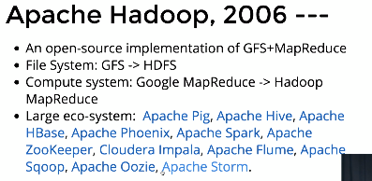

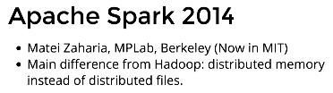

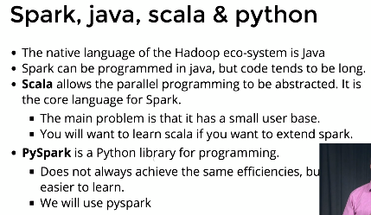



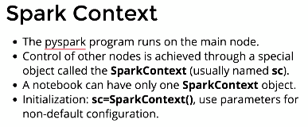

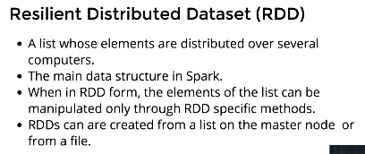

RDDs can be translated back into a local list using the command **collect**.



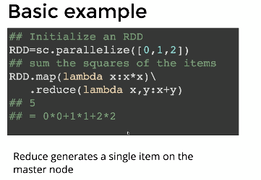

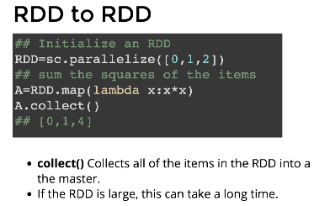

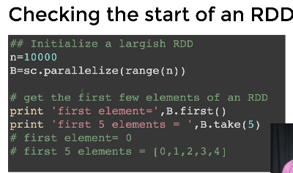

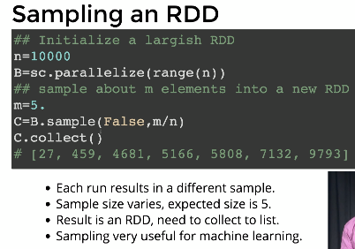

### 2.2.3 Spark Architecture

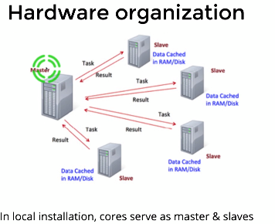

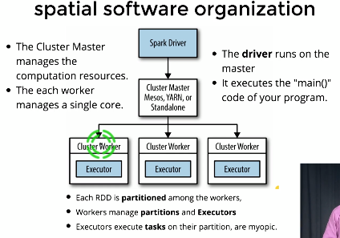

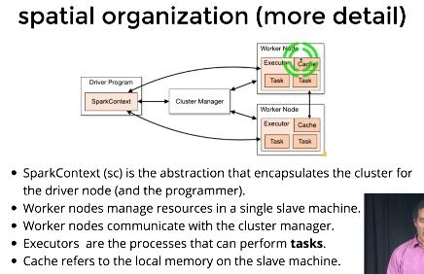

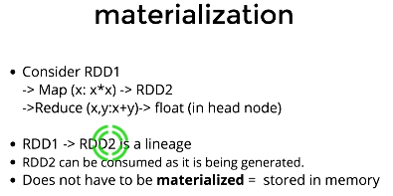

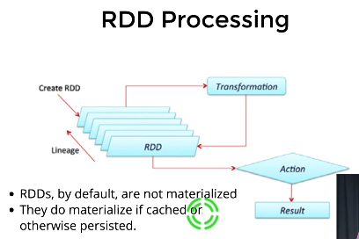

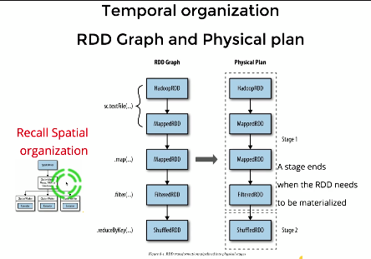

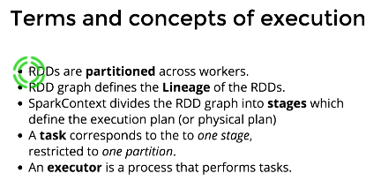

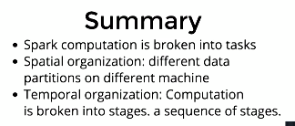

RDDs, by default, are stored in memory. (True/False)

* False 53%
* True 47%

A stage can be defined as...

* A set of operations that can be done without materialization 83%
* A set of operations that require materialization 14%
* A set of operations that are carried out after materialization 2%

### 2.2.4 Manipulating Plain RDD

If rdd is a resilient distributed dataset, rdd.collect() returns a

* list 93%
* dataframe 6%
* dictionary 1%

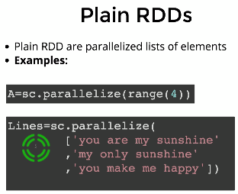

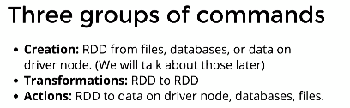

#### Plain RDD Actions



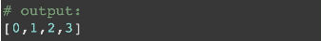



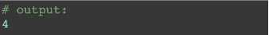

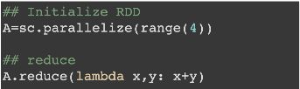

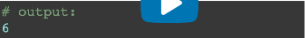

### 2.2.5 Manipulating KeyVal RDD

The key in an RDD has to be unique (True or False).

* False 88%
* True 12%

countByKey returns...

* a dictionary 70%
* A list of tuples 26%
* a list of lists 4%

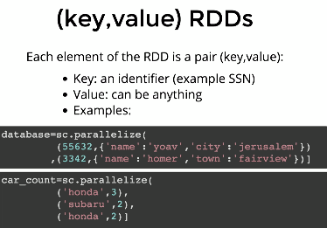

#### (key, Value) RDDs Transformations

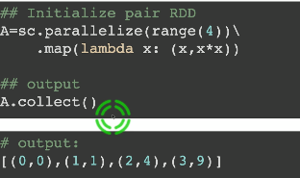

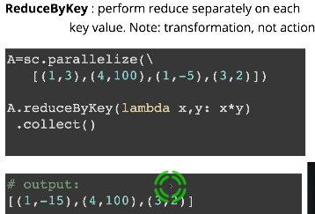

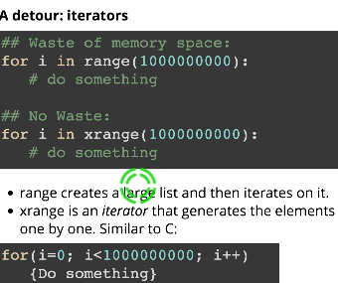

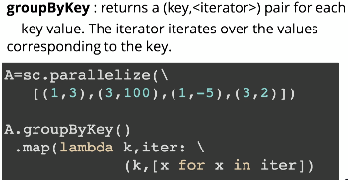

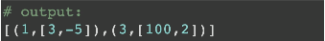

#### (key, Value) RDDs Actions

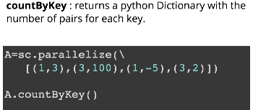

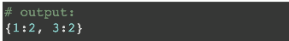

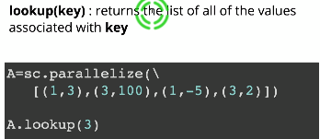

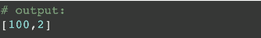

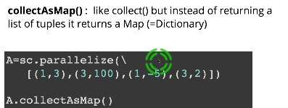

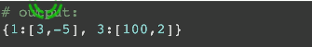

## 2.3 Assignment 1: Collinear Points

In this programming assignment, you will write python3 code using pyspark to find sets of collinear points given arbitrary number of 2D points.

To download the tar file for PA1 [click here](https://prod-edxapp.edx-cdn.org/assets/courseware/v1/3541a6c854381a1c22a7646815826600/asset-v1:UCSanDiegoX+DSE230x+1T2019a+type@asset+block/pa1.tgz). After Downloading the file, "cd" to the download directory and unpack it using the command: "tar -xzf pa1.tgz". You should get a directory named **pa1** which contains the jupyter notebook and the data files for PA1.

Depending on your installation setup, you could either mount the directory on docker (if you are using docker) OR just run jupyter locally and start working on the assignment. We do not currently support submission and grading of assignments for audit learners. However, there are lots of visible test cases in the assignment notebook that you can use to verify the correctness of your code.

### Programming Assignment 1: Collinear Points

For this programming assignment, we'll be using a Jupyter notebook.

#### Background

##### Collinear points

Definition of collinearity[1]: In geometry, collinearity of a set of points is the property of their lying on a single line. A set of points with this property is said to be collinear.

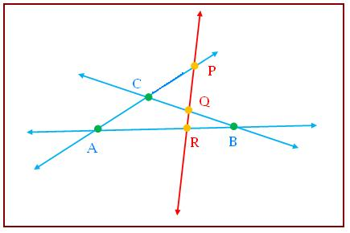

Here, points P,Q,R and A,R,B are collinear. However, points A,B,C are non-collinear. For more, refer [2].

1. <https://en.wikipedia.org/wiki/Collinearity>
2. <http://www.mathcaptain.com/geometry/collinear-points.html>

##### Parameterizing lines

In order to determine whether a set of points all lie on the same line we need a standard way to define (or parametrize) a line.

* One way of defining a line is as the set of points (x,y)(x,y) such that y=ax+by=ax+b for some fixed real values a,ba,b.
* We call aa the **slope** of the line and bb is the yy-intercept which is defined as the value of yy when x=0x=0.
* This parameterization works for *almost* all lines. It does not work for vertical lines. For those lines we define aa to be **infinity** and bb to be the xx intercept of the line (the line is parallel to the yy axis so it does not intercept the yy axis (other than if it is the vertical line going through the origin).

To summarize, given two different points (x1,y1)≠(x2,y2)(x1,y1)≠(x2,y2), we define the parameterization (a,b)(a,b) as:

* **if**x1=x2x1=x2**:**(Inf,x1)(Inf,x1)
* **Else:** (a,b)(a,b) such that y1=ax1+by1=ax1+b and y2=ax2+by2=ax2+b.

#### Task

Given an input file with an arbitrary set of co-ordinates, your task is to use pyspark library functions and write a program in python3 to find if three or more points are collinear. For instance, if given these points: {(1,1), (0,1), (2,2), (3,3), (0,5), (3,4), (5,6), (0,-3), (-2,-2)} Sets of collinear points are: {((-2,-2), (1,1), (2,2), (3,3)), ((0,1), (3,4), (5,6)), ((0,-3), (0,1), (0,5))}. Note that the ordering of the points in a set or the order of the sets does not matter. Note:

* Every set of collinear points has to have **at least three points** (any pair of points lie on a line).
* There are two types of test cases:
  + **Visible Test cases**: Test cases given to you as a part of the notebook. These tests will help you validate your program and figure out bugs in it .
  + **Hidden Test cases**: Test cases that are not given as a part of the notebook, but will be used for grading.   
    Cells in this notebook that have "*##Hidden test cases here*" are read-only cells containing hidden tests.
* Any cell that does not require you to submit code cannot be modified. For example: Assert statement unit test cells. Cells that have "**# YOUR CODE HERE**" are the ONLY ones you will need to alter.
* DO NOT change the names of functions.
* Remove the "Raise NotImplementedError()" line when you write the definition of your function.

#### Description of the Approach

The goal of this assignment is to make you familiar with programming using pyspark. There are many ways to find sets of collinear points from a list of points. For the purposes of this assignment, we shall stick with the below approach:

1. List all pairs of points. You can do that efficiently in spark by computing cartesian product of the list of points with itself. For example, given three points [(1,0),(2,0),(3,0)], we construct a list of nine pairs  
   [((1,0),(1,0)),((1,0),(2,0)),((1,0),(3,0))   
   ((2,0),(1,0)),((2,0),(2,0)),((2,0),(3,0))   
   ((3,0),(1,0)),((3,0),(2,0)),((3,0),(3,0))]
2. Remove the pairs in which the same point appears twice such as ((2,0),(2,0)). After these elimination you end up (for this example) with a list of just six pairs:  
   [((1,0),(2,0)),((1,0),(3,0)),((2,0),(1,0)),((2,0),(3,0)),((3,0),(1,0)),((3,0),(2,0))]
3. For each pair of points, find the parameterization (a,b) of the line connecting them as described above.
4. Group the pairs according to their parameters. Clearly, if two pairs have the same (a,b) values, all points in the two pairs lie on the same line.
5. Eliminate groups that contain only one pair (any pair of points defines a line).
6. In each of the remaining groups, unpack the point-pairs to identify the individual points. Note that if a set of points (x1,y1),…,(xk,yk) lie on the same line then each point will appear k−1 times in the list of point-pairs. You therefore need to transform the list of points into sets to remove duplicates.
7. Output the sets of 3 or more colinear points.

Your task is to implement the described algorithm in Spark. You should use RDD's all the way through and collect the results into the driver only at the end.

#### Notebook Setup

**from** **pyspark** **import** SparkContext, SparkConf

*#Create SparkConf() object, use it to initialize spark context*

conf = SparkConf().setAppName("Collinear Points").setMaster("local[4]") *#Initialize spark context using 4 local cores as workers*

sc = SparkContext(conf=conf)

**from** **pyspark.rdd** **import** RDD

#### Helper Functions

Here are some helper functions that you are encouraged to use in your implementations. Do not change these functions. The function format_result takes an element of the form shown below in the example. It outputs a tuple of all points that are collinear (shown below). Input: ((A,slope), [C1,..., Ck]) where each of A, C1, ..., Ck is a point of form (Ax, Ay) and slope is of type float.

**Example Code**

my_input = (((2, 1), 0.5), [(4, 2), (6, 3)])

format_result(my_input)

Output: (C1,..., Ck, A) each of A,C1,...,Ck is a point of form (Ax, Ay)

**Example Output**

((4, 2), (6, 3), (2, 1))

**Hint : ** The above example is given just to provide the input and output format. This function is called a different way in the spark exercise.

**def** format_result(x):

x[1].append(x[0][0])

**return** tuple(x[1])

**def** to_sorted_points(x):

*"""*

*Sorts and returns a tuple of points for further processing.*

*"""*

**return** tuple(sorted(x))

#### Exercises

Here are some functions that you will implement. You should follow the function definitions, and use them appropriately elsewhere in the notebook.

##### Exercise 1: to_tuple

**Example**

The function to_tuple converts each point of form 'Ax Ay' into a point of form (Ax, Ay) for further processing.

**Example Code**

my_input = '2 3'

to_tuple(my_input)

**Example Output**

(2, 3)

**Hint : ** The above example is given just to provide the input and output format. This function is called a different way in the spark exercise.

###### Definition

*## Insert answer in this cell. DON’T CHANGE NAME OF FUNCTION.*

**def** to_tuple(x):

*# YOUR CODE HERE*

**raise** **NotImplementedError**()

###### Unit Tests

**assert** type(to_tuple('1 1')) == tuple, "Incorrect type: Element returned is not a tuple"

**assert** type(to_tuple('1 1')[0])==int **and** type(to_tuple('1 1')[1])==int, "Incorrect element type: Element returned is not an integer"

**assert** to_tuple('1 1') == (1,1), "Incorrect Return Value: Value obtained does not match"

##### Exercise 2: non_duplicates

**Example**

The function non_duplicates checks if a set of points contains duplicates or not.

Input: Pair (A,B) where A and B are of form (Ax, Ay) and (Bx, By) respectively.

**Example Code**

my_input = ((0,0),(1,2))

non_duplicates(my_input)

Output: Returns True if A != B, False otherwise.

**Example Output**

True

**Hint : ** The above example is given just to provide the input and output format. This function is called a different way in the spark exercise.

###### Definition

*## Insert your answer in this cell. DO NOT CHANGE THE NAME OF THE FUNCTION.*

**def** non_duplicates(x):

*"""*

*Use this function inside the get_cartesian() function to 'filter' out pairs with duplicate points*

*"""*

*# YOUR CODE HERE*

**raise** **NotImplementedError**()

###### Unit Tests

**assert** type(non_duplicates(((0,0),(1,2)))) == bool, "Incorrect Return type: Function should return a boolean value"

**assert** non_duplicates(((0,0),(1,2))) == **True**, "No duplicates are present"

**assert** non_duplicates(((0,0),(0,0))) == **False**, "Duplicates exist: (0,0)"

##### Exercise 3: get_cartesian

**Example**

The function get_cartesian does a cartesian product of an RDD with itself and returns an RDD with **DISTINCT** pairs of points. Input: RDD containing the given list of points. Output: RDD containing The cartesian product of the RDD with itself

**Example Code**

test_rdd = sc.parallelize([(1,0), (2,0), (3,0)])

get_cartesian(test_rdd).collect()

**Example Output**

[((1, 0), (2, 0)), ((1, 0), (3, 0)), ((2, 0), (1, 0)), ((2, 0), (3, 0)), ((3, 0), (1, 0)), ((3, 0), (2, 0))]

Refer: <http://spark.apache.org/docs/latest/api/python/pyspark.html?highlight=cartesian#pyspark.RDD.cartesian>

###### Definition

*## Insert your answer in this cell. DO NOT CHANGE THE NAME OF THE FUNCTION.*

**def** get_cartesian(rdd):

*# YOUR CODE HERE*

**raise** **NotImplementedError**()

###### Unit Tests

test_rdd = sc.parallelize([(1,0), (2,0), (3,0)])

l = [((1, 0), (2, 0)), ((1, 0), (3, 0)), ((2, 0), (1, 0)), ((2, 0), (3, 0)), ((3, 0), (1, 0)), ((3, 0), (2, 0))]

**assert** isinstance(get_cartesian(test_rdd), RDD) == **True**, "Incorrect Return type: Function should return an RDD"

**assert** set(get_cartesian(test_rdd).collect()) == set(l), "Incorrect Return Value: Value obtained does not match"

*##Hidden test cases here*

*##Hidden test cases here*

##### Exercise 4: find_slope

**Example**

The function find_slope computes slope between points A and B and returns it in the format specified below. Input: Pair (A,B) where A and B are of form (Ax, Ay) and (Bx, By) respectively.

**Example Code**

my_input = ((1,2),(3,4))

find_slope(my_input)

Output: Pair ((A,slope), B) where A and B have the same definition as input and slope refers to the slope of the line segment connecting point A and B.

**Example Output**

(((1, 2), 1.0), (3, 4))

**Note: ** If Ax == Bx, use slope as "inf".

**Hint : ** The above example is given just to provide the input and output format. This function is called a different way in the spark exercise.

**Definition**

*## Insert your answer in this cell*

**def** find_slope(x):

*# YOUR CODE HERE*

**raise** **NotImplementedError**()

###### Unit Tests

**assert** type(find_slope(((1,2),(3,4)))) == tuple, "Function must return a tuple"

**assert** find_slope(((1,2),(-7,-2)))[0][1] == 0.5, "Slope value should be 0.5"

**assert** find_slope(((1,2),(3,4))) == (((1,2),1),(3,4)), "Incorrect return value: Value obtained does not match"

**assert** find_slope(((1,2),(1,5))) == (((1,2),"inf"),(1,5)), "Incorrect return value: Value obtained must have slope 'inf'"

**assert** find_slope(((1,2),(2,5))) == (((1,2),3),(2,5)), "Incorrect return value: Value obtained does not match"

*##Hidden test cases here*

*##Hidden test cases here*

*##Hidden test cases here*

##### Exercise 5: find_collinear

**Example**

The function find_collinear finds the set of collinear points. Input: An RDD (which is the output of the get_cartesian() function. Output: An RDD containing the list of collinear points formatted according to the format_result function.

Approach:

1. Find slope of the line between all pairs of points A = (Ax, Ay) and B = (Bx, By).
2. For each (A, B), find all points C = ((C1x, C1y), (C2x, C2y), ... (Cnx, Cny)) where slope of (A,B) = slope of (A, Ci).
3. Return (A, B, Ck) where Ck = all points of C which satisfy the condition 1.

The assert statement unit tests for this function will help you with this. **Hint : ** You should use the above helper functions in conjunction with Spark RDD API (refer <http://spark.apache.org/docs/latest/api/python/pyspark.html?highlight=rdd#pyspark.RDD>) Finally, use helper function format_result() appropriately from inside this function after you have implemented the above operations.

###### Definition

**def** find_collinear(rdd):

*# YOUR CODE HERE*

**raise** **NotImplementedError**()

###### Unit Tests

**def** verify_collinear_sets(collinearpointsRDD, testlist):

collinearpoints = [tuple(sorted(x)) **for** x **in** list(set(collinearpointsRDD.collect()))]

testlist = [tuple(sorted(x)) **for** x **in** list(set(testlist))]

**return** set(collinearpoints) == set(testlist)

test_rdd = sc.parallelize([((4, 2), (2, 1)), ((4, 2), (-3, 4)), ((4, 2), (6, 3)), ((2, 1), (4, 2)), ((2, 1), (-3, 4)), ((2, 1), (6, 3)), ((-3, 4), (4, 2)), ((-3, 4), (2, 1)), ((-3, 4), (6, 3)), ((6, 3), (4, 2)), ((6, 3), (2, 1)), ((6, 3), (-3, 4))])

**assert** isinstance(find_collinear(test_rdd), RDD) == **True**, "Incorrect return type: Function must return RDD"

**assert** verify_collinear_sets(find_collinear(test_rdd), [((2, 1), (4, 2), (6, 3))]), "Incorrect return value: Value obtained does not match"

*##Hidden test cases here*

###### Unit Tests II : Using the output of get_cartesian(rdd)

test_rdd = sc.parallelize([(4, -2), (2, -1), (-3,4), (6,3), (-9,4), (6, -3), (8,-4), (6,9)])

test_rdd = get_cartesian(test_rdd)

**assert** verify_collinear_sets(find_collinear(test_rdd), [((6, -3), (6, 3), (6, 9)), ((2, -1), (4, -2), (6, -3), (8, -4))]), "Incorrect return value: You have not implemented the find_collinear function in Python"

*##Hidden test cases here*

##### Exercise 6: The build_collinear_set function

**Example**

Using the above functions that you have written along with pyspark functions, write the **build_collinear_set** function and returns an RDD containing the set of collinear points. Input: RDD containing the given set of points Output: RDD containing the set of collinear points

**Hint : ** Remember that the input RDD consists of a set of strings. Remember to pre-process them using the to_tuple function before performing other operations.

###### Definition

**def** build_collinear_set(rdd):

*# YOUR CODE HERE*

**raise** **NotImplementedError**()

*# Sorting each of your returned sets of collinear points. This is for grading purposes.*

*# YOU MUST NOT CHANGE THIS.*

rdd = rdd.map(to_sorted_points)

**return** rdd

###### Unit Tests

test_rdd = sc.parallelize(['4 -2', '2 -1', '-3 4', '6 3', '-9 4', '6 -3', '8 -4', '6 9'])

**assert** isinstance(build_collinear_set(test_rdd), RDD) == **True**, "build_collinear_set should return an RDD."

##### The process function

###### Definition

**def** process(filename):

*"""*

*This is the process function used for finding collinear points using inputs from different files*

*Input: Name of the test file*

*Output: Set of collinear points*

*"""*

*# Load the data file into an RDD*

rdd = sc.textFile(filename)

rdd = build_collinear_set(rdd)

*# Collecting the collinear points RDD in a set to remove duplicate sets of collinear points. This is for grading purposes. You may ignore this.*

res = set(rdd.collect())

**return** res

###### Unit Tests: Testing the build_collinear_set function using the process function

NOTE: You may assume that input files do not have duplicate points.

**assert** process("data.txt") == {((-2, -2), (1, 1), (2, 2), (3, 3)), ((0, 1), (3, 4), (5, 6)), ((0, -3), (0, 1), (0, 5))}, "Your implementation of build_collinear_set is not correct."

**assert** process("data50.txt") ==

{((3, 6), (7, 4), (9, 3)), ((1, 6), (3, 6), (4, 6), (7, 6)),

((0, 2), (3, 1), (6, 0)), ((1, 0), (2, 0), (5, 0), (6, 0)),

((1, 3), (3, 6), (5, 9)), ((0, 8), (4, 6), (6, 5)),

((6, 0), (6, 1), (6, 5), (6, 9)),

((7, 2), (7, 3), (7, 4), (7, 6), (7, 8)), ((3, 1), (3, 3), (3, 6)),

((0, 2), (1, 2), (5, 2), (7, 2)), ((0, 3), (2, 5), (3, 6), (6, 9)),

((0, 2), (1, 3), (2, 4), (4, 6), (5, 7)), ((1, 2), (4, 3), (7, 4)),

((0, 3), (4, 6), (8, 9)), ((9, 3), (9, 4), (9, 5)), ((2, 5), (5, 7), (8, 9)),

((0, 5), (2, 4), (4, 3), (8, 1)), ((0, 8), (1, 6), (2, 4)),

((3, 6), (5, 2), (6, 0)), ((5, 9), (6, 9), (8, 9)),

((0, 8), (1, 8), (7, 8)), ((0, 4), (1, 3), (3, 1)), ((5, 9), (7, 6), (9, 3)),

((1, 2), (2, 4), (3, 6)), ((0, 7), (1, 5), (3, 1)),

((1, 5), (2, 4), (3, 3), (6, 0)), ((0, 2), (3, 3), (9, 5)),

((0, 7), (1, 6), (2, 5), (4, 3), (5, 2), (6, 1)),

((0, 4), (1, 5), (5, 9)), ((1, 5), (3, 6), (5, 7), (7, 8)),

((1, 6), (3, 3), (5, 0)), ((3, 6), (4, 3), (5, 0)),

((1, 2), (4, 5), (7, 8), (8, 9)), ((0, 2), (1, 1), (2, 0)),

((3, 3), (4, 5), (5, 7), (6, 9)), ((0, 2), (0, 3), (0, 4), (0, 5), (0, 7), (0, 8)),

((2, 0), (4, 3), (8, 9)), ((5, 7), (6, 5), (7, 3), (8, 1)), ((5, 0), (7, 6), (8, 9)),

((5, 0), (6, 1), (7, 2), (9, 4)), ((0, 4), (1, 2), (2, 0)),

((1, 1), (3, 1), (6, 1), (8, 1)), ((5, 7), (7, 6), (9, 5)), ((1, 1), (7, 4), (9, 5)),

((0, 4), (2, 4), (7, 4), (9, 4)), ((1, 0), (3, 1), (5, 2), (7, 3), (9, 4)),

((2, 0), (3, 3), (4, 6), (5, 9)), ((4, 3), (4, 5), (4, 6)),

((1, 0), (4, 3), (6, 5), (7, 6)), ((0, 3), (2, 4), (4, 5)),

((1, 6), (4, 5), (7, 4)), ((1, 0), (1, 1), (1, 2), (1, 3), (1, 5), (1, 6), (1, 8)),

((0, 3), (1, 3), (3, 3), (4, 3), (7, 3), (9, 3)), ((0, 4), (2, 5), (4, 6)),

((0, 7), (3, 6), (6, 5), (9, 4)), ((1, 8), (4, 6), (7, 4)),

((0, 5), (3, 3), (6, 1)), ((1, 8), (3, 6), (4, 5), (7, 2), (8, 1)),

((1, 2), (3, 1), (5, 0)), ((1, 1), (5, 2), (9, 3)),

((5, 0), (5, 2), (5, 7), (5, 9)), ((0, 5), (1, 5), (2, 5), (4, 5), (6, 5), (9, 5)),

((3, 1), (4, 5), (5, 9)), ((2, 0), (2, 4), (2, 5)), ((5, 2), (6, 5), (7, 8))}, "Your implementation of build_collinear_set is not correct."

*##Hidden test cases here*

*##Hidden test cases here*

*##Hidden test cases here*

*##Hidden test cases here*

## 2.4 Pyspark and RDDs

### 2.4.1 Spark Notebook Basics pt. 1

Which library do we need to import to create a SparkContext?

* pyspark 98%
* matplotlib 2%
* pandas 0%
* scipy 0%

Which of the following stops the SparkContext kernel?

* sc.stop() 92%
* Kernels are not required 5%
* kern.exit() 2%
* exit 1%

What did Professor Freund say is the simplest way to create an RDD?

* A = sc.parallelize(L) where L is a list 97%
* sparkContext(A) where A is an RDD object 2%
* A = sc.create(L) where L is a list 1%

This notebook introduces two fundamental objects in Spark:

* The Spark Context
* The Resilient Distributed DataSet or RDD

#### Spark Context

We start by creating a **SparkContext** object named **sc**. In this case we create a spark context that uses 4 *executors* (one per core)

*#start the SparkContext*

**import** **findspark**

findspark.init()

**from** **pyspark** **import** SparkContext

sc = SparkContext(master="local[4]")

print(sc)

<SparkContext master=local[4] appName=pyspark-shell>

##### Only one sparkContext at a time!

* Spark is designed for single user
* Only one sparkContext per program/notebook.
* Before starting a new sparkContext. Stop the one currently running

*# sc.stop() #commented out so that you don't stop your context by mistake*

#### RDDs

RDD (or Resilient Distributed DataSet) = main novel data structure in Spark. You can think of it as a list whose elements are stored on several computers.

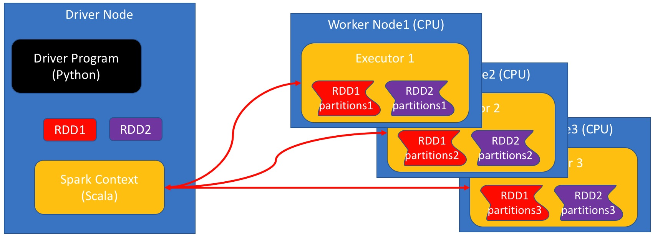

The elements of each RDD are distributed across the **worker nodes** which are the nodes that perform the actual computations. This notebook, however, is running on the **Driver node**. As the RDD is not stored on the driver-node you cannot access it directly. The variable name RDD is really just a pointer to a python object which holds the information regardnig the actual location of the elements.

##### Some basic RDD commands

###### Parallelize

* Simplest way to create an RDD.
* The method A=sc.parallelize(L), creates an RDD named A from list L.
* A is an RDD of type PythonRDD.

A=sc.parallelize(range(3))

A

PythonRDD[1] at RDD at PythonRDD.scala:48

###### Collect

* RDD content is distributed among all executors.
* collect() is the inverse of `parallelize()'
* collects the elements of the RDD
* Returns a list

L=A.collec t()

print(type(L))

print(L)

<class 'list'>

[0, 1, 2]

**Using .collect() eliminates the benefits of parallelism**

It is often tempting to .collect() and RDD, make it into a list, and then process the list using standard python. However, note that this means that you are using only the head node to perform the computation which means that you are not getting any benefit from spark.

Using RDD operations, as described below, **will** make use of all of the computers at your disposal.

###### Map

* applies a given operation to each element of an RDD
* parameter is the function defining the operation.
* returns a new RDD.
* Operation performed in parallel on all executors.
* Each executor operates on the data local to it.

A.map(**lambda** x: x*x).collect()

[0, 1, 4]

**Note:** Here we are using **lambda** functions, later we will see that regular functions can also be used.

For more on lambda function see [here](http://www.secnetix.de/olli/Python/lambda_functions.hawk)

###### Reduce

* Takes RDD as input, returns a single value.
* **Reduce operator** takes **two** elements as input returns **one** as output.
* Repeatedly applies a **reduce operator**
* Each executor reduces the data local to it.
* The results from all executors are combined.

The simplest example of a 2-to-1 operation is the sum:

A.reduce(**lambda** x,y:x+y)

3

Here is an example of a reduce operation that finds the shortest string in an RDD of strings.

words=['this','is','the','best','mac','ever']

wordRDD=sc.parallelize(words)

wordRDD.reduce(**lambda** w,v: w **if** len(w)<len(v) **else** v)

'is'

###### Properties of reduce operations

* Reduce operations **must not depend on the order**
* Order of operands should not matter
* Order of application of reduce operator should not matter
* Multiplication and summation are good:

1 + 3 + 5 + 2 5 + 3 + 1 + 2

* Division and subtraction are bad:

1 - 3 - 5 - 2 1 - 3 - 5 - 2

###### Why must reordering not change the result?

You can think about the reduce operation as a binary tree where the leaves are the elements of the list and the root is the final result. Each triplet of the form (parent, child1, child2) corresponds to a single application of the reduce function. The order in which the reduce operation is applied is **determined at run time** and depends on how the RDD is partitioned across the cluster. There are many different orders to apply the reduce operation. If we want the input RDD to uniquely determine the reduced value **all evaluation orders must must yield the same final result**. In addition, the order of the elements in the list must not change the result. In particular, reversing the order of the operands in a reduce function must not change the outcome.

For example the arithmetic operations multiply * and add + can be used in a reduce, but the operations subtract - and divide / should not.

Doing so will not raise an error, but the result is unpredictable.

B=sc.parallelize([1,3,5,2])

B.reduce(**lambda** x,y: x-y)

-9

Which of these the following orders was executed?

* ((1−3)−5)−2((1−3)−5)−2

or

* (1−3)−(5−2)(1−3)−(5−2)

###### Using regular functions instead of lambda functions

* lambda function are short and sweet.
* but sometimes it's hard to use just one line.
* We can use full-fledged functions instead.

A.reduce(**lambda** x,y: x+y)

3

Suppose we want to find the

* last word in a lexicographical order
* among
* the longest words in the list.

We could achieve that as follows

**def** largerThan(x,y):

**if** len(x)>len(y): **return** x

**elif** len(y)>len(x): **return** y

**else**: *#lengths are equal, compare lexicographically*

**if** x>y:

**return** x

**else**:

**return** y

wordRDD.reduce(largerThan)

'this'

#### Summary

We saw how to:

* Start a SparkContext
* Create an RDD
* Perform Map and Reduce operations on an RDD
* Collect the final results back to head node.

### 2.4.2 Changing Number of Workers

**The effect of changing the number of workers**

* When you initialize SparkContext, you can specify the number of workers.
* Usually the recommendation is for one worker per core.
* But the number of workers can be smaller or larger than the number of cores

**from** **time** **import** time

**from** **pyspark** **import** SparkContext

**for** j **in** range(1,10):

sc = SparkContext(master="local[**%d**]"%(j))

t0=time()

**for** i **in** range(10):

sc.parallelize([1,2]*1000000).reduce(**lambda** x,y:x+y)

print("**%2d** executors, time=**%4.3f**"%(j,time()-t0))

sc.stop()

1 executors, time=17.836

2 executors, time=14.356

3 executors, time=14.686

4 executors, time=14.881

5 executors, time=15.043

6 executors, time=15.079

7 executors, time=15.422

8 executors, time=15.360

9 executors, time=15.856

#### Summary

* This machine has 4 cores
* Increasing the number of executors from 1 to 3 speeds up the computation
* From 3 and up you have fluctuations in performance.
* More than one worker per core is usually unhelpful

### 2.4.3 Execution Plans Lazy Eval and Caching

Task: calculate the sum of squares :

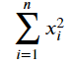

The standard (or **busy**) way to do this is

1. Calculate the square of each element.
2. Sum the squares.

This requires **storing** all intermediate results.

#### Busy Evaluation

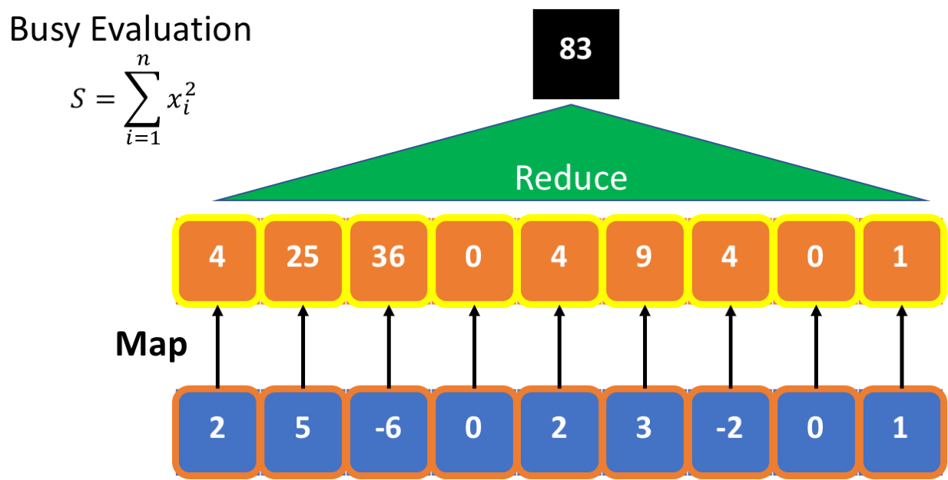

##### lazy evaluation:

* **postpone** computing the square until result is needed.
* No need to store intermediate results.
* Scan through the data once, rather than twice.

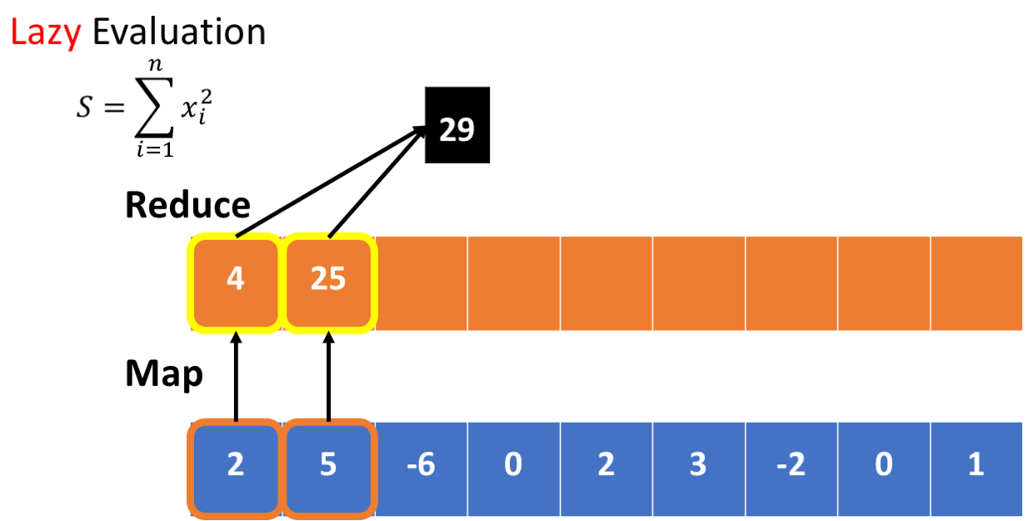

#### Lazy Evaluation

Unlike a regular python program, map/reduce commands do not always perform any computation when they are executed. Instead, they construct something called an **execution plan**. Only when a result is needed does the computation start. This approach is also called **lazy execution**.

The benefit from lazy execution is in minimizing the the number of memory accesses. Consider for example the following map/reduce commands:

A=RDD.map(**lambda** x:x*x).filter(**lambda** x: x%2==0)

A.reduce(**lambda** x,y:x+y)

The commands defines the following plan. For each number x in the RDD:

1. Compute the square of x
2. Filter out x*x whose value is odd.
3. Sum the elements that were not filtered out.

A naive execution plan is to square all items in the RDD, store the results in a new RDD, then perform a filtering pass, generating a second RDD, and finally perform the summation. Doing this will require iterating through the RDD three times, and creating 2 interim RDDs. As memory access is the bottleneck in this type of computation, the execution plan is slow.

A better execution plan is to perform all three operations on each element of the RDD in sequence, and then move to the next element. This plan is faster because we iterate through the elements of the RDD only once, and because we don't need to save the intermediate results. We need to maintain only one variable: the partial sum, and as that is a single variable, we can use a CPU register.

For more on RDDs and lazy evaluation see [here in the spark manual](http://spark.apache.org/docs/latest/programming-guide.html#rdd-operations)

#### Experimenting with Lazy Evaluation

##### The %%time magic

The %%time command is a *cell magic* which measures the execution time of the cell. We will mostly be interested in the wall time, which includes the time it takes to move data in the memory hierarchy.

For more on jupyter magics [See here](https://ipython.org/ipython-doc/3/interactive/magics.html)

##### Preparations

In the following cells we create an RDD and define a function which wastes some time and then returns cos(i). We want the function to waste some time so that the time it takes to compute the map operation is significant.

**from** **pyspark** **import** SparkContext

sc = SparkContext(master="local[4]") *#note that we set the number of workers to 3*

We create an RDD with one million elements to amplify the effects of lazy evaluation and caching.

%%time

RDD=sc.parallelize(range(1000000))

CPU times: user 0 ns, sys: 0 ns, total: 0 ns

Wall time: 604 ms

It takes about 01.-0.5 sec. to create the RDD.

print(RDD.toDebugString().decode())

(4) PythonRDD[1] at RDD at PythonRDD.scala:48 []

| ParallelCollectionRDD[0] at parallelize at PythonRDD.scala:175 []

##### Define a computation

The role of the function taketime is to consume CPU cycles.

**from** **math** **import** cos

**def** taketime(i):

[cos(j) **for** j **in** range(100)]

**return** cos(i)

%%time

taketime(1)

CPU times: user 0 ns, sys: 0 ns, total: 0 ns

Wall time: 52 µs

0.5403023058681398

##### Time units

* 1 second = 1000 Milli-second (msms)
* 1 Millisecond = 1000 Micro-second (μsμs)
* 1 Microsecond = 1000 Nano-second (nsns)

##### Clock Rate

One cycle of a 3GHz cpu takes 13ns13ns

taketime(1000) takes about 25 μsμs = 75,000 clock cycles.

##### The map operation.

%%time

Interm=RDD.map(**lambda** x: taketime(x))

CPU times: user 0 ns, sys: 0 ns, total: 0 ns

Wall time: 33.4 µs

##### How come so fast?

* We expect this map operation to take 1,000,000 * 25 μs = 25 Seconds.
* **Why** did the previous cell take just 29 μs?
* Because **no** computation **was done**
* The cell defined an execution **plan**, but did not execute it yet.

**Lazy Execution** refers to this type of behaviour. The system delays actual computation until the latest possible moment. Instead of computing the content of the RDD, it adds the RDD to the **execution plan**.

Using Lazy evaluation of a plan has two main advantages relative to immediate execution of each step:

1. A single pass over the data, rather than multiple passes.
2. Smaller memory footprint becase no intermediate results are saved.

##### Execution Plans

At this point the variable Interm does not point to an actual data structure. Instead, it points to an execution plan expressed as a **dependence graph**. The dependence graph defines how the RDDs are computed from each other.

The dependence graph associated with an RDD can be printed out using the method toDebugString().

print(Interm.toDebugString().decode())

(4) PythonRDD[2] at RDD at PythonRDD.scala:48 []

| ParallelCollectionRDD[0] at parallelize at PythonRDD.scala:175 []

**Interm=** (4) PythonRDD[2] at RDD at PythonRDD.scala:48 []  
______(4) corresponds to the number of partitions

**RDD**= | ParallelCollectionRDD[0] at parallelize at PythonRDD.scala:489 []

At this point only the two left blocks of the plan have been declared.

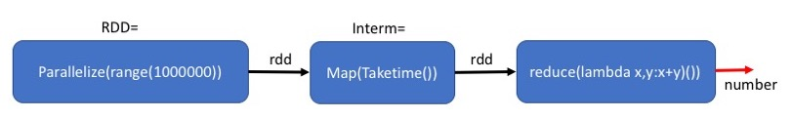

##### Actual execution

The reduce command needs to output an actual output, **spark** therefor has to actually execute the map and the reduce. Some real computation needs to be done, which takes about 1 - 3 seconds (Wall time) depending on the machine used and on it's load.

%%time

print('out=',Interm.reduce(**lambda** x,y:x+y))

out= -0.2887054679684464

CPU times: user 10 ms, sys: 10 ms, total: 20 ms

Wall time: 25 s

##### How come so fast? (take 2)

* We expect this map operation to take 1,000,000 * 25 μsμs = 25 Seconds.
* Map+reduce takes only ~4 second.
* Why?
* Because we have 4 workers, rather than one.
* Because the measurement of a single iteration of taketime is an overestimate.

##### Executing a different calculation based on the same plan.

The plan defined by Interm might need to be executed more than once.

**Example:** compute the number of map outputs that are larger than zero.

%%time

print('out=',Interm.filter(**lambda** x:x>0).count())

out= 500000

CPU times: user 20 ms, sys: 0 ns, total: 20 ms

Wall time: 22.7 s

##### The price of not materializing

* The run-time (3.4 sec) is similar to that of the reduce (4.4 sec).
* Because the intermediate results in Interm have not been saved in memory (materialized)
* They need to be recomputed.

The middle block: Map(Taketime) is executed twice. Once for each final step.

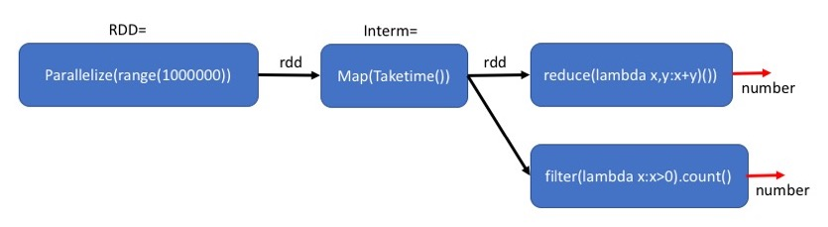

##### Caching intermediate results

* We sometimes want to keep the intermediate results in memory so that we can reuse them later without recalculating. * This will reduce the running time, at the cost of requiring more memory.
* The method cache() indicates that the RDD generates in this plan should be stored in memory. Note that this is a **plan to cache**. The actual caching will be done only when the final result is needed.

%%time

Interm=RDD.map(**lambda** x: taketime(x)).cache()

CPU times: user 10 ms, sys: 0 ns, total: 10 ms

Wall time: 47.1 ms

By adding the Cache after Map(Taketime), we save the results of the map for the second computation.

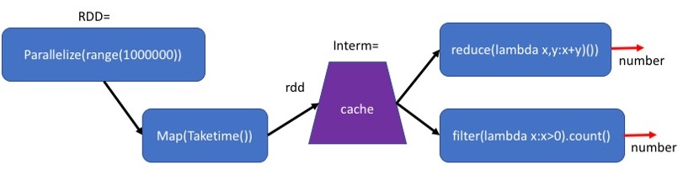

##### Plan to cache

The definition of Interm is almost the same as before. However, the *plan* corresponding to Interm is more elaborate and contains information about how the intermediate results will becached and replicated.

Note that PythonRDD[4] is now [Memory Serialized 1x Replicated]

print(Interm.toDebugString().decode())

(4) PythonRDD[5] at RDD at PythonRDD.scala:48 [Memory Serialized 1x Replicated]

| ParallelCollectionRDD[0] at parallelize at PythonRDD.scala:489 [Memory Serialized 1x Replicated]

##### Comparing plans with and without cache

Plan with Cache

(4) PythonRDD[33] at RDD at PythonRDD.scala:48 [Memory Serialized 1x Replicated]

| ParallelCollectionRDD[0] at parallelize at PythonRDD.scala:489 [Memory Serialized 1x Replicated]

Plan without Cache

(4) PythonRDD[2] at RDD at PythonRDD.scala:48 []

| ParallelCollectionRDD[0] at parallelize at PythonRDD.scala:489 []

The difference is that the plan for both RDDs includes **[Memory Serialized 1x Replicated]** which is the plan to materialize both RDDs when they are computed.

##### Creating the cache

The following command executes the first map-reduce command **and** caches the result of the mapcommand in memory.

%%time

print('out=',Interm.reduce(**lambda** x,y:x+y))

out= -0.2887054679684655

CPU times: user 5.43 ms, sys: 3.79 ms, total: 9.22 ms

Wall time: 3.59 s

##### Using the cache

This time Interm is cached. Therefor the second use of Interm is much faster than when we did not use cache: 0.25 second instead of 1.9 second. (your milage may vary depending on the computer you are running this on).

%%time

print('out=',Interm.filter(**lambda** x:x>0).count())

out= 500000

CPU times: user 5.31 ms, sys: 2.97 ms, total: 8.28 ms

Wall time: 121 ms

#### Summary

* Spark uses **Lazy Evaluation** to save time and space.
* When the same RDD is needed as input for several computations, it can be better to keep it in memory, also called cache().
* Next Video, Partitioning and Gloming

### 2.4.4 Partition and Gloming

* When an RDD is created, you can specify the number of partitions.
* The default is the number of workers defined when you set up SparkContext

A=sc.parallelize(range(1000000))

print(A.getNumPartitions())

4

We can repartition A into a different number of partitions.

D=A.repartition(10)

print(D.getNumPartitions())

10

We can also define the number of partitions when creating the RDD.

A=sc.parallelize(range(1000000),numSlices=10)

print(A.getNumPartitions())

10

#### Why is the #Partitions important?

* They define the unit the executor works on.
* You should have at least as pany partitions as workers.
* Smaller partitions can allow more parallelization.

#### Repartitioning for Load Balancing

Suppose we start with 10 partitions, all with exactly the same number of elements

A=sc.parallelize(range(1000000))\

.map(**lambda** x:(x,x)).partitionBy(10)

print(A.glom().map(len).collect())

[100000, 100000, 100000, 100000, 100000, 100000, 100000, 100000, 100000, 100000]

* Suppose we want to use filter() to select some of the elements in A.
* Some partitions might have more elements remaining than others.

*#select 10% of the entries*

B=A.filter(**lambda** pair: pair[0]%**5**==0)

*# get no. of partitions*

print(B.glom().map(len).collect())

[100000, 0, 0, 0, 0, 100000, 0, 0, 0, 0]

* Future operations on B will use only two workers.
* The other workers will do nothing,  
  because their partitions are empty.
* To fix the situation we need to repartition the RDD.
* One way to do that is to repartition using a new key.
* The method **.partitionBy(k)** expects to get a **(key,value)** RDD where keys are integers.
* Partitions the RDD into **k** partitions.
* The element **(key,value)** is placed into partition no. **key % k**

C=B.map(**lambda** pair:(pair[1]/10,pair[1])).partitionBy(10)

print(C.glom().map(len).collect())

[20000, 20000, 20000, 20000, 20000, 20000, 20000, 20000, 20000, 20000]

Another approach is to use random partitioning using **repartition(k)**

* An **advantage** of random partitioning is that it does not require defining a key.
* A **disadvantage** of random partitioning is that you have no control on the partitioning.

C=B.repartition(10)

print(C.glom().map(len).collect())

[20000, 20000, 20000, 20000, 20000, 20000, 20000, 20000, 20000, 20000]

#### Glom()

* In general, spark does not allow the worker to refer to specific elements of the RDD.
* Keeps the language clean, but can be a major limitation.
* **glom()** transforms each partition into a tuple (immutabe list) of elements.
* Creates an RDD of tules. One tuple per partition.
* workers can refer to elements of the partition by index.
* but you cannot assign values to the elements, the RDD is still immutable.
* Now we can understand the command used above to count the number of elements in each partition.
* We use glom() to make each partition into a tuple.
* We use len on each partition to get the length of the tuple - size of the partition.
* We collect the results to print them out.

print(C.glom().map(len).collect())

[20000, 20000, 20000, 20000, 20000, 20000, 20000, 20000, 20000, 20000]

#### A more elaborate example

There are many things that you can do using glom().

Below is an example, can you figure out what it does?

**def** getPartitionInfo(G):

d=0

**if** len(G)>1:

**for** i **in** range(len(G)-1):

d+=abs(G[i+1][1]-G[i][1]) *# access the glomed RDD that is now a list*

**return** (G[0][0],len(G),d)

**else**:

**return**(**None**)

output=B.glom().map(**lambda** B: getPartitionInfo(B)).collect()

print(output)

[(0, 100000, 999990), None, None, None, None, (5, 100000, 999990), None, None, None, None]

#### Summary

* We learned why partitions are important and how to control them.
* We Learned how glom() can be used to allow workers to access their partitions as lists.

### 2.4.5 Spark Basics pt. 2

#### Chaining

We can **chain** transformations and aaction to create a computation **pipeline**

Suppose we want to compute the sum of the squares

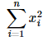

where the elements xi are stored in an RDD.

*#start the SparkContext*

**import** **findspark**

findspark.init()

**from** **pyspark** **import** SparkContext

sc = SparkContext(master="local[4]")

print(sc)

<SparkContext master=local[4] appName=pyspark-shell>

#### Create an RDD

In [2]:

B=sc.parallelize(range(4))

B.collect()

Out[2]:

[0, 1, 2, 3]

#### Sequential syntax for chaining

Perform assignment after each computation

In [3]:

Squares=B.map(**lambda** x:x*x)

Squares.reduce(**lambda** x,y:x+y)

Out[3]:

14

#### Cascaded syntax for chaining

Combine computations into a single cascaded command

In [4]:

B.map(**lambda** x:x*x)\

.reduce(**lambda** x,y:x+y)

Out[4]:

14

#### Both syntaxes mean exactly the same thing

The only difference:

* In the sequential syntax the intermediate RDD has a name Squares
* In the cascaded syntax the intermediate RDD is *anonymous*

The execution is identical!

#### Sequential execution

The standard way that the map and reduce are executed is

* perform the map
* store the resulting RDD in memory
* perform the reduce

#### Disadvantages of Sequential execution

1. Intermediate result (Squares) requires memory space.
2. Two scans of memory (of B, then of Squares) - double the cache-misses.

#### Pipelined execution

Perform the whole computation in a single pass. For each element of **B**

1. Compute the square
2. Enter the square as input to the reduce operation.

#### Advantages of Pipelined execution

1. Less memory required - intermediate result is not stored.
2. Faster - only one pass through the Input RDD.

#### Lazy Evaluation

This type of pipelined evaluation is related to **Lazy Evaluation**. The word **Lazy** is used because the first command (computing the square) is not executed immediately. Instead, the execution is delayed as long as possible so that several commands are executed in a single pass.

The delayed commands are organized in an **Execution plan**

For more on Pipelined execution, Lazy evaluation and Execution Plans see [spark programming guide/RDD operations](http://spark.apache.org/docs/latest/rdd-programming-guide.html#rdd-operations)

#### An instructive mistake

Here is another way to compute the sum of the squares using a single reduce command. Can you figure out how it comes up with this unexpected result?

In [5]:

C=sc.parallelize([1,1,2])

C.reduce(**lambda** x,y: x*x+y*y)

Out[5]:

8

**Answer:**

1. reduce first operates on the pair (1,1)(1,1), replacing it with 12+12=212+12=2
2. reduce then operates on the pair (2,2)(2,2), giving the final result 22+22=822+22=8

#### getting information about an RDD

RDD's typically have hundreds of thousands of elements. It usually makes no sense to print out the content of a whole RDD. Here are some ways to get manageable amounts of information about an RDD

Create an RDD of length **n** which is a repetition of the pattern 1,2,3,4

In [6]:

n=1000000

B=sc.parallelize([1,2,3,4]*int(n/4))

In [7]:

*#find the number of elements in the RDD*

B.count()

Out[7]:

1000000

In [8]:

*# get the first few elements of an RDD*

print('first element=',B.first())

print('first 5 elements = ',B.take(5))

first element= 1

first 5 elements = [1, 2, 3, 4, 1]

#### Sampling an RDD

* RDDs are often very large.
* Aggregates, such as averages, can be approximated efficiently by using a sample.
* Sampling is done in parallel and requires limited computation.

The method RDD.sample(withReplacement,p) generates a sample of the elements of the RDD. where

* withReplacement is a boolean flag indicating whether or not a an element in the RDD can be sampled more than once.
* p is the probability of accepting each element into the sample. Note that as the sampling is performed independently in each partition, the number of elements in the sample changes from sample to sample.

In [29]:

*# get a sample whose expected size is m*

*# Note that the size of the sample is different in different runs*

m=5.

print('sample1=',B.sample(**False**,m/n).collect())

print('sample2=',B.sample(**False**,m/n).collect())

sample1= [4, 4, 4]

sample2= [2, 2]

#### Things to note and think about

* Each time you run the previous cell, you get a different estimate
* The accuracy of the estimate is determined by the size of the sample n∗pn∗p
* See how the error changes as you vary pp
* Can you give a formula that relates the variance of the estimate to (p∗n)(p∗n) ? (The answer is in the Probability and statistics course).

#### filtering an RDD

The method RDD.filter(func) Return a new dataset formed by selecting those elements of the source on which func returns true.

In [10]:

print('the number of elements in B that are > 3 =',B.filter(**lambda** n: n > 3).count())

the number of elements in B that are > 3 = 250000

#### Removing duplicate elements from an RDD

The method RDD.distinct() Returns a new dataset that contains the distinct elements of the source dataset.

This operation requires a **shuffle** in order to detect duplication across partitions.

In [11]:

*# Remove duplicate element in DuplicateRDD, we get distinct RDD*

DuplicateRDD = sc.parallelize([1,1,2,2,3,3])

print('DuplicateRDD=',DuplicateRDD.collect())

print('DistinctRDD = ',DuplicateRDD.distinct().collect())

DuplicateRDD= [1, 1, 2, 2, 3, 3]

DistinctRDD = [1, 2, 3]

#### flatmap an RDD

The method RDD.flatMap(func) is similar to map, but each input item can be mapped to 0 or more output items (so func should return a Seq rather than a single item).

In [12]:

text=["you are my sunshine","my only sunshine"]

text_file = sc.parallelize(text)

*# map each line in text to a list of words*

print('map:',text_file.map(**lambda** line: line.split(" ")).collect())

*# create a single list of words by combining the words from all of the lines*

print('flatmap:',text_file.flatMap(**lambda** line: line.split(" ")).collect())

map: [['you', 'are', 'my', 'sunshine'], ['my', 'only', 'sunshine']]

flatmap: ['you', 'are', 'my', 'sunshine', 'my', 'only', 'sunshine']

#### Set operations

In this part, we explore set operations including **union**,**intersection**,**subtract**, **cartesian** in pyspark

In [13]:

rdd1 = sc.parallelize([1, 1, 2, 3])

rdd2 = sc.parallelize([1, 3, 4, 5])

##### union(other)

* Return the union of this RDD and another one.
* Note that that repetitions are allowed. The RDDs are **bags** not **sets**
* To make the result a set, use .distinct

In [14]:

rdd2=sc.parallelize(['a','b',1])

print('rdd1=',rdd1.collect())

print('rdd2=',rdd2.collect())

print('union as bags =',rdd1.union(rdd2).collect())

print('union as sets =',rdd1.union(rdd2).distinct().collect())

rdd1= [1, 1, 2, 3]

rdd2= ['a', 'b', 1]

union as bags = [1, 1, 2, 3, 'a', 'b', 1]

union as sets = [1, 'a', 2, 3, 'b']

##### intersection(other)

* Return the intersection of this RDD and another one. The output will not contain any duplicate elements, even if the input RDDs did.Note that this method performs a shuffle internally.

In [15]:

rdd2=sc.parallelize([1,1,2,5])

print('rdd1=',rdd1.collect())

print('rdd2=',rdd2.collect())

print('intersection=',rdd1.intersection(rdd2).collect())

rdd1= [1, 1, 2, 3]

rdd2= [1, 1, 2, 5]

intersection= [1, 2]

##### subtract(other, numPartitions=None)

* Return each value in self that is not contained in other.

In [16]:

print('rdd1=',rdd1.collect())

print('rdd2=',rdd2.collect())

print('rdd1.subtract(rdd2)=',rdd1.subtract(rdd2).collect())

rdd1= [1, 1, 2, 3]

rdd2= [1, 1, 2, 5]

rdd1.subtract(rdd2)= [3]

##### cartesian(other)

* Return the Cartesian product of this RDD and another one, that is, the RDD of all pairs of elements (a, b) where **a** is in **self** and **b** is in **other**.

In [17]:

rdd2=sc.parallelize([1,1,2])

rdd2=sc.parallelize(['a','b'])

print('rdd1=',rdd1.collect())

print('rdd2=',rdd2.collect())

print('rdd1.cartesian(rdd2)=**\n**',rdd1.cartesian(rdd2).collect())

rdd1= [1, 1, 2, 3]

rdd2= ['a', 'b']

rdd1.cartesian(rdd2)=

[(1, 'a'), (1, 'b'), (1, 'a'), (1, 'b'), (2, 'a'), (2, 'b'), (3, 'a'), (3, 'b')]

#### Summary

* Chaining: creating a pipeline of RDD operations.
* counting, taking and sampling an RDD
* More Transformations: filter, distinct, flatmap
* Set transformations: union, intersection, subtract, cartesian

### 2.4.6 Word Count

Counting the number of occurances of words in a text is a popular first exercise using map-reduce.

#### The Task

**Input:** A text file consisisting of words separated by spaces.  
**Output:** A list of words and their counts, sorted from the most to the least common.

We will use the book "Moby Dick" as our input.

In [1]:

*#start the SparkContext*

**from** **pyspark** **import** SparkContext

sc=SparkContext(master="local[4]")

*# set import path*

**import** **sys**

sys.path.append('../../Utils/')

*#from plan2table import plan2table*

In [34]:

**def** pretty_print_plan(rdd):

**for** x **in** rdd.toDebugString().decode().split('**\n**'):

print(x)

#### Download data file from S3

%%time

*##If this cell fails, download the file from https://mas-dse-open.s3.amazonaws.com/Moby-Dick.txt on your browser*

*# and put it in the '../../Data/ directory*

**import** **requests**

data_dir='../../Data'

filename='Moby-Dick.txt'

url = "https://mas-dse-open.s3.amazonaws.com/"+filename

local_path = data_dir+'/'+filename

!mkdir -p {data_dir}

*# Copy URL content to local_path*

r = requests.get(url, allow_redirects=**True**)

open(local_path, 'wb').write(r.content)

*# check that the text file is where we expect it to be*

!ls -l $local_path

#### Define an RDD that will read the file

* Execution of read is lazy
* File has been opened.
* Reading starts when stage is executed.

In [3]:

%%time

text_file = sc.textFile(data_dir+'/'+filename)

type(text_file)

CPU times: user 0 ns, sys: 0 ns, total: 0 ns

Wall time: 1.6 s

#### Steps for counting the words

* split line by spaces.
* map word to (word,1)
* count the number of occurances of each word.

In [4]:

%%time

words = text_file.flatMap(**lambda** line: line.split(" "))

not_empty = words.filter(**lambda** x: x!='')

key_values= not_empty.map(**lambda** word: (word, 1))

counts= key_values.reduceByKey(**lambda** a, b: a + b)

CPU times: user 20 ms, sys: 10 ms, total: 30 ms

Wall time: 318 ms

#### flatMap()

Note the line:

words = text_file.flatMap(**lambda** line: line.split(" "))

Why are we using flatMap, rather than map?

The reason is that the operation line.split(" ") generates a **list** of strings, so had we used map the result would be an RDD of lists of words. Not an RDD of words.

The difference between map and flatMap is that the second expects to get a list as the result from the map and it **concatenates** the lists to form the RDD.

##### The execution plan

In the last cell we defined the execution plan, but we have not started to execute it.

* Preparing the plan took ~100ms, which is a non-trivial amount of time,
* But much less than the time it will take to execute it.
* Lets have a look a the execution plan.

#### Understanding the details

To see which step in the plan corresponds to which RDD we print out the execution plan for each of the RDDs.

Note that the execution plan for words, not_empty and key_values are all the same.

In [35]:

pretty_print_plan(text_file)

(2) ../../Data/Moby-Dick.txt MapPartitionsRDD[1] at textFile at NativeMethodAccessorImpl.java:0 []

| ../../Data/Moby-Dick.txt HadoopRDD[0] at textFile at NativeMethodAccessorImpl.java:0 []

In [36]:

pretty_print_plan(words)

(2) PythonRDD[9] at RDD at PythonRDD.scala:48 []

| ../../Data/Moby-Dick.txt MapPartitionsRDD[1] at textFile at NativeMethodAccessorImpl.java:0 []

| ../../Data/Moby-Dick.txt HadoopRDD[0] at textFile at NativeMethodAccessorImpl.java:0 []

In [37]:

pretty_print_plan(not_empty)

(2) PythonRDD[8] at RDD at PythonRDD.scala:48 []

| ../../Data/Moby-Dick.txt MapPartitionsRDD[1] at textFile at NativeMethodAccessorImpl.java:0 []

| ../../Data/Moby-Dick.txt HadoopRDD[0] at textFile at NativeMethodAccessorImpl.java:0 []

In [38]:

pretty_print_plan(key_values)

(2) PythonRDD[7] at RDD at PythonRDD.scala:48 []

| ../../Data/Moby-Dick.txt MapPartitionsRDD[1] at textFile at NativeMethodAccessorImpl.java:0 []

| ../../Data/Moby-Dick.txt HadoopRDD[0] at textFile at NativeMethodAccessorImpl.java:0 []

In [39]:

pretty_print_plan(counts)

(2) PythonRDD[23] at RDD at PythonRDD.scala:48 []

| MapPartitionsRDD[22] at mapPartitions at PythonRDD.scala:122 []

| ShuffledRDD[21] at partitionBy at NativeMethodAccessorImpl.java:0 []

+-(2) PairwiseRDD[20] at reduceByKey at <timed exec>:1 []

| PythonRDD[19] at reduceByKey at <timed exec>:1 []

| ../../Data/Moby-Dick.txt MapPartitionsRDD[1] at textFile at NativeMethodAccessorImpl.java:0 []

| ../../Data/Moby-Dick.txt HadoopRDD[0] at textFile at NativeMethodAccessorImpl.java:0 []

|  |  |  |
| --- | --- | --- |
| Execution plan | RDD | Comments |
| (2)_PythonRDD[6] at RDD at PythonRDD.scala:48 [] | **counts** | Final RDD |
| _/__MapPartitionsRDD[5] at mapPartitions at PythonRDD.scala:436 [] | **---"---** |  |
| _/__ShuffledRDD[4] at partitionBy at NativeMethodAccessorImpl.java:0 [ | **---"---** | RDD is partitioned by key |
| _+-(2)_PairwiseRDD[3] at reduceByKey at <timed exec>:4 [] | **---"---** | Perform mapByKey |
| ____/__PythonRDD[2] at reduceByKey at <timed exec>:4 [] | **words, not_empty, key_values** | The result of partitioning into words |
|  |  | removing empties, and making into (word,1) pairs |
| ____/__../../Data/Moby-Dick.txt MapPartitionsRDD[1] at textFile at Nat | **text_file** | The partitioned text |
| ____/__../../Data/Moby-Dick.txt HadoopRDD[0] at textFile at NativeMeth | **---"---** | The text source |

#### Execution

Finally we count the number of times each word has occured. Now, the Lazy execution model finally performs some actual work, which takes a significant amount of time.

In [11]:

%%time

*## Run #1*

Count=counts.count() *# Count = the number of different words*

Sum=counts.map(**lambda** x:x[1]).reduce(**lambda** x,y:x+y) *#*

print('Different words=**%5.0f**, total words=**%6.0f**, mean no. occurances per word=**%4.2f**'%(Count,Sum,float(Sum)/Count))

Different words=33781, total words=215133, mean no. occurances per word=6.37

CPU times: user 10.5 ms, sys: 7.39 ms, total: 17.9 ms

Wall time: 1.04 s

#### Amortization

When the same commands are performed repeatedly on the same data, the execution time tends to decrease in later executions. The cells below are identical to the one above, with one exception at Run #3 Observe that Run #2 take much less time that Run #1. Even though no cache() was explicitly requested. The reason is that Spark caches (or materializes) key_values, before executing  reduceByKey()

because performng reduceByKey requires a shuffle, and a shuffle requires that the input RDD is materialized. In other words, sometime caching happens even if the programmer did not ask for it.

In [5]:

%%time

*## Run #2*

Count=counts.count()

Sum=counts.map(**lambda** x:x[1]).reduce(**lambda** x,y:x+y)

print('Different words=**%5.0f**, total words=**%6.0f**, mean no. occurances per word=**%4.2f**'%(Count,Sum,float(Sum)/Count))

Different words=33781, total words=215133, mean no. occurances per word=6.37

CPU times: user 20 ms, sys: 10 ms, total: 30 ms

Wall time: 3.9 s

#### Explicit Caching

In Run #3 we explicitly ask for counts to be cached. This will reduce the execution time in the following run by a little bit, but not by much.

In [6]:

%%time

*## Run #3, cache*

Count=counts.cache().count()

Sum=counts.map(**lambda** x:x[1]).reduce(**lambda** x,y:x+y)

print('Different words=**%5.0f**, total words=**%6.0f**, mean no. occurances per word=**%4.2f**'%(Count,Sum,float(Sum)/Count))

Different words=33781, total words=215133, mean no. occurances per word=6.37

CPU times: user 20 ms, sys: 0 ns, total: 20 ms

Wall time: 597 ms

In [7]:

%%time

*#Run #4*

Count=counts.count()

Sum=counts.map(**lambda** x:x[1]).reduce(**lambda** x,y:x+y)

print('Different words=**%5.0f**, total words=**%6.0f**, mean no. occurances per word=**%4.2f**'%(Count,Sum,float(Sum)/Count))

Different words=33781, total words=215133, mean no. occurances per word=6.37

CPU times: user 20 ms, sys: 10 ms, total: 30 ms

Wall time: 432 ms

In [8]:

%%time

*#Run #5*

Count=counts.count()

Sum=counts.map(**lambda** x:x[1]).reduce(**lambda** x,y:x+y)

print('Different words=**%5.0f**, total words=**%6.0f**, mean no. occurances per word=**%4.2f**'%(Count,Sum,float(Sum)/Count))

Different words=33781, total words=215133, mean no. occurances per word=6.37

CPU times: user 20 ms, sys: 0 ns, total: 20 ms

Wall time: 307 ms

#### Summary

This was our first real pyspark program, hurray!

###### Some things you learned:

1) An RDD is a distributed immutable array.  
It is the core data structure of Spark is an RDD.

2) You cannot operate on an RDD directly. Only through **Transformations** and **Actions**.

3) **Transformations** transform an RDD into another RDD.

4) **Actions** output their results on the head node.

5) After the action is done, you are using just the head node, not the workers.

###### Lazy Execution

1) RDD operations are added to an **Execution Plan**.

2) The plan is executed when a result is needed.

3) Explicit and implicit caching cause internediate results to be saved.

**Next:** Finding the most common words.

### 2.4.7 Finding Most Common Words

* counts: RDD with 33301 pairs of the form (word,count).
* Find the 5 most frequent words.
* **Method1:** collect and sort on head node.
* **Method2:** Pure Spark, collect only at the end.

#### Method1: collect and sort on head node

##### Collect the RDD into the driver node

* Collect can take significant time.

In [9]:

%%time

C=counts.collect()

CPU times: user 50 ms, sys: 0 ns, total: 50 ms

Wall time: 200 ms

##### Sort

* RDD collected into list in driver node.
* No longer using spark parallelism.
* Sort in python
* will not scale to very large documents.

In [10]:

%%time

C.sort(key=**lambda** x:x[1])

print('most common words**\n**'+'**\n**'.join(['**%s**:**\t%d**'%c **for** c **in** reversed(C[-5:])]))

most common words

the: 13766

of: 6587

and: 5951

a: 4533

to: 4510

CPU times: user 10 ms, sys: 0 ns, total: 10 ms

Wall time: 18.1 ms

##### Compute the mean number of occurances per word.

In [11]:

Count2=len(C)

Sum2=sum([i **for** w,i **in** C])

print('count2=**%f**, sum2=**%f**, mean2=**%f**'%(Count2,Sum2,float(Sum2)/Count2))

count2=33781.000000, sum2=215133.000000, mean2=6.368462

#### Method2: Pure Spark, collect only at the end.

* Collect into the head node only the more frquent words.
* Requires multiple **stages**

##### Step 1 split, clean and map to (word,1)

In [12]:

%%time

word_pairs=text_file.flatMap(**lambda** x: x.split(' '))\

.filter(**lambda** x: x!='')\

.map(**lambda** word: (word,1))

CPU times: user 0 ns, sys: 0 ns, total: 0 ns

Wall time: 66.3 µs

##### Step 2 Count occurances of each word.

In [13]:

%%time

counts=word_pairs.reduceByKey(**lambda** x,y:x+y)

CPU times: user 10 ms, sys: 0 ns, total: 10 ms

Wall time: 37.5 ms

##### Step 3 Reverse (word,count) to (count,word) and sort by key

In [14]:

%%time

*# reverse order of word and count*

reverse_counts=counts.map(**lambda** x:(x[1],x[0]))

sorted_counts=reverse_counts.sortByKey(ascending=**False**)

CPU times: user 30 ms, sys: 10 ms, total: 40 ms

Wall time: 1.49 s

##### Full execution plan

We now have a complete plan to compute the most common words in the text. Nothing has been executed yet! Not even a single byte has been read from the file Moby-Dick.txt !

For more on execution plans and lineage see [jace Klaskowski's blog](https://jaceklaskowski.gitbooks.io/mastering-apache-spark/content/spark-rdd-lineage.html#toDebugString)

In [40]:

print('word_pairs:')

pretty_print_plan(word_pairs)

print('**\n**counts:')

pretty_print_plan(counts)

print('**\n**reverse_counts:')

pretty_print_plan(reverse_counts)

print('**\n**sorted_counts:')

pretty_print_plan(sorted_counts)

word_pairs:

(2) PythonRDD[18] at RDD at PythonRDD.scala:48 []

| ../../Data/Moby-Dick.txt MapPartitionsRDD[1] at textFile at NativeMethodAccessorImpl.java:0 []

| ../../Data/Moby-Dick.txt HadoopRDD[0] at textFile at NativeMethodAccessorImpl.java:0 []

counts:

(2) PythonRDD[23] at RDD at PythonRDD.scala:48 []

| MapPartitionsRDD[22] at mapPartitions at PythonRDD.scala:122 []

| ShuffledRDD[21] at partitionBy at NativeMethodAccessorImpl.java:0 []

+-(2) PairwiseRDD[20] at reduceByKey at <timed exec>:1 []

| PythonRDD[19] at reduceByKey at <timed exec>:1 []

| ../../Data/Moby-Dick.txt MapPartitionsRDD[1] at textFile at NativeMethodAccessorImpl.java:0 []

| ../../Data/Moby-Dick.txt HadoopRDD[0] at textFile at NativeMethodAccessorImpl.java:0 []

reverse_counts:

(2) PythonRDD[30] at RDD at PythonRDD.scala:48 []

| MapPartitionsRDD[22] at mapPartitions at PythonRDD.scala:122 []

| ShuffledRDD[21] at partitionBy at NativeMethodAccessorImpl.java:0 []

+-(2) PairwiseRDD[20] at reduceByKey at <timed exec>:1 []

| PythonRDD[19] at reduceByKey at <timed exec>:1 []

| ../../Data/Moby-Dick.txt MapPartitionsRDD[1] at textFile at NativeMethodAccessorImpl.java:0 []

| ../../Data/Moby-Dick.txt HadoopRDD[0] at textFile at NativeMethodAccessorImpl.java:0 []

sorted_counts:

(2) PythonRDD[31] at RDD at PythonRDD.scala:48 []

| MapPartitionsRDD[29] at mapPartitions at PythonRDD.scala:122 []

| ShuffledRDD[28] at partitionBy at NativeMethodAccessorImpl.java:0 []

+-(2) PairwiseRDD[27] at sortByKey at <timed exec>:2 []

| PythonRDD[26] at sortByKey at <timed exec>:2 []

| MapPartitionsRDD[22] at mapPartitions at PythonRDD.scala:122 []

| ShuffledRDD[21] at partitionBy at NativeMethodAccessorImpl.java:0 []

+-(2) PairwiseRDD[20] at reduceByKey at <timed exec>:1 []

| PythonRDD[19] at reduceByKey at <timed exec>:1 []

| ../../Data/Moby-Dick.txt MapPartitionsRDD[1] at textFile at NativeMethodAccessorImpl.java:0 []

| ../../Data/Moby-Dick.txt HadoopRDD[0] at textFile at NativeMethodAccessorImpl.java:0 []

###### sorted_counts:

|  |  |
| --- | --- |
| Execution plan | RDD |
| (2)_PythonRDD[20] at RDD at PythonRDD.scala:48 [] | **sorted_counts** |
| _/__MapPartitionsRDD[19] at mapPartitions at PythonRDD.scala:436 [] | **---"---** |
| _/__ShuffledRDD[18] at partitionBy at NativeMethodAccessorImpl.java:0 | **---"---** |
| _+-(2)_PairwiseRDD[17] at sortByKey at <timed exec>:2 [] | **---"---** |
| ____/__PythonRDD[16] at sortByKey at <timed exec>:2 [] | **counts, reverse_counts** |
| ____/__MapPartitionsRDD[13] at mapPartitions at PythonRDD.scala:436 [] | **---"---** |
| ____/__ShuffledRDD[12] at partitionBy at NativeMethodAccessorImpl.java | **---"---** |
| ____+-(2)_PairwiseRDD[11] at reduceByKey at <timed exec>:1 [] | **---"---** |
| _______/__PythonRDD[10] at reduceByKey at <timed exec>:1 [] | **word_pairs** |
| _______/__../../Data/Moby-Dick.txt MapPartitionsRDD[1] at textFile at | **---"---** |
| _______/__../../Data/Moby-Dick.txt HadoopRDD[0] at textFile at NativeM | **---"---** |

##### Step 4 Take the top 5 words

In [15]:

%%time

D=sorted_counts.take(5)

print('most common words**\n**'+'**\n**'.join(['**%d**:**\t%s**'%c **for** c **in** D]))

most common words

13766: the

6587: of

5951: and

4533: a

4510: to

CPU times: user 10 ms, sys: 0 ns, total: 10 ms

Wall time: 398 ms

#### Summary

We showed two ways for finding the most common words:

1. Collecting and sorting at the head node. -- Does not scale.
2. Using RDDs to the end.

### 2.4.8 Operations on KeyVal RDDs

#### Types of spark operations

There are Three types of operations on RDDs: Transformations, Actions and Shuffles.

* The most expensive operations are those the require communication between nodes.

##### Transformations: RDD →→ RDD.

* **Examples** map, filter, sample, [More](http://spark.apache.org/docs/latest/rdd-programming-guide.html#transformations)
* **No** communication needed.

##### **Actions:** RDD →→ Python-object in head node.

* **Examples:** reduce, collect, count, take, [More](http://spark.apache.org/docs/latest/rdd-programming-guide.html#actions)
* **Some** communication needed.

##### **Shuffles:** RDD →→ RDD, **shuffle** needed

* **Examples:** sort, distinct, repartition, sortByKey, reduceByKey, join [More](http://spark.apache.org/docs/latest/rdd-programming-guide.html#shuffle-operations)
* **A LOT** of communication might be needed.

##### Key/value pairs

* A python dictionary is a collection of *key/value* pairs.
* The **key** is used to find a set of pairs with the particular key.
* The **value** can be anything.
* Spark has a set of special operations for *(key,value)* RDDs.

Spark provides specific functions to deal with RDDs in which each element is a key/value pair. Key/value RDDs expose new operations (e.g. aggregating and grouping together data with the same key and grouping together two different RDDs.) Such RDDs are also called pair RDDs. **In python, each element of a pair RDD is a pair tuple.**

In [1]:

*#start the SparkContext*

**import** **findspark**

findspark.init()

**from** **pyspark** **import** SparkContext

sc = SparkContext(master="local[4]")

#### Creating (key,value) RDDS

##### **Method 1:** parallelize a list of pairs.

In [2]:

pair_rdd = sc.parallelize([(1,2), (3,4)])

print(pair_rdd.collect())

[(1, 2), (3, 4)]

##### **Method 2:** map a function that maps elements to key/value pairs.

In [3]:

regular_rdd = sc.parallelize([1, 2, 3, 4, 2, 5, 6])

pair_rdd = regular_rdd.map( **lambda** x: (x, x*x) )

print(pair_rdd.collect())

[(1, 1), (2, 4), (3, 9), (4, 16), (2, 4), (5, 25), (6, 36)]

#### Transformations on (key,value) rdds

##### reduceByKey(func)

Apply the reduce function on the values with the same key.

In [4]:

rdd = sc.parallelize([(1,2), (2,4), (2,6)])

print("Original RDD :", rdd.collect())

print("After transformation : ", rdd.reduceByKey(**lambda** a,b: a+b).collect())

Original RDD : [(1, 2), (2, 4), (2, 6)]

After transformation : [(1, 2), (2, 10)]

Note that although it is similar to the reduce function, it is implemented as a transformation and not as an action because the dataset can have very large number of keys. So, it does not return values to the driver program. Instead, it returns a new RDD.

##### sortByKey():

Sort RDD by keys in ascending order.

In [5]:

rdd = sc.parallelize([(2,2), (1,4), (3,6)])

print("Original RDD :", rdd.collect())

print("After transformation : ", rdd.sortByKey().collect())

Original RDD : [(2, 2), (1, 4), (3, 6)]

After transformation : [(1, 4), (2, 2), (3, 6)]

**Note:** The output of sortByKey() is an RDD. This means that RDDs do have a meaningful order, which extends between partitions.

##### mapValues(func):

Apply func to each value of RDD without changing the key.

In [6]:

rdd = sc.parallelize([(1,2), (2,4), (2,6)])

print("Original RDD :", rdd.collect())

print("After transformation : ", rdd.mapValues(**lambda** x: x*2).collect())

Original RDD : [(1, 2), (2, 4), (2, 6)]

After transformation : [(1, 4), (2, 8), (2, 12)]

##### groupByKey():

Returns a new RDD of (key,<iterator>) pairs where the iterator iterates over the values associated with the key. [Iterators](http://anandology.com/python-practice-book/iterators.html) are python objects that generate a sequence of values. Writing a loop over n elements as

**for** i **in** range(n):

*##do something*

is inefficient because it first allocates a list of n elements and then iterates over it. Using the iterator xrange(n) achieves the same result without materializing the list. Instead, elements are generated on the fly. To materialize the list of values returned by an iterator we will use the list comprehension command:

[a **for** a **in** <iterator>]

In [7]:

rdd = sc.parallelize([(1,2), (2,4), (2,6)])

print("Original RDD :", rdd.collect())

print("After transformation : ", rdd.groupByKey().mapValues(**lambda** x:[a **for** a **in** x]).collect())

Original RDD : [(1, 2), (2, 4), (2, 6)]

After transformation : [(1, [2]), (2, [4, 6])]

##### flatMapValues(func):

Similar to flatMap(): creates a separate key/value pair for each element of the list generated by the map operation. func is a function that takes as input a single value and returns an iterator that generates a sequence of values. The application of flatMapValues operates on a key/value RDD. It applies func to each value, and gets an list (generated by the iterator) of values. It then combines each of the values with the original key to produce a list of key-value pairs. These lists are concatenated as in flatMap

In [8]:

rdd = sc.parallelize([(1,2), (2,4), (2,6)])

print("Original RDD :", rdd.collect())

*# lambda function generates for each i, iterator producing i,i+1*

print("After transformation : ", rdd.flatMapValues(**lambda** x: list(range(x,x+2))).collect())

Original RDD : [(1, 2), (2, 4), (2, 6)]

After transformation : [(1, 2), (1, 3), (2, 4), (2, 5), (2, 6), (2, 7)]

##### (Advanced) combineByKey(createCombiner, mergeValue, mergeCombiner):

Combine values with the same key using a different result type. This is the most general of the per-key aggregation functions. Most of the other per-key combiners are implemented using it. The elements of the original RDD are considered here *values.*

Values are converted into *combiners* which refer to "accumulators". Example: mapping of value *word* to accumulator (*word*,1) is done in WordCount.accumulators are then combined with values and other combiner to generate a result for each key. F.ex., we use it to calculate per-activity average durations as follows. Consider RDD of key/value pairs where keys correspond to different activities and values correspond to duration.

In [9]:

rdd = sc.parallelize([("Sleep", 7), ("Work",5), ("Play", 3),

("Sleep", 6), ("Work",4), ("Play", 4),

("Sleep", 8), ("Work",5), ("Play", 5)])

sum_counts = rdd.combineByKey(

*#* createCombiner *maps each value into combiner (accumulator)*

(**lambda** x: (x, 1)),

*#mergeValue defines how to* merge *a accumulator with a value (saves on mapping each value to an accumulator first)*

(**lambda** acc, value: (acc[0]+value, acc[1]+1)),

*# combine accumulators*

(**lambda** acc1, acc2: (acc1[0]+acc2[0], acc1[1]+acc2[1]))

)

print(sum_counts.collect())

duration_means_by_activity = sum_counts.mapValues(**lambda** value: value[0]*1.0/value[1]) \

.collect()

print(duration_means_by_activity)

[('Work', (14, 3)), ('Play', (12, 3)), ('Sleep', (21, 3))]

[('Work', 4.666666666666667), ('Play', 4.0), ('Sleep', 7.0)]

To understand combineByKey(), it’s useful to think of how it handles each element it processes. As combineByKey() traverses through the elements in a partition, each element either has a key it hasn’t seen before or has the same key as a previous element. If it’s a new key, createCombiner() is called to create the initial value for the accumulator on that key. In the above example, the accumulator is a tuple initialized as (x, 1) where x is a value in original RDD. Note that createCombiner() is called only when a key is seen for the first time in **each partition.** If it is a key we have seen before while processing that partition, it will instead use the provided function, mergeValue(), with the current value for the accumulator for that key and the new value. Since each partition is processed independently, we can have multiple accumulators for the same key. When we are merging the results from each partition, if two or more partitions have an accumulator for the same key, we merge the accumulators using the user-supplied mergeCombiners() function. In the above example, we are just adding the 2 accumulators element-wise.

#### Transformations on two (key-value) RDDs

In [10]:

rdd1 = sc.parallelize([(1,2),(2,1),(2,2)])

rdd2 = sc.parallelize([(2,5),(3,1)])

print('rdd1=',rdd1.collect())

print('rdd2=',rdd2.collect())

rdd1= [(1, 2), (2, 1), (2, 2)]

rdd2= [(2, 5), (3, 1)]

##### 1. subtractByKey:

Remove from RDD1 all elements whose key is present in RDD2.

In [11]:

print('rdd1=',rdd1.collect())

print('rdd2=',rdd2.collect())

print("Result:", rdd1.subtractByKey(rdd2).collect())

rdd1= [(1, 2), (2, 1), (2, 2)]

rdd2= [(2, 5), (3, 1)]

Result: [(1, 2)]

##### 2. join:

* A fundamental operation in relational databases.
* assumes two tables have a **key** column in common.
* merges rows with the same key.

Suppose we have two (key,value) datasets

|  |  |  |  |  |
| --- | --- | --- | --- | --- |
| dataset 1 |  | .......... | dataset 2 |  |
| key=name | **(gender,occupation,age)** |  | **key=name** | **hair color** |
| John | (male,cook,21) |  | Jill | blond |
| Jill | (female,programmer,19) |  | Grace | brown |
| John | (male, kid, 2) |  | John | black |
| Kate | (female, wrestler, 54) |  |  |  |

When Join is called on datasets of type (Key, V) and (Key, W), it returns a dataset of (Key, (V, W)) pairs with all pairs of elements for each key. Joining the 2 datasets above yields:

|  |  |
| --- | --- |
| key = name | (gender,occupation,age),haircolor |
| John | ((male,cook,21),black) |
| John | ((male, kid, 2),black) |
| Jill | ((female,programmer,19),blond) |

In [12]:

print('rdd1=',rdd1.collect())

print('rdd2=',rdd2.collect())

print("Result:", rdd1.join(rdd2).collect())

rdd1= [(1, 2), (2, 1), (2, 2)]

rdd2= [(2, 5), (3, 1)]

Result: [(2, (1, 5)), (2, (2, 5))]

###### Variants of join.

There are four variants of join which differ in how they treat keys that appear in one dataset but not the other.

* join is an *inner* join which means that keys that appear only in one dataset are eliminated.
* leftOuterJoin keeps all keys from the left dataset even if they don't appear in the right dataset. The result of leftOuterJoin in our example will contain the keys John, Jill, Kate
* rightOuterJoin keeps all keys from the right dataset even if they don't appear in the left dataset. The result of leftOuterJoin in our example will contain the keys Jill, Grace, John
* FullOuterJoin keeps all keys from both datasets. The result of leftOuterJoin in our example will contain the keys Jill, Grace, John, Kate

In outer joins, if the element appears only in one dataset, the element in (K,(V,W)) that does not appear in the dataset is represented bye None

##### 3. rightOuterJoin:

Perform a right join between two RDDs. Every key in the right/second RDD will be present at least once.

In [13]:

print('rdd1=',rdd1.collect())

print('rdd2=',rdd2.collect())

print("Result:", rdd1.rightOuterJoin(rdd2).collect())

rdd1= [(1, 2), (2, 1), (2, 2)]

rdd2= [(2, 5), (3, 1)]

Result: [(2, (1, 5)), (2, (2, 5)), (3, (None, 1))]

##### 4. leftOuterJoin: Perform a left join between two RDDs. Every key in the left RDD will be present at least once.

In [14]:

print('rdd1=',rdd1.collect())

print('rdd2=',rdd2.collect())

print("Result:", rdd1.leftOuterJoin(rdd2).collect())

rdd1= [(1, 2), (2, 1), (2, 2)]

rdd2= [(2, 5), (3, 1)]

Result: [(1, (2, None)), (2, (1, 5)), (2, (2, 5))]

#### Actions on (key,val) RDDs

In [15]:

rdd = sc.parallelize([(1,2), (2,4), (2,6)])

##### 1. countByKey():

Count number of elements for each key. Returns a dictionary for easy access to keys.

In [16]:

print("RDD: ", rdd.collect())

result = rdd.countByKey()

print("Result:", result)

RDD: [(1, 2), (2, 4), (2, 6)]

Result: defaultdict(<class 'int'>, {1: 1, 2: 2})

##### 2. collectAsMap():

Collect the result as a dictionary to provide easy lookup.

In [17]:

print("RDD: ", rdd.collect())

result = rdd.collectAsMap()

print("Result:", result)

RDD: [(1, 2), (2, 4), (2, 6)]

Result: {1: 2, 2: 6}

##### 3. lookup(key):

Return all values associated with the provided key.

In [18]:

print("RDD: ", rdd.collect())

result = rdd.lookup(2 )

print("Result:", result)

RDD: [(1, 2), (2, 4), (2, 6)]

Result: [4, 6]

#### Summary

* We saw some more of the operations on Pair RDDs
* For more, see the spark [RDD programming guide](http://spark.apache.org/docs/latest/rdd-programming-guide.html)

### 2.4.9 Parsing Large Files

#### How to transform large text files into Parquet files

This file needs to be run on AWS, and we need to make sure that the dbutils code works. The weather data, as text, is about 7GB, after some organization, stored in 94 files, each of size about 85MB. Initially, I used the following code to read in the data. Even though I used a reasonably large cluster, with about 100GB of memory, 5 worker nodes and 20 cores. It took about 106 minutes (one hour and 46 minutes) to complete this job! Why? For this first exercise, we will use the reduced dataset (10 percent) provided for the KDD Cup 1999, containing nearly half million **nework interactions**. First, download and read the gzip file:

In [3]:

*#start the SparkContext*

*#import findspark*

*#findspark.init()*

**from** **pyspark** **import** SparkContext

sc = SparkContext(master="local[3]")

In [4]:

**import** **urllib.request**, **urllib.parse**, **urllib.error**

f = urllib.request.urlretrieve ("http://kdd.ics.uci.edu/databases/kddcup99/kddcup.data_10_percent.gz", "kddcup.data_10_percent.gz")

data_file = "./kddcup.data_10_percent.gz"

raw_data = sc.textFile(data_file)

print(raw_data.count())

print(raw_data.take(1))

494021

['0,tcp,http,SF,181,5450,0,0,0,0,0,1,0,0,0,0,0,0,0,0,0,0,8,8,0.00,0.00,0.00,0.00,1.00,0.00,0.00,9,9,1.00,0.00,0.11,0.00,0.00,0.00,0.00,0.00,normal.']

**from** **pyspark.sql** **import** Row

**import** **numpy** **as** **np**

*# 1. Split each line using comma,*

*# 2. remove first line (which is the names of each column)*

*# 3. sort the data based on the "year" attribute*

path = '/mnt/NCDC-weather/WeatherUncompressed/'

file_list=dbutils.fs.ls(path)

dataRows=range(len(file_list))

dataFrames=range(len(file_list))

**for** i **in** range(len(file_list)):

filename=file_list[i].path

data = sc.textFile(filename)

dataRows[i] = data.map(**lambda** s: s.split(',')) \

.filter(**lambda** d: d[0] != 'station') \

.filter(**lambda** d:len(d)==368)\

.map(**lambda** d: tuple(d[0:2]) + tuple([convert(x) **for** x **in** d[2:]])) \

.sortBy(**lambda** d: d[2])

dataFrames[i] = sqlContext.createDataFrame(dataRows[i], index)

**if** i==0:

combinedDataFrame=dataFrames[i]

**else**:

combinedDataFrame=combinedDataFrame.unionAll(dataFrames[i])

**print** filename

**print** combinedDataFrame.count()

The reason that this code is so slow is that the for loop which iterates over the files, while quite sensible for a single computer, is a very bad idea when using a cluster with 20 cores. It forces the cluster to read one file at a time, which means that at each point of time only one file is being read. A simpler code, shown below, finished the same task in 8 minutes!

**from** **pyspark.sql** **import** Row

**import** **numpy** **as** **np**

*# 1. Split each line using comma,*

*# 2. remove first line (which is the names of each column)*

*# 3. sort the data based on the "year" attribute*

dataRows=range(len(file_list))

dataFrames=range(len(file_list))

path = '/mnt/NCDC-weather/WeatherUncompressed/'

data = sc.textFile(path)

dataRows = data.map(**lambda** s: s.split(',')) \

.filter(**lambda** d: d[0] != 'station') \

.filter(**lambda** d:len(d)==368)\

.map(**lambda** d: tuple(d[0:2]) + tuple([convert(x) **for** x **in** d[2:]])) \

.sortBy(**lambda** d: d[2])

dataFrame = sqlContext.createDataFrame(dataRows, index)

The resulting Parquet files are 4GB (almost half the original 7GB).

dataFrame.write.parquet("/mnt/NCDC-weather/Weather.parquet")

*# the smaller file that we use in class was generated as follows:*

sampled_df=dataFrame.sample(False,0.001)

sampled_df.write.parquet("/mnt/NCDC-weather/Weather_sampled.parquet")

In [5]:

sc.stop()

## 2.5 Spark SQL and DataFrames

### 2.5.1 Dataframes

#### Dataframes

* Dataframes are a restricted sub-type of RDDs.
* Restircing the type allows for more optimization.
* Dataframes store 2 dimensional data, similar to type of data stored in a spreadsheet.
* Each column in a dataframe can have a different type.
* Each row contains a record.
* Similar to, but not the same as, [pandas dataframes](http://pandas.pydata.org/pandas-docs/stable/dsintro.html#dataframe) and [R dataframes](http://www.r-tutor.com/r-introduction/data-frame)

In [1]:

**from** **pyspark** **import** SparkContext

sc = SparkContext(master="local[4]")

sc.version

Out[1]:

'2.3.0'

In [2]:

**import** **os**

**import** **sys**

**from** **pyspark** **import** SparkContext

**from** **pyspark.sql** **import** SQLContext

**from** **pyspark.sql.types** **import** Row, StructField, StructType, StringType, IntegerType

%**pylab** inline

Populating the interactive namespace from numpy and matplotlib

In [3]:

*# Just like using Spark requires having a SparkContext, using SQL requires an SQLContext*

sqlContext = SQLContext(sc)

sqlContext

Out[3]:

<pyspark.sql.context.SQLContext at 0x7f6a30c77e10>

#### Constructing a DataFrame from an RDD of Rows

Each Row defines it's own fields, the schema is *inferred*.

In [4]:

*# One way to create a DataFrame is to first define an RDD from a list of Rows*

some_rdd = sc.parallelize([Row(name=u"John", age=19),

Row(name=u"Smith", age=23),

Row(name=u"Sarah", age=18)])

some_rdd.collect()

Out[4]:

[Row(age=19, name='John'),

Row(age=23, name='Smith'),

Row(age=18, name='Sarah')]

In [5]:

*# The DataFrame is created from the RDD or Rows*

*# Infer schema from the first row, create a DataFrame and print the schema*

some_df = sqlContext.createDataFrame(some_rdd)

some_df.printSchema()

root

|-- age: long (nullable = true)

|-- name: string (nullable = true)

In [6]:

*# A dataframe is an RDD of rows plus information on the schema.*

*# performing **collect()* on either the RDD or the DataFrame gives the same result.*

print(type(some_rdd),type(some_df))

print('some_df =',some_df.collect())

print('some_rdd=',some_rdd.collect())

<class 'pyspark.rdd.RDD'> <class 'pyspark.sql.dataframe.DataFrame'>

some_df = [Row(age=19, name='John'), Row(age=23, name='Smith'), Row(age=18, name='Sarah')]

some_rdd= [Row(age=19, name='John'), Row(age=23, name='Smith'), Row(age=18, name='Sarah')]

#### Defining the Schema explicitly

The advantage of creating a DataFrame using a pre-defined schema allows the content of the RDD to be simple tuples, rather than rows.

In [7]:

*# In this case we create the dataframe from an RDD of tuples (rather than Rows) and provide the schema explicitly*

another_rdd = sc.parallelize([("John", 19), ("Smith", 23), ("Sarah", 18)])

*# Schema with two fields - person_name and person_age*

schema = StructType([StructField("person_name", StringType(), **False**), StructField("person_age", IntegerType(), **False**)])

*# Create DataFrame by applying schema to RDD and print the schema*

another_df = sqlContext.createDataFrame(another_rdd, schema)

another_df.printSchema()

*# root*

*# |-- age: binteger (nullable = true)*

*# |-- name: string (nullable = true)*

root

|-- person_name: string (nullable = false)

|-- person_age: integer (nullable = false)

#### Loading DataFrames from disk

Many maethods to load DataFrames from Disk. Three of these methods

1. Parquet
2. JSON (on your own)
3. CSV (on your own)

In addition, there are API's for connecting Spark to an external database. We will not discuss this type of connection in this class.

##### Loading dataframes from JSON files

[JSON](http://www.json.org/) is a very popular readable file format for storing structured data. Among it's many uses are **twitter**, javascriptcommunication packets, and many others. In fact this notebook file (with the extension .ipynb is in json format. JSON can also be used to store tabular data and can be easily loaded into a dataframe.

In [9]:

!wget 'https://mas-dse-open.s3.amazonaws.com/Moby-Dick.txt' -P ../../Data/

--2018-04-09 00:48:07-- https://mas-dse-open.s3.amazonaws.com/Moby-Dick.txt

Resolving mas-dse-open.s3.amazonaws.com (mas-dse-open.s3.amazonaws.com)... 54.231.176.210

Connecting to mas-dse-open.s3.amazonaws.com (mas-dse-open.s3.amazonaws.com)|54.231.176.210|:443... connected.

HTTP request sent, awaiting response... 200 OK

Length: 1257260 (1.2M) [text/plain]

Saving to: ‘../../Data/Moby-Dick.txt.1’

Moby-Dick.txt.1 100%[===================>] 1.20M 1.15MB/s in 1.0s

2018-04-09 00:48:08 (1.15 MB/s) - ‘../../Data/Moby-Dick.txt.1’ saved [1257260/1257260]

In [10]:

*# when loading json files you can specify either a single file or a directory containing many json files.*

path = "../../Data/people.json"

!cat $path

*# Create a DataFrame from the file(s) pointed to by path*

people = sqlContext.read.json(path)

print('people is a',type(people))

*# The inferred schema can be visualized using the printSchema() method.*

people.show()

people.printSchema()

{"name":"Michael"}

{"name":"Andy", "age":30}

{"name":"Justin", "age":19}

people is a <class 'pyspark.sql.dataframe.DataFrame'>

+----+-------+

| age| name|

+----+-------+

|null|Michael|

| 30| Andy|

| 19| Justin|

+----+-------+

root

|-- age: long (nullable = true)

|-- name: string (nullable = true)

##### Excercise: Loading csv files into dataframes

Spark 2.0 includes a facility for reading csv files. In this excercise you are to create similar functionality using your own code. You are to write a class called

csv_reader which has the following methods:

* __init__(self,filepath): recieves as input the path to a csv file. It throws an exeption NoSuchFile if the file does not exist.
* Infer_Schema() opens file, reads first 10 lines (or less if file is shorter), and infers the schema. The first line of the csv file defines the column names. The following lines should have the same number of columns and all of the elements of the column should be of the same type. The only types allowed are int, float, string.
* The method infers the types of the columns, checks that they are consistent, and defines a dataframe schema of the form:

schema = StructType([StructField("person_name", StringType(), False), StructField("person_age", IntegerType(), False)])

If everything checks out, the method defines a self. variable that stores schema and returns schema as it's output. If error found, exception BadCsvFormat is raised.

* read_DataFrame(): reads the file, parses it and creates a dataframe using the inferred schema. If one of the lines beyond the first 10 (i.e. a line that was not read by InferSchema) is not parsed correctly, the line is not added to the Dataframe. Instead, it is added to an RDD called bad_lines. The methods returns the dateFrame and the bad_linesRDD.

##### Parquet files

* [Parquet](http://parquet.apache.org/) is a popular columnar format.
* Spark SQL allows [SQL](https://en.wikipedia.org/wiki/SQL) queries to retrieve a subset of the rows without reading the whole file.
* Compatible with HDFS : allows parallel retrieval on a cluster.
* Parquet compresses the data in each column.

###### Spark and Hive

* Parquet is a **file format** not an independent database server.
* Spark can work with the [Hive](https://cwiki.apache.org/confluence/display/Hive/Hive+on+Spark%3A+Getting+Started) relational database system that supports the full array of database operations.
* Hive is compatible with HDFS.

In [11]:

dir='../../Data'

parquet_file=dir+"/users.parquet"

!ls $dir

Moby-Dick.txt namesAndFavColors.parquet users.parquet US_stations.tsv.gz

Moby-Dick.txt.1 people.json US_stations.tsv Weather

In [12]:

*#load a Parquet file*

print(parquet_file)

df = sqlContext.read.load(parquet_file)

df.show()

../../Data/users.parquet

+------+--------------+----------------+

| name|favorite_color|favorite_numbers|

+------+--------------+----------------+

|Alyssa| null| [3, 9, 15, 20]|

| Ben| red| []|

+------+--------------+----------------+

In [13]:

df2=df.select("name", "favorite_color")

df2.show()

+------+--------------+

| name|favorite_color|

+------+--------------+

|Alyssa| null|

| Ben| red|

+------+--------------+

In [14]:

outfilename="namesAndFavColors.parquet"

!rm -rf $dir/$outfilename

df2.write.save(dir+"/"+outfilename)

!ls -ld $dir/$outfilename

drwxrwxrwx 1 jovyan staff 4096 Apr 9 2018 ../../Data/namesAndFavColors.parquet

A new interface object has been added in **Spark 2.0** called **SparkSession**. A spark session is initialized using a builder. For example

spark = SparkSession.builder \

.master("local") \

.appName("Word Count") \

.config("spark.some.config.option", "some-value") \

.getOrCreate()

Using a SparkSession a Parquet file is read [as follows:](http://spark.apache.org/docs/2.1.0/api/python/pyspark.sql.html#pyspark.sql.DataFrameReader.parquet):

df = spark.read.parquet(

'python/test_support/sql/parquet_partitioned')

#### Lets have a look at a real-world dataframe

This dataframe is from a large dataframe (15GB) which stores meteorological data from stations around the world. We will read the dataframe from a zipped parquet file.

In [22]:

**from** **os.path** **import** split,join,exists

**from** **os** **import** mkdir,getcwd,remove

**from** **glob** **import** glob

*# create directory if needed*

notebook_dir=getcwd()

data_dir=join(split(split(notebook_dir)[0])[0],'Data')

weather_dir=join(data_dir,'Weather')

**if** exists(weather_dir):

print('directory',weather_dir,'already exists')

**else**:

print('making',weather_dir)

mkdir(weather_dir)

file_index='NY'

zip_file='**%s**.tgz'%(file_index) *#the .csv extension is a mistake, this is a pickle file, not a csv file.*

old_files='**%s**/**%s**\*'%(weather_dir,zip_file[:-3])

**for** f **in** glob(old_files):

print('removing',f)

!rm -rf {f}

directory /home/jovyan/work/Sections/Data/Weather already exists

removing /home/jovyan/work/Sections/Data/Weather/NY.parquet

removing /home/jovyan/work/Sections/Data/Weather/NY.tgz

In [23]:

command="wget https://mas-dse-open.s3.amazonaws.com/Weather/by_state/**%s** -P **%s** "%(zip_file, weather_dir)

print(command)

!$command

!ls -lh $weather_dir/$zip_file

wget https://mas-dse-open.s3.amazonaws.com/Weather/by_state/NY.tgz -P /home/jovyan/work/Sections/Data/Weather

--2018-04-09 00:52:22-- https://mas-dse-open.s3.amazonaws.com/Weather/by_state/NY.tgz

Resolving mas-dse-open.s3.amazonaws.com (mas-dse-open.s3.amazonaws.com)... 52.218.144.50

Connecting to mas-dse-open.s3.amazonaws.com (mas-dse-open.s3.amazonaws.com)|52.218.144.50|:443... connected.

HTTP request sent, awaiting response... 200 OK

Length: 23182008 (22M) [application/x-tar]

Saving to: ‘/home/jovyan/work/Sections/Data/Weather/NY.tgz’

NY.tgz 100%[===================>] 22.11M 1.47MB/s in 15s

2018-04-09 00:52:37 (1.51 MB/s) - ‘/home/jovyan/work/Sections/Data/Weather/NY.tgz’ saved [23182008/23182008]

-rwxrwxrwx 1 jovyan staff 23M Mar 16 20:25 /home/jovyan/work/Sections/Data/Weather/NY.tgz

In [24]:

*#extracting the parquet file*

!tar zxvf {weather_dir}/{zip_file} -C {weather_dir}

NY.parquet/

NY.parquet/_SUCCESS

NY.parquet/part-00000-8342bcf4-7fc2-4183-8e11-aefdb4915fbb-c000.snappy.parquet

NY.parquet/part-00001-8342bcf4-7fc2-4183-8e11-aefdb4915fbb-c000.snappy.parquet

NY.parquet/part-00002-8342bcf4-7fc2-4183-8e11-aefdb4915fbb-c000.snappy.parquet

NY.parquet/part-00003-8342bcf4-7fc2-4183-8e11-aefdb4915fbb-c000.snappy.parquet

NY.parquet/part-00004-8342bcf4-7fc2-4183-8e11-aefdb4915fbb-c000.snappy.parquet

NY.parquet/part-00005-8342bcf4-7fc2-4183-8e11-aefdb4915fbb-c000.snappy.parquet

NY.parquet/part-00006-8342bcf4-7fc2-4183-8e11-aefdb4915fbb-c000.snappy.parquet

NY.parquet/part-00007-8342bcf4-7fc2-4183-8e11-aefdb4915fbb-c000.snappy.parquet

NY.parquet/part-00008-8342bcf4-7fc2-4183-8e11-aefdb4915fbb-c000.snappy.parquet

NY.parquet/part-00009-8342bcf4-7fc2-4183-8e11-aefdb4915fbb-c000.snappy.parquet

NY.parquet/part-00010-8342bcf4-7fc2-4183-8e11-aefdb4915fbb-c000.snappy.parquet

NY.parquet/part-00011-8342bcf4-7fc2-4183-8e11-aefdb4915fbb-c000.snappy.parquet

NY.parquet/part-00012-8342bcf4-7fc2-4183-8e11-aefdb4915fbb-c000.snappy.parquet

NY.parquet/part-00013-8342bcf4-7fc2-4183-8e11-aefdb4915fbb-c000.snappy.parquet

In [28]:

weather_parquet = join(weather_dir, zip_file[:-3]+'parquet')

print(weather_parquet)

df = sqlContext.read.load(weather_parquet)

df.show(1)

/home/jovyan/work/Sections/Data/Weather/NY.parquet

+-----------+-----------+----+--------------------+-----+

| Station|Measurement|Year| Values|State|

+-----------+-----------+----+--------------------+-----+

|USC00303452| PRCP|1903|[00 7E 00 7E 00 7...| NY|

+-----------+-----------+----+--------------------+-----+

only showing top 1 row

In [26]:

*#selecting a subset of the rows so it fits in slide.*

df.select('station','year','measurement').show(5)

+-----------+----+-----------+

| station|year|measurement|

+-----------+----+-----------+

|USC00303452|1903| PRCP|

|USC00303452|1904| PRCP|

|USC00303452|1905| PRCP|

|USC00303452|1906| PRCP|

|USC00303452|1907| PRCP|

+-----------+----+-----------+

only showing top 5 rows

#### Summary

* Dataframes are an efficient way to store data tables.
* All of the values in a column have the same type.
* A good way to store a dataframe in disk is to use a Parquet file.

### 2.5.2 Dataframe Operations

*#Initialize and load weather dataframe*

**from** **pyspark** **import** SparkContext

sc = SparkContext(master="local[4]")

*#sc.version*

**import** **os**

**import** **sys**

**from** **pyspark** **import** SparkContext

**from** **pyspark.sql** **import** SQLContext

**from** **pyspark.sql.types** **import** Row, StructField, StructType, StringType, IntegerType

%**pylab** inline

*# Just like using Spark requires having a SparkContext, using SQL requires an SQLContext*

sqlContext = SQLContext(sc)

**from** **os.path** **import** split,join,exists

**from** **os** **import** mkdir,getcwd,remove

**from** **glob** **import** glob

*# create directory if needed*

notebook_dir=getcwd()

data_dir=join(split(split(notebook_dir)[0])[0],'Data')

weather_dir=join(data_dir,'Weather')

**if** exists(weather_dir):

print('directory',weather_dir,'already exists')

**else**:

print('making',weather_dir)

mkdir(weather_dir)

file_index='NY'

zip_file='**%s**.tgz'%(file_index) *#the .csv extension is a mistake, this is a pickle file, not a csv file.*

old_files='**%s**/**%s**\*'%(weather_dir,zip_file[:-3])

**for** f **in** glob(old_files):

print('removing',f)

!rm -rf {f}

command="wget https://mas-dse-open.s3.amazonaws.com/Weather/by_state/**%s** -P **%s** "%(zip_file, weather_dir)

print(command)

!$command

!ls -lh $weather_dir/$zip_file

*#extracting the parquet file*

!tar zxvf {weather_dir}/{zip_file} -C {weather_dir}

weather_parquet = join(weather_dir,zip_file[:-3]+'parquet')

print(weather_parquet)

df = sqlContext.read.load(weather_parquet)

df.show(1)

Populating the interactive namespace from numpy and matplotlib

directory /home/jovyan/work/Sections/Data/Weather already exists

removing /home/jovyan/work/Sections/Data/Weather/NY.parquet

removing /home/jovyan/work/Sections/Data/Weather/NY.tgz

wget https://mas-dse-open.s3.amazonaws.com/Weather/by_state/NY.tgz -P /home/jovyan/work/Sections/Data/Weather

--2018-04-09 01:16:40-- https://mas-dse-open.s3.amazonaws.com/Weather/by_state/NY.tgz

Resolving mas-dse-open.s3.amazonaws.com (mas-dse-open.s3.amazonaws.com)... 52.218.196.178

Connecting to mas-dse-open.s3.amazonaws.com (mas-dse-open.s3.amazonaws.com)|52.218.196.178|:443... connected.

HTTP request sent, awaiting response... 200 OK

Length: 23182008 (22M) [application/x-tar]

Saving to: ‘/home/jovyan/work/Sections/Data/Weather/NY.tgz’

NY.tgz 100%[===================>] 22.11M 279KB/s in 65s

2018-04-09 01:17:46 (347 KB/s) - ‘/home/jovyan/work/Sections/Data/Weather/NY.tgz’ saved [23182008/23182008]

-rwxrwxrwx 1 jovyan staff 23M Mar 16 20:25 /home/jovyan/work/Sections/Data/Weather/NY.tgz

NY.parquet/

NY.parquet/_SUCCESS

NY.parquet/part-00000-8342bcf4-7fc2-4183-8e11-aefdb4915fbb-c000.snappy.parquet

NY.parquet/part-00001-8342bcf4-7fc2-4183-8e11-aefdb4915fbb-c000.snappy.parquet

NY.parquet/part-00002-8342bcf4-7fc2-4183-8e11-aefdb4915fbb-c000.snappy.parquet

NY.parquet/part-00003-8342bcf4-7fc2-4183-8e11-aefdb4915fbb-c000.snappy.parquet

NY.parquet/part-00004-8342bcf4-7fc2-4183-8e11-aefdb4915fbb-c000.snappy.parquet

NY.parquet/part-00005-8342bcf4-7fc2-4183-8e11-aefdb4915fbb-c000.snappy.parquet

NY.parquet/part-00006-8342bcf4-7fc2-4183-8e11-aefdb4915fbb-c000.snappy.parquet

NY.parquet/part-00007-8342bcf4-7fc2-4183-8e11-aefdb4915fbb-c000.snappy.parquet

NY.parquet/part-00008-8342bcf4-7fc2-4183-8e11-aefdb4915fbb-c000.snappy.parquet

NY.parquet/part-00009-8342bcf4-7fc2-4183-8e11-aefdb4915fbb-c000.snappy.parquet

NY.parquet/part-00010-8342bcf4-7fc2-4183-8e11-aefdb4915fbb-c000.snappy.parquet

NY.parquet/part-00011-8342bcf4-7fc2-4183-8e11-aefdb4915fbb-c000.snappy.parquet

NY.parquet/part-00012-8342bcf4-7fc2-4183-8e11-aefdb4915fbb-c000.snappy.parquet

NY.parquet/part-00013-8342bcf4-7fc2-4183-8e11-aefdb4915fbb-c000.snappy.parquet

/home/jovyan/work/Sections/Data/Weather/NY.parquet

+-----------+-----------+----+--------------------+-----+

| Station|Measurement|Year| Values|State|

+-----------+-----------+----+--------------------+-----+

|USC00303452| PRCP|1903|[00 7E 00 7E 00 7...| NY|

+-----------+-----------+----+--------------------+-----+

only showing top 1 row

#### Dataframe operations

Spark DataFrames allow operations similar to pandas Dataframes. We demonstrate some of those. For more, see the [official guide](https://spark.apache.org/docs/latest/sql-programming-guide.html) and [this article](https://www.analyticsvidhya.com/blog/2016/10/spark-dataframe-and-operations/)

In [2]:

df.printSchema()

root

|-- Station: string (nullable = true)

|-- Measurement: string (nullable = true)

|-- Year: integer (nullable = true)

|-- Values: binary (nullable = true)

|-- State: string (nullable = true)

In [3]:

print(df.count())

df.show(1)

84199

+-----------+-----------+----+--------------------+-----+

| Station|Measurement|Year| Values|State|

+-----------+-----------+----+--------------------+-----+

|USC00303452| PRCP|1903|[00 7E 00 7E 00 7...| NY|

+-----------+-----------+----+--------------------+-----+

only showing top 1 row

##### .describe()

The method df.describe() computes five statistics for each column of the dataframe df. The statistics are: **count, mean, std, min,max**

You get the following man page using the command df.describe?

Signature: df.describe(*cols)

Docstring:

Computes statistics for numeric and string columns.

This include count, mean, stddev, min, and max. If no columns are given, this function computes statistics for all numerical or string columns.

.. note:: This function is meant for exploratory data analysis, as we make no guarantee about the backward compatibility of the schema of the resulting DataFrame.

>>> df.describe(['age']).show()

+-------+------------------+

|summary| age|

+-------+------------------+

| count| 2|

| mean| 3.5|

| stddev|2.1213203435596424|

| min| 2|

| max| 5|

+-------+------------------+

>>> df.describe().show()

+-------+------------------+-----+

|summary| age| name|

+-------+------------------+-----+

| count| 2| 2|

| mean| 3.5| null|

| stddev|2.1213203435596424| null|

| min| 2|Alice|

| max| 5| Bob|

+-------+------------------+-----+

.. versionadded:: 1.3.1

File: ~/spark-2.2.1-bin-hadoop2.7/python/pyspark/sql/dataframe.py

Type: method

In [4]:

df.describe().select('station','measurement').show()

+-----------+-----------+

| station|measurement|

+-----------+-----------+

| 84199| 84199|

| null| null|

| null| null|

|USC00300015| PRCP|

|USW00094794| TOBS|

+-----------+-----------+

##### groupby and agg

The method .groupby(col) groups rows according the value of the column col.  
The method .agg(spec) computes a summary for each group as specified in spec

In [5]:

df.groupby('measurement').agg({'year': 'min', 'station':'count'}).show()

+-----------+---------+--------------+

|measurement|min(year)|count(station)|

+-----------+---------+--------------+

| TMIN| 1873| 13442|

| TOBS| 1876| 10956|

| TMAX| 1873| 13437|

| SNOW| 1884| 15629|

| SNWD| 1888| 14617|

| PRCP| 1871| 16118|

+-----------+---------+--------------+

In [6]:

*# THis command will load the python module that defines the SQL functions*

*#%load ls ~/spark-latest/python/pyspark/sql/functions.py*

#### Using SQL queries on DataFrames

There are two main ways to manipulate DataFrames:

##### Imperative manipulation

Using python methods such as .select and .groupby.

* Advantage: order of operations is specified.
* Disrdavantage : need to describe both what is the result you want and how to get it.

##### Declarative Manipulation (SQL)

* Advantage: You need to describe only **what** is the result you want.
* Disadvantage: SQL does not have primitives for common analysis operations such as **covariance**

##### Using sql commands on a dataframe

Spark supports a [subset](https://spark.apache.org/docs/latest/sql-programming-guide.html#supported-hive-features) of the Hive SQL query language. For example, You can use [Hive select syntax](https://cwiki.apache.org/confluence/display/Hive/LanguageManual+Select) to select a subset of the rows in a dataframe. To use sql on a dataframe you need to first register it as a TempTable. for variety, we are using here a small dataframe loaded from a JSON file.

In [7]:

*# when loading json files you can specify either a single file or a directory containing many json files.*

path = "../../Data/people.json"

*# Create a DataFrame from the file(s) pointed to by path*

people = sqlContext.read.json(path)

*#print('people is a',type(people))*

*# Inferred schema can be visualized using printSchema() method.*

people.show()

+----+-------+

| age| name|

+----+-------+

|null|Michael|

| 30| Andy|

| 19| Justin|

+----+-------+

In [8]:

people.printSchema()

root

|-- age: long (nullable = true)

|-- name: string (nullable = true)

In [9]:

*# Register this DataFrame as a table.*

people.registerTempTable("people")

*# SQL statements run by using sql methods provided by sqlContext*

teenagers = sqlContext.sql("SELECT name FROM people WHERE age >= 13 AND age <= 19")

**for** each **in** teenagers.collect():

print(each[0])

Justin

###### Counting the number of occurances of each measurement, imparatively

In [10]:

L=df.groupBy('measurement').count().collect()

*#L is a list (collected DataFrame)*

In [11]:

D=[(e.measurement,e['count']) **for** e **in** L]

sorted(D,key=**lambda** x:x[1], reverse=**False**)[:6]

Out[11]:

[('TOBS', 10956),

('TMAX', 13437),

('TMIN', 13442),

('SNWD', 14617),

('SNOW', 15629),

('PRCP', 16118)]

###### Counting the number of occurances of each measurement, declaratively.

In [12]:

sqlContext.registerDataFrameAsTable(df,'weather') *#using older sqlContext instead of newer (V2.0) sparkSession*

In [13]:

query="""

SELECT measurement,COUNT(measurement) AS count,

MIN(year) AS MinYear

FROM weather

GROUP BY measurement

ORDER BY count

"""

print(query)

sqlContext.sql(query).show()

SELECT measurement,COUNT(measurement) AS count,

MIN(year) AS MinYear

FROM weather

GROUP BY measurement

ORDER BY count

+-----------+-----+-------+

|measurement|count|MinYear|

+-----------+-----+-------+

| TOBS|10956| 1876|

| TMAX|13437| 1873|

| TMIN|13442| 1873|

| SNWD|14617| 1888|

| SNOW|15629| 1884|

| PRCP|16118| 1871|

+-----------+-----+-------+

##### Performing a map command

* In order to perform a map on a dataframe, you first need to transform it into an RDD.
* **Not** the recommended way. Better way is to use built-in sparkSQL functions.
* Or register new ones (Advanced).

In [14]:

**def** find_century(row):

**if** row.Year < 1900:

**return** '19th'

**elif** row.Year <2000:

**return** '20th'

**elif** row.Year <2010:

**return** '21st'

**else**:

**return** 'possibly_bad_data'

In [15]:

df.rdd.map(find_century).take(5)

Out[15]:

['20th', '20th', '20th', '20th', '20th']

##### Aggregations

* **Aggregation** can be used, in combination with built-in sparkSQL functions to compute statistics of a dataframe.
* computation will be fast thanks to combined optimzations with database operations.
* A partial list : count(), approx_count_distinct(), avg(), max(), min()
* Of these, the interesting one is approx_count_distinct() which uses sampling to get an approximate count fast.
* [The gory details](http://spark.apache.org/docs/2.2.0/api/python/_modules/pyspark/sql/functions.html)

In [16]:

**import** **pyspark.sql.functions** **as** **F** *# used here just for show.*

In [17]:

df.agg({'station':'approx_count_distinct'}).show()

+------------------------------+

|approx_count_distinct(station)|

+------------------------------+

| 339|

+------------------------------+

##### Approximate Quantile

* Suppose we want to partition the years into 10 ranges
* such that in each range we have approximately the same number of records.
* The method .approxQuantile will use a sample to do this for us.

In [18]:

print('with accuracy 0.1: ',df.approxQuantile('year', [0.1*i **for** i **in** range(1,10)], 0.1))

print('with accuracy 0.01: ',df.approxQuantile('year', [0.1*i **for** i **in** range(1,10)], 0.01))

with accuracy 0.1: [1871.0, 1945.0, 1949.0, 1965.0, 1972.0, 1978.0, 1984.0, 1988.0, 2013.0]

with accuracy 0.01: [1917.0, 1936.0, 1949.0, 1957.0, 1966.0, 1975.0, 1984.0, 1993.0, 2003.0]

###### Lets collect the exact number of rows for each year

This will take much longer than ApproxQuantile on a large file

In [19]:

*# Lets collect the exact number of rows for each year ()*

query='SELECT year,COUNT(year) AS count FROM weather GROUP BY year ORDER BY year'

print(query)

counts=sqlContext.sql(query)

print('counts is ',counts)

SELECT year,COUNT(year) AS count FROM weather GROUP BY year ORDER BY year

counts is DataFrame[year: int, count: bigint]

In [20]:

**import** **pandas** **as** **pd**

A=counts.toPandas() *# Transform a spark Dataframe to a Pandas Dataframe*

A.plot.line('year','count')

grid()

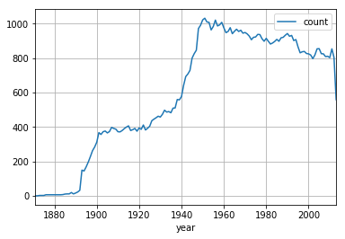

##### Reading rows selectively

Suppose we are only interested in snow measurements. We can apply an SQL query directly to the parquet files. As the data is organized in columnar structure, we can do the selection efficiently without loading the whole file to memory. Here the file is small, but in real applications it can consist of hundreds of millions of records. In such cases loading the data first to memory and then filtering it is very wasteful.

In [21]:

data_dir='../../Data'

query="""SELECT station,measurement,year

FROM parquet.`**%s**.parquet`

WHERE measurement=**\"**SNOW**\"** """%(weather_dir+'/'+zip_file[:-4])

print(query)

df2 = sqlContext.sql(query)

print(df2.count(),df2.columns)

df2.show(5)

SELECT station,measurement,year

FROM parquet.`/home/jovyan/work/Sections/Data/Weather/NY.parquet`

WHERE measurement="SNOW"

15629 ['station', 'measurement', 'year']

+-----------+-----------+----+

| station|measurement|year|

+-----------+-----------+----+

|USC00303452| SNOW|1903|

|USC00303452| SNOW|1904|

|USC00303452| SNOW|1905|

|USC00303452| SNOW|1906|

|USC00303452| SNOW|1907|

+-----------+-----------+----+

only showing top 5 rows

#### Summary

* Dataframes can be manipulated decleratively, which allows for more optimization.
* Dataframes can be stored and retrieved from Parquet files.
* It is possible to refer directly to a parquet file in an SQL query.
* See you next time!

##### References

* For an introduction to Spark SQL and Dataframes see: [Spark SQL, DataFrames](https://spark.apache.org/docs/latest/sql-programming-guide.html#spark-sql-dataframes-and-datasets-guide)
* Also [spark-dataframe-and-operations](https://www.analyticsvidhya.com/blog/2016/10/spark-dataframe-and-operations/) from [analyticsvidhya.com](https://www.analyticsvidhya.com)

For complete API reference see

* [SQL programming guide](https://spark.apache.org/docs/latest/sql-programming-guide.html) For Java, Scala and Python (Implementation is first in Scala and Python, later pyspark)
* [pyspark API for the DataFrame class](http://spark.apache.org/docs/latest/api/python/pyspark.sql.html#pyspark.sql.DataFrame)
* [pyspark API for the pyspark.sql module](http://spark.apache.org/docs/latest/api/python/pyspark.sql.html#pyspark-sql-module)

### 2.5.3 Loading and Using Parquet

#### Moving Data Around

* When you need to process a lot of data, a big part of the execution time of your program is devoted to moving the data between storage units.
* This notebook is **NOT** intended to be run on your personal computer. It is intended to show you the main steps needed when processing a large file on a multi-computer cluster. The main emphasis here is on the **Wall time** required for different operations.

#### Some terminology

##### Data Serialization.

* Data in memory is usually stored in **data structures** that allow for fast manipulation. This often means that the amount of memory needed is significantly larger than the amount that would be needed to store the same data on disk.
* We say that the data on disk is **serial** and the data stored in data structures is **deserialized**

##### AWS-EMR

We demonstrate the movement of data on "Amazon Web Services" (AWS) "Elastic Map Reduce" (EMR). Recall the slide about data organization in the video "a short history of affordable massive computing" In the next figure we add to that slide the way it fits within AWS-EMR. **Three file systems:**

1. **S3:** long term persistent memory.
2. **Head Node:** standard Unix file system.
3. **HDFS:** distributed file system on the workers.

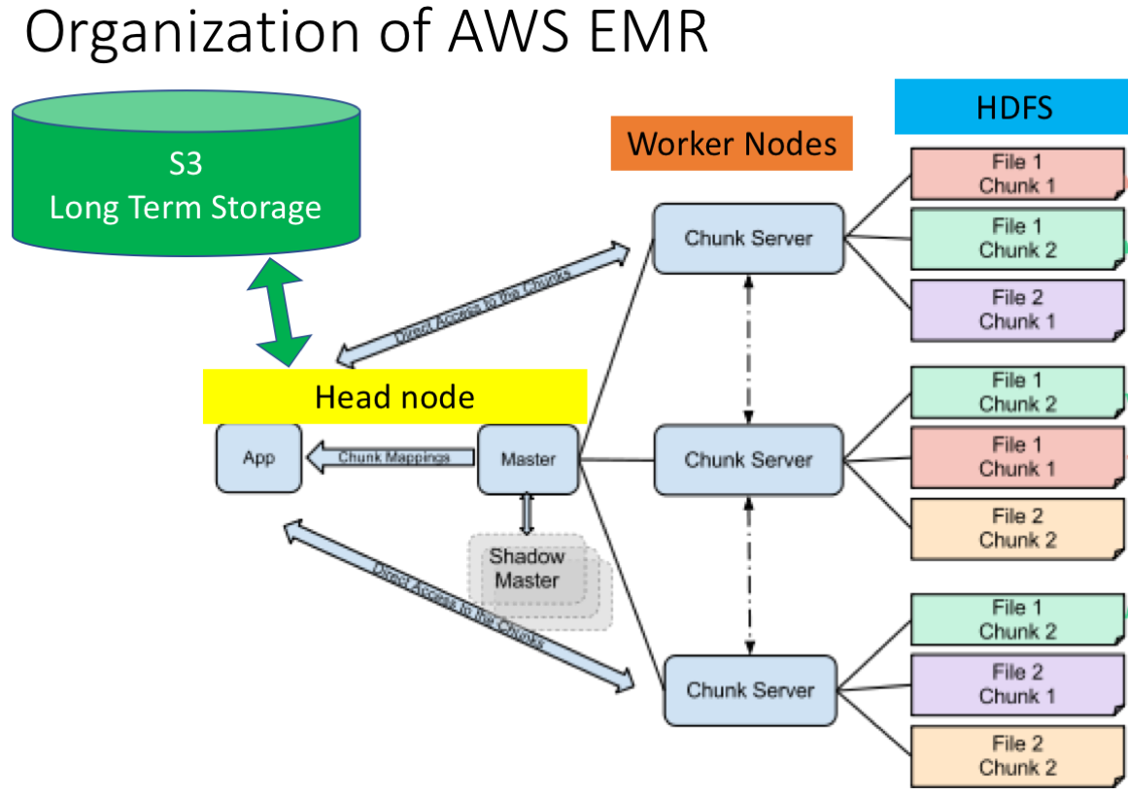

#### Reading a CSV file from S3

We start with a CSV file on S3, which we move through the head node to HDFS and than parse into a spark RDD.

##### Moving a file from S3 to the head node

In [1]:

<div class="mark">

%**cd** /mnt/workspace/edX-Micro-Master-in-Data-Science/big-data-analytics-using-spark/notebooks/Data/

!ls</div><i class="fa fa-lightbulb-o "></i>

/mnt/workspace/edX-Micro-Master-in-Data-Science/big-data-analytics-using-spark/notebooks/Data

kmeans_data.txt OldData people.json Weather

In [2]:

*#create directory to hold data one node*

!mkdir Weather

%**cd** Weather/

mkdir: cannot create directory ‘Weather’: File exists

/mnt/workspace/edX-Micro-Master-in-Data-Science/big-data-analytics-using-spark/notebooks/Data/Weather

In [4]:

*#list files on S3*

!aws s3 ls s3://dse-weather/ALL.csv.gz

*#compressed file is about 1.5GB*

2016-02-09 04:09:49 1511481989 ALL.csv.gz

In [5]:

%%time

*#copy file from S3*

!aws s3 cp s3://dse-weather/ALL.csv.gz ./ALL.csv.gz

download: s3://dse-weather/ALL.csv.gz to ./ALL.csv.gz

CPU times: user 956 ms, sys: 280 ms, total: 1.24 s

Wall time: 11.9 s

In [6]:

%%time

*#unompress file*

!rm ALL.csv

!gunzip ALL.csv.gz

CPU times: user 720 ms, sys: 260 ms, total: 980 ms

Wall time: 54.5 s

In [7]:

!ls -l ALL.csv

*# About 7.7 GB*

-rw-rw-r-- 1 hadoop hadoop 7668890105 Feb 9 2016 ALL.csv

In [8]:

!head -2 ALL.csv

station,year,measurement,1,2,3,4,5,6,7,8,9,10,11,12,13,14,15,16,17,18,19,20,21,22,23,24,25,26,27,28,29,30,31,32,33,34,35,36,37,38,39,40,41,42,43,44,45,46,47,48,49,50,51,52,53,54,55,56,57,58,59,60,61,62,63,64,65,66,67,68,69,70,71,72,73,74,75,76,77,78,79,80,81,82,83,84,85,86,87,88,89,90,91,92,93,94,95,96,97,98,99,100,101,102,103,104,105,106,107,108,109,110,111,112,113,114,115,116,117,118,119,120,121,122,123,124,125,126,127,128,129,130,131,132,133,134,135,136,137,138,139,140,141,142,143,144,145,146,147,148,149,150,151,152,153,154,155,156,157,158,159,160,161,162,163,164,165,166,167,168,169,170,171,172,173,174,175,176,177,178,179,180,181,182,183,184,185,186,187,188,189,190,191,192,193,194,195,196,197,198,199,200,201,202,203,204,205,206,207,208,209,210,211,212,213,214,215,216,217,218,219,220,221,222,223,224,225,226,227,228,229,230,231,232,233,234,235,236,237,238,239,240,241,242,243,244,245,246,247,248,249,250,251,252,253,254,255,256,257,258,259,260,261,262,263,264,265,266,267,268,269,270,271,272,273,274,275,276,277,278,279,280,281,282,283,284,285,286,287,288,289,290,291,292,293,294,295,296,297,298,299,300,301,302,303,304,305,306,307,308,309,310,311,312,313,314,315,316,317,318,319,320,321,322,323,324,325,326,327,328,329,330,331,332,333,334,335,336,337,338,339,340,341,342,343,344,345,346,347,348,349,350,351,352,353,354,355,356,357,358,359,360,361,362,363,364,365

ASN00054128,DAPR,1969,,,,,,,,,,,,,,,,,,,,,,,,,,,,,,,,,,,,,,,,,,,,,,,,,,,,,,,,,,,,,,,,,,,,,,,,,,,,,,,,,,,,,,,,,,,,,,,,,,,,,,,,,,,,,,,,,,,,,,,,,,,,,,,,,,,,,,,,,,,,,,,,,,,,,,,,,,,,,,,,,,,,,,,,,,,,,,,,,,,,,,,,,,,,,,,,,,,,,,,,,,,,,,,,,,,,,,,,,,,,,,,,,,,,,,,,,,,,,,,,,,,,,,,2,,,,,,,,,,,,,,,,,,,,,,,,,,,,,,,,,,,,,,,,,,,,,,,,,,,,,,,,,,,,,,,,,,,,,,,,,,,,,,,,,,,,,,,,,,,,,,,,,,,,,,,,,,,,,,,,,,,,,,

##### Distribute file into HDFS

copy file from the head-node file system to HDFS

In [2]:

%%time

!hadoop fs -mkdir /weather

/bin/sh: hadoop: command not found

CPU times: user 2.72 ms, sys: 7.76 ms, total: 10.5 ms

Wall time: 125 ms

In [12]:

%%time

*#create a data directory on hdfs*

!hadoop fs -copyFromLocal ALL.csv hdfs:///weather/weather.csv

copyFromLocal: `/weather/weather.csv': File exists

CPU times: user 36 ms, sys: 12 ms, total: 48 ms

Wall time: 2.11 s

In [1]:

!hadoop fs -ls /weather

/bin/sh: hadoop: command not found

##### Read csv file into an RDD

In [ ]:

%**cd** /mnt/workspace/edX-Micro-Master-in-Data-Science/big-data-analytics-using-spark/notebooks/Section2-PCA/PCA/data_preparation/

!ls lib

In [15]:

%**pwd**

!ls -l lib/numpy_pack.py

-rw-rw-r-- 1 hadoop hadoop 1085 Mar 1 20:32 lib/numpy_pack.py

In [16]:

%%time

%pwd

**from** **pyspark** **import** SparkContext

sc = SparkContext(pyFiles=['/mnt/workspace/edX-Micro-Master-in-Data-Science/big-data-analytics-using-spark/notebooks/Section2-PCA/PCA/data_preparation/lib/numpy_pack.py'])

CPU times: user 172 ms, sys: 16 ms, total: 188 ms

Wall time: 16.6 s

In [17]:

%%time

RDD=sc.textFile('/weather/weather.csv')

CPU times: user 0 ns, sys: 4 ms, total: 4 ms

Wall time: 367 ms

In [18]:

fs_file="/mnt/workspace/edX-Micro-Master-in-Data-Science/big-data-analytics-using-spark/notebooks/Data/Weather/ALL.csv"

!ls -l $fs_file

-rw-rw-r-- 1 hadoop hadoop 7668890105 Feb 9 2016 /mnt/workspace/edX-Micro-Master-in-Data-Science/big-data-analytics-using-spark/notebooks/Data/Weather/ALL.csv

In [19]:

%%time

**with** open(fs_file,'r') **as** f:

text=f.readlines()

print(len(text))

9358395

CPU times: user 2.21 s, sys: 5.12 s, total: 7.33 s

Wall time: 7.32 s

##### Code for packing and unpacking byte arrays

In [20]:

**import** **numpy** **as** **np**

*"""Code for packing and unpacking a numpy array into a byte array.*

*the array is flattened if it is not 1D.*

*This is intended to be used as the interface for storing*

*This code is intended to be used to store numpy array as fields in a dataframe and then store the*

*dataframes in a parquet file.*

*"""*

Out[20]:

'Code for packing and unpacking a numpy array into a byte array.\n the array is flattened if it is not 1D.\n This is intended to be used as the interface for storing \n \n This code is intended to be used to store numpy array as fields in a dataframe and then store the \n dataframes in a parquet file.\n'

In [21]:

**def** packArray(a):

*"""*

*pack a numpy array into a bytearray that can be stored as a single*

*field in a spark DataFrame*

*:param a: a numpy ndarray*

*:returns: a bytearray*

*:rtype:*

*"""*

**if** type(a)!=np.ndarray:

**raise** **Exception**("input to packArray should be numpy.ndarray. It is instead "+str(type(a)))

**return** bytearray(a.tobytes())

In [22]:

**def** unpackArray(x,data_type=np.float16):

*"""*

*unpack a bytearray into a numpy.ndarray*

*:param x: a bytearray*

*:param data_type: The dtype of the array. This is important because if determines how many bytes go into each entry in the array.*

*:returns: a numpy array*

*:rtype: a numpy ndarray of dtype data_type.*

*"""*

**return** np.frombuffer(x,dtype=data_type)

##### range values

Using code that was removed we find that the range of values is

-1000.0, 97892.0

which means that as ints we will need 32 but, but with float we can use just 16.

In [23]:

*#main parsing code*

**import** **numpy** **as** **np**

**def** parse_weather(line):

L=line.split(',')

**try**:

**assert** len(L)==368

i=2

L[i]=int(L[i])

**for** i **in** range(3,368):

**if** L[i]!='':

L[i]=np.float16(L[i])

**else**:

L[i]=np.nan

**except**:

*#if error in parsing, return (1, input line)*

**return** (1,line)

Out=L[:3]

Out.append(packArray(np.array(L[3:],dtype=np.float16)))

*# if parsing OK, return (0, parsed data)*

**return** (0,Out)

In [24]:

*#this cell demonstrates how to test the parse_weather function on an individual row.*

Debug=**False**

**if** Debug:

lines=RDD.take(10)

GG=parse_weather(lines[-2])

GG

In [25]:

%%time

Parsed=RDD.map(parse_weather).cache() *# filter out bad rows which are mapped (1,line)*

DATA=Parsed.filter(**lambda** x:x[0]==0).map(**lambda** x:x[1])

ERRORS=Parsed.filter(**lambda** x:x[0]==1).map(**lambda** x:x[1])

CPU times: user 8 ms, sys: 0 ns, total: 8 ms

Wall time: 26.3 ms

In [26]:

print(DATA.toDebugString().decode())

(58) PythonRDD[3] at RDD at PythonRDD.scala:48 []

| PythonRDD[2] at RDD at PythonRDD.scala:48 []

| /weather/weather.csv MapPartitionsRDD[1] at textFile at NativeMethodAccessorImpl.java:0 []

| /weather/weather.csv HadoopRDD[0] at textFile at NativeMethodAccessorImpl.java:0 []

In [27]:

%%time

PRCP=DATA.filter(**lambda** row:row[1]=='PRCP')

print('PRCP records:',PRCP.count())

('PRCP records:', 2521007)

CPU times: user 16 ms, sys: 12 ms, total: 28 ms

Wall time: 2min 2s

In [28]:

%%time

print('bad records:',ERRORS.count())

*#all lines: 9358395*

*# only the first line (the header) is bad.*

*# Good lines: 9358394*

('bad records:', 1)

CPU times: user 4 ms, sys: 8 ms, total: 12 ms

Wall time: 2.3 s

In [29]:

DATA.take(1)

Out[29]:

[[u'ASN00054128',

u'DAPR',

1969,

bytearray(b'\x00~\x00~\x00~\x00~\x00~\x00~\x00~\x00~\x00~\x00~\x00~\x00~\x00~\x00~\x00~\x00~\x00~\x00~\x00~\x00~\x00~\x00~\x00~\x00~\x00~\x00~\x00~\x00~\x00~\x00~\x00~\x00~\x00~\x00~\x00~\x00~\x00~\x00~\x00~\x00~\x00~\x00~\x00~\x00~\x00~\x00~\x00~\x00~\x00~\x00~\x00~\x00~\x00~\x00~\x00~\x00~\x00~\x00~\x00~\x00~\x00~\x00~\x00~\x00~\x00~\x00~\x00~\x00~\x00~\x00~\x00~\x00~\x00~\x00~\x00~\x00~\x00~\x00~\x00~\x00~\x00~\x00~\x00~\x00~\x00~\x00~\x00~\x00~\x00~\x00~\x00~\x00~\x00~\x00~\x00~\x00~\x00~\x00~\x00~\x00~\x00~\x00~\x00~\x00~\x00~\x00~\x00~\x00~\x00~\x00~\x00~\x00~\x00~\x00~\x00~\x00~\x00~\x00~\x00~\x00~\x00~\x00~\x00~\x00~\x00~\x00~\x00~\x00~\x00~\x00~\x00~\x00~\x00~\x00~\x00~\x00~\x00~\x00~\x00~\x00~\x00~\x00~\x00~\x00~\x00~\x00~\x00~\x00~\x00~\x00~\x00~\x00~\x00~\x00~\x00~\x00~\x00~\x00~\x00~\x00~\x00~\x00~\x00~\x00~\x00~\x00~\x00~\x00~\x00~\x00~\x00~\x00~\x00~\x00~\x00~\x00~\x00~\x00~\x00~\x00~\x00~\x00~\x00~\x00~\x00~\x00~\x00~\x00~\x00~\x00~\x00~\x00~\x00~\x00~\x00~\x00~\x00~\x00~\x00~\x00~\x00~\x00~\x00~\x00~\x00~\x00~\x00~\x00~\x00~\x00~\x00~\x00~\x00~\x00~\x00~\x00~\x00~\x00~\x00~\x00~\x00~\x00~\x00~\x00~\x00~\x00~\x00~\x00~\x00~\x00~\x00~\x00~\x00~\x00~\x00~\x00~\x00~\x00~\x00~\x00~\x00~\x00~\x00~\x00~\x00~\x00~\x00@\x00~\x00~\x00~\x00~\x00~\x00~\x00~\x00~\x00~\x00~\x00~\x00~\x00~\x00~\x00~\x00~\x00~\x00~\x00~\x00~\x00~\x00~\x00~\x00~\x00~\x00~\x00~\x00~\x00~\x00~\x00~\x00~\x00~\x00~\x00~\x00~\x00~\x00~\x00~\x00~\x00~\x00~\x00~\x00~\x00~\x00~\x00~\x00~\x00~\x00~\x00~\x00~\x00~\x00~\x00~\x00~\x00~\x00~\x00~\x00~\x00~\x00~\x00~\x00~\x00~\x00~\x00~\x00~\x00~\x00~\x00~\x00~\x00~\x00~\x00~\x00~\x00~\x00~\x00~\x00~\x00~\x00~\x00~\x00~\x00~\x00~\x00~\x00~\x00~\x00~\x00~\x00~\x00~\x00~\x00~\x00~\x00~\x00~\x00~\x00~\x00~\x00~\x00~\x00~\x00~\x00~\x00~\x00~\x00~\x00~\x00~\x00~\x00~\x00~\x00~\x00~\x00~\x00~')]]

#### Transform RDD into a Spark DataFrame

In [30]:

**import** **os**

**import** **sys**

**from** **pyspark** **import** SparkContext

**from** **pyspark.sql** **import** SQLContext

**from** **pyspark.sql.types** **import** Row, StructField, StructType, StringType, IntegerType, BinaryType, FloatType

*# Just like using Spark requires having a SparkContext, using SQL requires an SQLContext*

sqlContext = SQLContext(sc)

sqlContext

Out[30]:

<pyspark.sql.context.SQLContext at 0x7fd7e1266650>

In [31]:

*### Defining the Schema explicitly*

*# The advantage of creating a DataFrame using a pre-defined schema allows the content of the RDD to be simple tuples, rather than rows.*

*# In this case we create the dataframe from an RDD of tuples (rather than Rows) and provide the schema explicitly*

*# Schema with two fields - person_name and person_age*

schema = StructType([StructField("Station", StringType(), **True**),

StructField("Measurement", StringType(), **True**),

StructField("Year", IntegerType(),**True**),

StructField("Values", BinaryType(),**True**)

])

schema

Out[31]:

StructType(List(StructField(Station,StringType,true),StructField(Measurement,StringType,true),StructField(Year,IntegerType,true),StructField(Values,BinaryType,true)))

In [32]:

%%time

*# Create DataFrame by applying schema to RDD and print the schema*

ALL_DataFrame = sqlContext.createDataFrame(DATA, schema)

ALL_DataFrame.printSchema()

root

|-- Station: string (nullable = true)

|-- Measurement: string (nullable = true)

|-- Year: integer (nullable = true)

|-- Values: binary (nullable = true)

CPU times: user 460 ms, sys: 0 ns, total: 460 ms

Wall time: 1.29 s

##### Write out data frame into Parquet directory

In [33]:

%%time

!hadoop fs -rm -r /weather/weather.parquet

18/03/01 21:55:39 INFO fs.TrashPolicyDefault: Namenode trash configuration: Deletion interval = 0 minutes, Emptier interval = 0 minutes.

Deleted /weather/weather.parquet

CPU times: user 52 ms, sys: 76 ms, total: 128 ms

Wall time: 2.2 s

In [34]:

%%time

outfilename="hdfs:///weather/weather.parquet"

ALL_DataFrame.write.save(outfilename)

CPU times: user 4 ms, sys: 4 ms, total: 8 ms

Wall time: 17.1 s

In [35]:

!hadoop fs -du /weather/

7668890105 /weather/weather.csv

2302800781 /weather/weather.parquet

##### Copy parquet directory to head node and then to S3

In [36]:

%**cd** /mnt/workspace/Data/

!rm -rf weather.parquet/

!ls -lrt

/mnt/workspace/Data

total 0

drwxrwxr-x 2 hadoop hadoop 199 Mar 1 20:07 stations.parquet

In [37]:

%%time

!hadoop fs -copyToLocal /weather/weather.parquet weather.parquet

CPU times: user 84 ms, sys: 140 ms, total: 224 ms

Wall time: 6.46 s

In [38]:

!du .

1612 ./stations.parquet

2248960 ./weather.parquet

2250572 .

In [39]:

%%time

*#rm parquet directory from s3*

!aws s3 rm --recursive --quiet s3://dse-weather/weather.parquet

CPU times: user 16 ms, sys: 80 ms, total: 96 ms

Wall time: 1.14 s

In [40]:

%%time

*# Copy parquet directory from headnode to s3*

!aws s3 cp --recursive --quiet ./weather.parquet s3://dse-weather/weather.parquet

CPU times: user 344 ms, sys: 208 ms, total: 552 ms

Wall time: 18.1 s

##### Loading and using a parquet file

In [41]:

!ls

stations.parquet weather.parquet

In [42]:

!rm -rf weather.parquet/

In [43]:

%%time

!aws s3 cp --recursive --quiet s3://dse-weather/weather.parquet ./weather.parquet

CPU times: user 328 ms, sys: 224 ms, total: 552 ms

Wall time: 17.1 s

In [44]:

%%time

!hadoop fs -copyFromLocal weather.parquet /weather/weather.parquet

CPU times: user 176 ms, sys: 144 ms, total: 320 ms

Wall time: 9.53 s

In [45]:

%%time

parquet_name='/weather/weather'

query="""SELECT station,measurement,year

FROM parquet.`**%s**.parquet`

WHERE measurement=**\"**PRCP**\"** """%parquet_name

print(query)

df2 = sqlContext.sql(query)

print 'number of rows=',df2.count()

df2.show(5)

SELECT station,measurement,year

FROM parquet.`/weather/weather.parquet`

WHERE measurement="PRCP"

number of rows= 2521007

+-----------+-----------+----+

| station|measurement|year|

+-----------+-----------+----+

|IN011020501| PRCP|1939|

|IN011020501| PRCP|1940|

|IN011020501| PRCP|1941|

|IN011020501| PRCP|1942|

|IN011020501| PRCP|1943|

+-----------+-----------+----+

only showing top 5 rows

CPU times: user 12 ms, sys: 0 ns, total: 12 ms

Wall time: 2.59 s

## 2.6 Preparing for Data Analysis

### 2.6.1 Where is the Data Dense

### 2.6.2 Moving and Deserialization

### 2.6.3 Deserialization

### 2.6.4 Transform RDD into Spark

## 2.7 Programming Assignment 2

In this programming assignment, you will write pyspark code to analyze Twitter data. You will parse tweets that are represented as JSON objects, to extract information such as: number of posts made by a group of users, find tokens that are popular among users. The data is represented as rows of of JSON strings. It consists of tweets, messages, and a small amount of broken data (cannot be parsed as JSON). For this homework, we will only focus on tweets and ignore all other messages. 

**Audit Learners**

You will find the starter code and a small data-set on which you can test your code [here](https://prod-edxapp.edx-cdn.org/assets/courseware/v1/97df4425a542cd8a72a64ed3c65ab133/asset-v1:UCSanDiegoX+DSE230x+1T2019a+type@asset+block/hw2_startercode.zip). Note that we do not currently support running your code on a cluster. However, the notebook contains enough information for you to test your code locally.

# 3 PCA and Weather Analysis

## 3.1 Covariance and PCA

### 3.1.1 High Dimensional Vectors

How can we visualize a 5-dimensional vector?

* f(1, 2, 3, 4, 5) 69%
* As a d-1 dimensional array 26%
* Other 5%
* [1 0] 0%

We can visualize any d-dimensional vectors as function from 1, 2, ..., d to the reals. In this case, visualize a 5-dimensional vector as a function from 1, 2, 3, 4, 5 to the reals.

What is a Fourier basis?

* An arbitrary set of functions
* A set of constant functions
* A set of vectors in a vector space
* a set of orthonormal functions made or sines and cosines
* any set of orthogonal functions

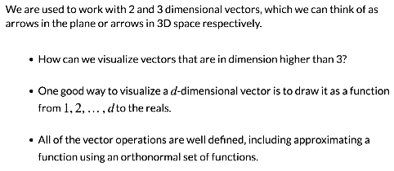

#### Function Approximation

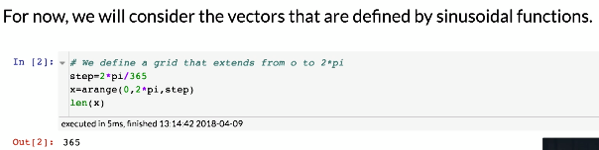

##### Define orthonormal set

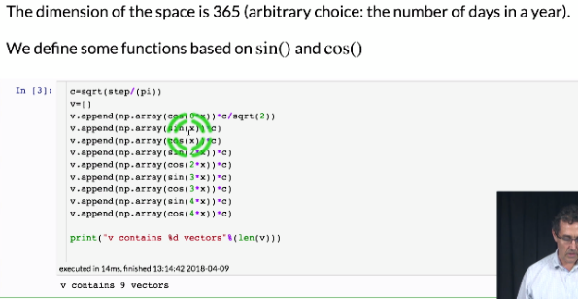

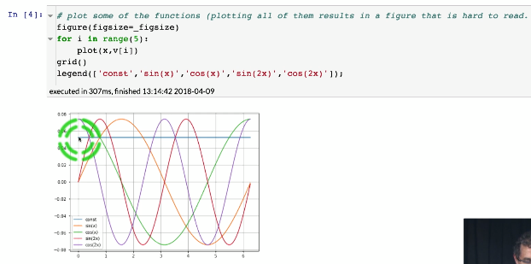

##### Check that they are orthonormal

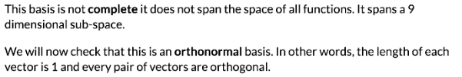

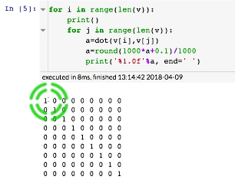

##### Rewrite the set of vectors as a matrix



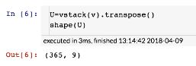

#### Approximating an arbitrary function

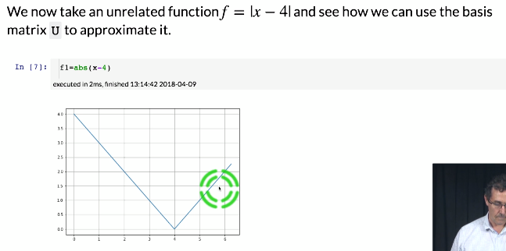

##### Approximation of increasing accuracy

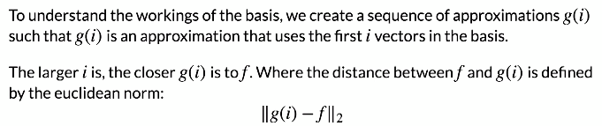

##### Plot the approximations



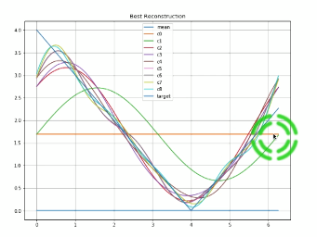

#### Recovering from noise

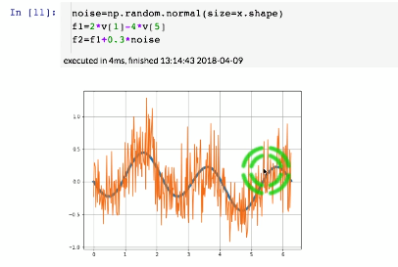

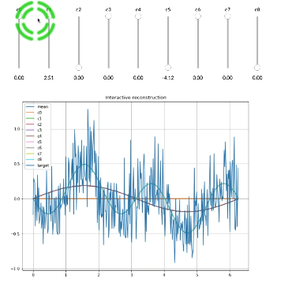

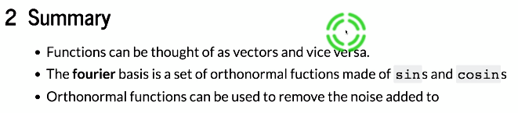

### 3.1.2 Computing PCA Using RDD

#### PCA

#### 





##### Compute Covariance Matrix

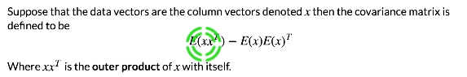

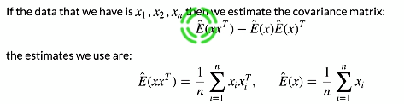

##### Compue Covariance Matrix where nans are

###### Effect of nans



###### Calculate mean of vector with nan’s

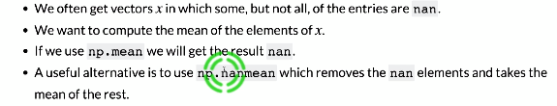

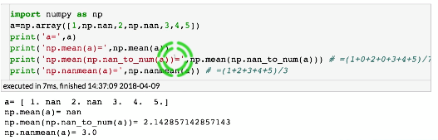

##### Outer Product of vector with nans with itself

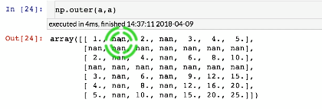

##### When NOT to use np.nanmean

##### Compute covariance when there are nans

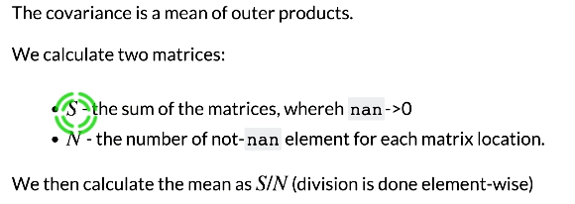

##### Compute mean together with covariance

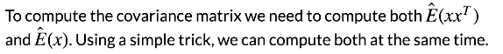

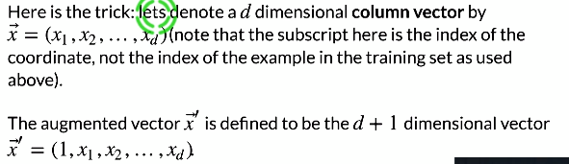

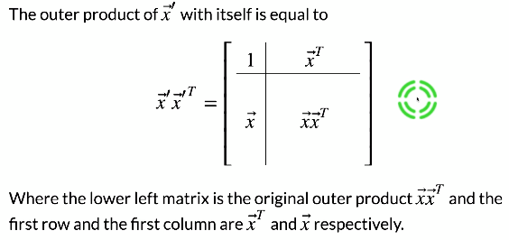

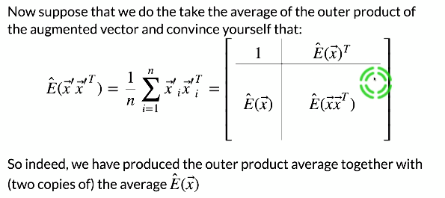

#### Climate Data

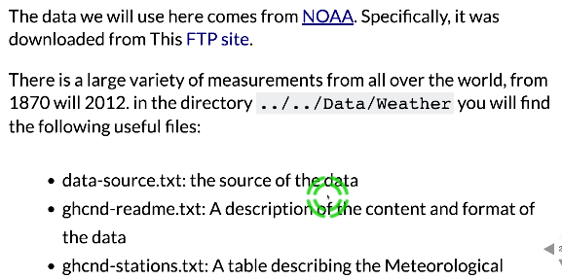

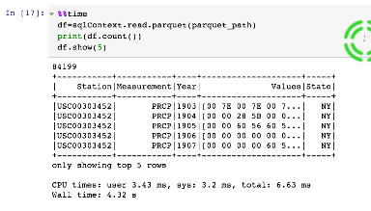

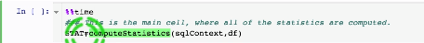

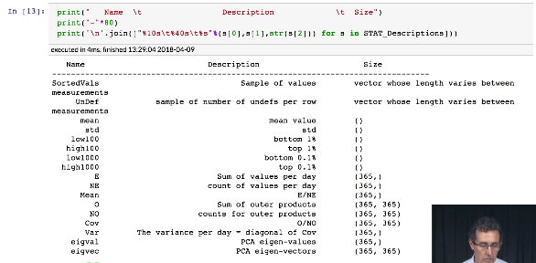

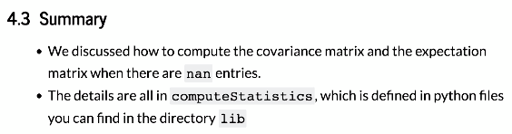

### 3.1.3 Loading the Data

#### Climate Data

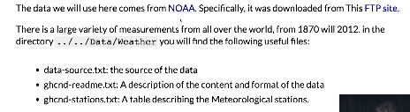

#### Data Cleaning

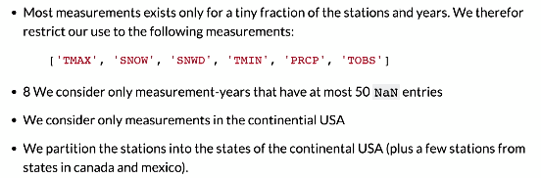

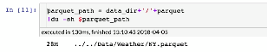

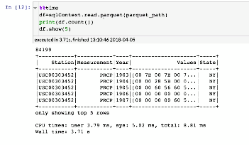

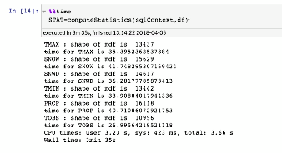

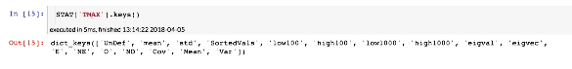

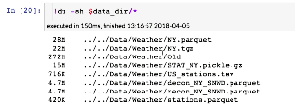

## 3.2 Visualizing PCA Coefficients

### 3.2.1 Weather Data Visualization

#### For NY

##### Read Raw Data for State

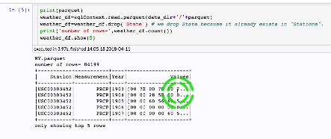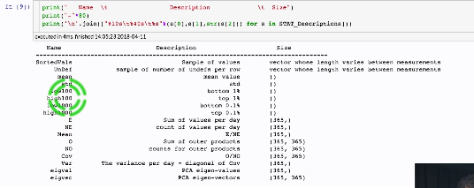

##### Read Information about US weather stations

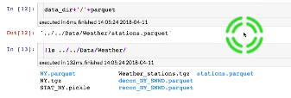

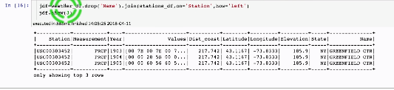

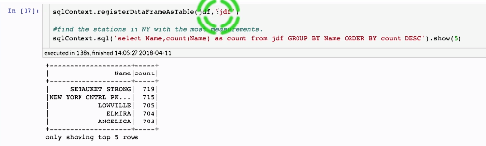

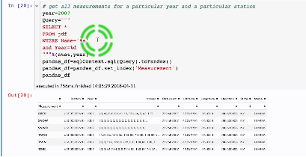

##### Plots

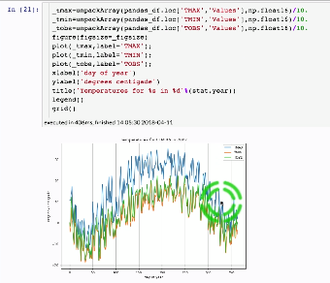

### 3.2.2 Variance Explained by Eigenvectors

## 3.3 Programming Assignment 3

In this programming assignment, you will write python3 code to efficiently compute the covariance matrix.

**For Audit Learners**

To download the tar file for PA3 [click here](https://prod-edxapp.edx-cdn.org/assets/courseware/v1/c68b70412b68177c67131fdbe7f8e29a/asset-v1:UCSanDiegoX+DSE230x+1T2019a+type@asset+block/pa3.tgz). After Downloading the file, "cd" to the download directory and unpack it using the command: "tar -xzf pa3.tgz"

You should get a directory named **pa3** which contains the jupyter notebook for Programming Assignment 3. Depending on your installation setup, you could either mount the directory on docker (if you are using docker) OR just run jupyter locally and start working on the assignment. We do not currently support submission and grading of assignments for audit learners. However, there are lots of visible test cases in the assignment notebook that you can use to verify the correctness of your code.

## 3.4 Vizualizing PCA Residuals I

### 3.4.1 Spectral Analysis of Snow Depth in NY Part 1

### 3.4.2 Spectral Analysis of Snow Depth in NY Part 2

### 3.4.3 Spectral Analysis of Snow Depth in NY Part 3

## 3.5 Vizualizing PCA Residuals II

### 3.5.1 Spectral Analysis of Snow Depth in NY Part 4

### 3.5.2 Snow Changes from Yr to Yr

## 3.6 Programming Assignment 4

#### Inferring from Weather data

In this homework, you are required to go through the notebooks in **Section2-Weather-PCA_PART1** and **Section2-Weather-PCA_PART2**. These notebooks are uploaded in [**Notebooks for Week 3 & 4**.](https://courses.edx.org/courses/course-v1:UCSanDiegoX+DSE230x+1T2018/courseware/21a3de418515472e93d9164fcc88e241/aa13890ebc8d4cd2a9bf96afae207ad7/1?activate_block_id=block-v1%3AUCSanDiegoX%2BDSE230x%2B1T2018%2Btype%40vertical%2Bblock%40158edf703c504603b8d1f62c1071eb9e) The required notebooks to answer the questions are also uploaded on the online workbench for Verified learners only. Note that you don't have to submit anything on the workbench and the notebooks are not graded.

**Note that you will have to change variables such as state names, measurement type, etc**. Specifically in this homework, you will be working on weather data for the state of **Washington (WA)**. The measurements that you will be working with are the smoothed values - specifically - **PRCP_s20** and **TOBS_s20**. *It is recommended that you watch and understand week 3 & 4 videos before attempting this homework.*

*If you encounter "module 'astropy' missing for the docker image" error, please use pip install to install the module.*

# 4 K-Means and Intrinsic Dimensions

## 4.1 K-Means Clustering

### 4.1.1 K-Means Animation

### 4.1.2 K-Means Theory

### 4.1.3 K-Means Measure of Performance - Part 1

### 4.1.4 K-Means Measure of Performance - Part 2

### 4.1.5 Clustering and K-means

### 4.1.6 Initialization of K-means

### 4.1.7 Data in High Dimensions

## 4.2 Intrinsic Dimension

### 4.2.1 Intrinsic Dimensions

### 4.2.2 Examples of Intrinsic Dimensions

### 4.2.3 Fractional Dimensions

### 4.2.4 Recognizing Facial Gestures

## 4.4 Programming Assignment 5

In this programming assignment, you will write pyspark code to estimate the intrinsic dimension of a dataset using K-means clustering. Given a sample set of a synthetically generated dataset, you will use the Spark K-means API to estimate the centroids of the data points. After obtaining the centroids of the data, you will calculate the mean-squared error of the dataset by calculating the mean-squared distance of each

datapoint from it's respective representative centroid. This experiment is to be repeated for different values of K (K being the number of centroids), for the same sample of data. Using the information obtained from these experiments, you can estimate the intrinsic dimension of the sample set. You are expected to repeat the above procedure for sample sets of different sizes and thereby estimate the intrinsic dimension of each sample set. **For Audit Learners**

To download the tar file for PA5 [click here.](https://prod-edxapp.edx-cdn.org/assets/courseware/v1/51d809b0e216f8a23d2d7734e08246ca/asset-v1:UCSanDiegoX+DSE230x+1T2019a+type@asset+block/pa5.tar) After Downloading the file, "cd" to the download directory and unpack it using the command: "tar -xzf pa5.tar"

You should get a directory named **pa5** which contains the jupyter notebook for Programming Assignment 5.  Depending on your installation setup, you could either mount the directory on docker (if you are using docker) OR just run jupyter locally and start working on the assignment. We do not currently support submission and grading of assignments for audit learners. However, the assignment notebook contains the necessary information that you can use to verify the correctness of your code.

# 5 Decision Trees, Random Forests, Boosting

Download the compressed folders from the following links:

[**Slides.tgz**](https://prod-edxapp.edx-cdn.org/assets/courseware/v1/fa1d5bbe136681d881fab60310a7a5a4/asset-v1:UCSanDiegoX+DSE230x+1T2019a+type@asset+block/Slides.tgz)

[**Visualization.tgz**](https://prod-edxapp.edx-cdn.org/assets/courseware/v1/d8da91908222fb596c276310ba1e0b89/asset-v1:UCSanDiegoX+DSE230x+1T2019a+type@asset+block/Visualization.tgz)

After Downloading the files  unpack it using the commands:

tar -xf Slides.tgz

tar -xf Visualization.tgz

You should get directories named **Slides**and **Visualization**which contains materials needed for Weeks 7 and 8. Download compressed folder for XGBoost materials from:

[**XGBoost.tgz**](https://prod-edxapp.edx-cdn.org/assets/courseware/v1/8117e0f2b4d0d3ee3c76340b6ad61889/asset-v1:UCSanDiegoX+DSE230x+1T2019a+type@asset+block/XGBoost.tgz)

After Downloading the files  unpack it using the command:

tar -xf XGBoost.tgz

You should get directory named **XGBoost**. You'll notice that **XGBoost/Data** folder is empty. Download the following zip files and add the files extracted into the Data folder.

[**Data1.zip**](https://prod-edxapp.edx-cdn.org/assets/courseware/v1/c53d5c7b6583baa32b854c87a1457de7/asset-v1:UCSanDiegoX+DSE230x+1T2019a+type@asset+block/Data1.zip)

[**Data2.zip**](https://prod-edxapp.edx-cdn.org/assets/courseware/v1/197a75b66943965be15e57f595c499c1/asset-v1:UCSanDiegoX+DSE230x+1T2019a+type@asset+block/Data2.zip)

Ideally, it should look like this:

XGBoost

└── Data

└── processed_data_150mb.np  
  └── processed_data_15mb.np  
 └── whale_data_15mb.np  
 └── xgboost_output_full_data.pk

You'll be all set to use the notebooks and materials needed for Weeks 7 and 8.

## 5.1 Decision Trees

### 5.1.1 Decision Tree

### 5.1.2 The Splitting Step

### 5.1.3 Pruning Trees

### 5.1.4 Generative and Discriminative Models

## 5.2 Boosting

### 5.2.1 Boosting I

### 5.2.2 Boosting II

### 5.2.3 Boosting as a Gradient Descent

### 5.2.4 Weak Learner Styles

### 5.2.5 Boosting and Overfitting

### 5.2.6 Boosting and Overfitting II

### 5.2.7 Applications of Boosting

### 5.2.8 Face Detection

## 5.3 Ensemble

## 5.4 Real-World Aplication

### 5.4.1 Whale Classification

### 5.4.2 Classification with XGBoost

## 5.5 Programming Assignment 6

#### Gradient Boosting and Random Forests

In this programming assignment, you will write python3 code using pyspark to classify geographical locations according to their predicted tree cover using Gradient Boosting and Random Forest classfiers.  **For Audit Learners** To download the zip file for PA6[**click here.**](https://prod-edxapp.edx-cdn.org/assets/courseware/v1/02fb207a9229d77c8c926bf279a03ae2/asset-v1:UCSanDiegoX+DSE230x+1T2019a+type@asset+block/pa6.zip)After downloading the file, unzip to get a directory named **pa6** which contains the jupyter notebook and a few other files for Programming Assignment 6.

Depending on your installation setup, you could either mount the directory on docker (if you are using docker) OR just run jupyter locally and start working on the assignment. We do not currently support submission and grading of assignments for audit learners. However, the assignment notebook contains the necessary information that you can use to verify the correctness of your code.

## 5.6 Programming Assignment 7

#### XGBoost for Whale Classification

You have been provided a dataset that consists of echo-location clicks of two types of whales, namely, Gervais and Cuviers. In this assignment, your task is to classify the different types whales using Gradient Boosting with the help of the XGBoost library. You are expected to fill in functions that would complete this task. **For Audit Learners**

To download the tar file for PA7 [**click here.**](https://prod-edxapp.edx-cdn.org/assets/courseware/v1/1ea515d337a19456d876d380fada2bb7/asset-v1:UCSanDiegoX+DSE230x+1T2019a+type@asset+block/pa7.tar)After Downloading the file, "cd" to the download directory and unpack it using the command: "tar -xzf pa7.tar"

You should get a directory named **pa7** which contains the jupyter notebook for Programming Assignment 7. Depending on your installation setup, you could either mount the directory on docker (if you are using docker) OR just run jupyter locally and start working on the assignment. We do not currently support submission and grading of assignments for audit learners. However, the assignment notebook contains the necessary information that you can use to verify the correctness of your code.

# 6 Neural Networks and TensorFlow

## 6.1 Neural Networks

### 6.1.1 Historical Perspective

### 6.1.2 Skeptical View

## 6.2 NN Basics

### 6.2.1 Back Prop

### 6.2.2 TensorFlow Linear Regression

## 6.3 TensorFlow Base API

### 6.3.1 TensorFlow Logistic Regression

### 6.3.2 TensorFlow base API

## 6.4 TensorFlow Estimator API

### 6.4.1 TensorFlow Pre-defined Estimator

### 6.4.2 TensorFlow Custom Estimator

### 6.4.3 Convolutional Neural Network

## 6.5 Programming Assignment 8

#### Neural Networks with Tensorflow

In this programming assignment, you will write Tensorflow code to distinguish between a signal process which produces Higgs bosons and a background process which does not. We model this problem as a binary classification problem. You will Implement a basic feedforward neural network with 2 hidden layers, using Tensorflow's programming paradigm and inbuilt optimizers for neural network training. **Note:** This assignment is not designed to make you a professional Tensorflow programmer, but rather to introduce you to, and make you practice, the basic constructs and functionalities of Tensorflow.

**For Audit Learners** To download the zip file for PA8 [click here](https://prod-edxapp.edx-cdn.org/assets/courseware/v1/2ce8db42802fcf8a630603871a3c5986/asset-v1:UCSanDiegoX+DSE230x+1T2019a+type@asset+block/pa8-fixed.zip)**.** Unzip this file to get pa8 directory. This **pa8** which contains the jupyter notebook and data directories for Programming Assignment 8. The data directories provided are smaller sized for ease of use. If your network can work well with smaller sized dataset, you can [download the larger dataset from here.](https://drive.google.com/file/d/1BL3WHAmablshKG_bEzNDB17B5osTpRnI/view?usp=sharing) *(Note: It is hosted on Google Drive due to the large size; you can by-pass the Google Drive's virus scan since it's from a trusted source)*

This is a drive link to a downloadable zip file. Unzipping this will give you a directory with two files - **higgs_train_large.csv** and **higgs_test_large.csv**. Place these files under**pa8/Data/** folder before you can use them. Depending on your installation setup, you could either mount the directory on docker (if you are using docker) OR just run jupyter locally and start working on the assignment. We do not currently support submission and grading of assignments for audit learners. However, the assignment notebook contains the necessary information that you can use to verify the correctness of your code.

# Appendix 1 Jupyter Nbextensions Configurator

[**LINK**](https://github.com/Jupyter-contrib/jupyter_nbextensions_configurator)

A server extension for jupyter notebook which provides configuration interfaces for notebook extensions (nbextensions). The jupyter_nbextensions_configurator jupyter server extension provides graphical user interfaces for configuring which nbextensions are enabled (load automatically for every notebook). In addition, for nbextensions which include an appropriate yaml descriptor file (see below), the interface also renders their markdown readme files, and provides controls to configure the nbextensions' options.

## Usage

Once jupyter_nbextensions_configurator is installed and enabled, and your notebook server has been restarted, you should be able to find the nbextensions configuration interface at the url <base_url>nbextensions, where <base_url> is described below (for simple installs, it's usually just /, so the UI is at /nbextensions).

[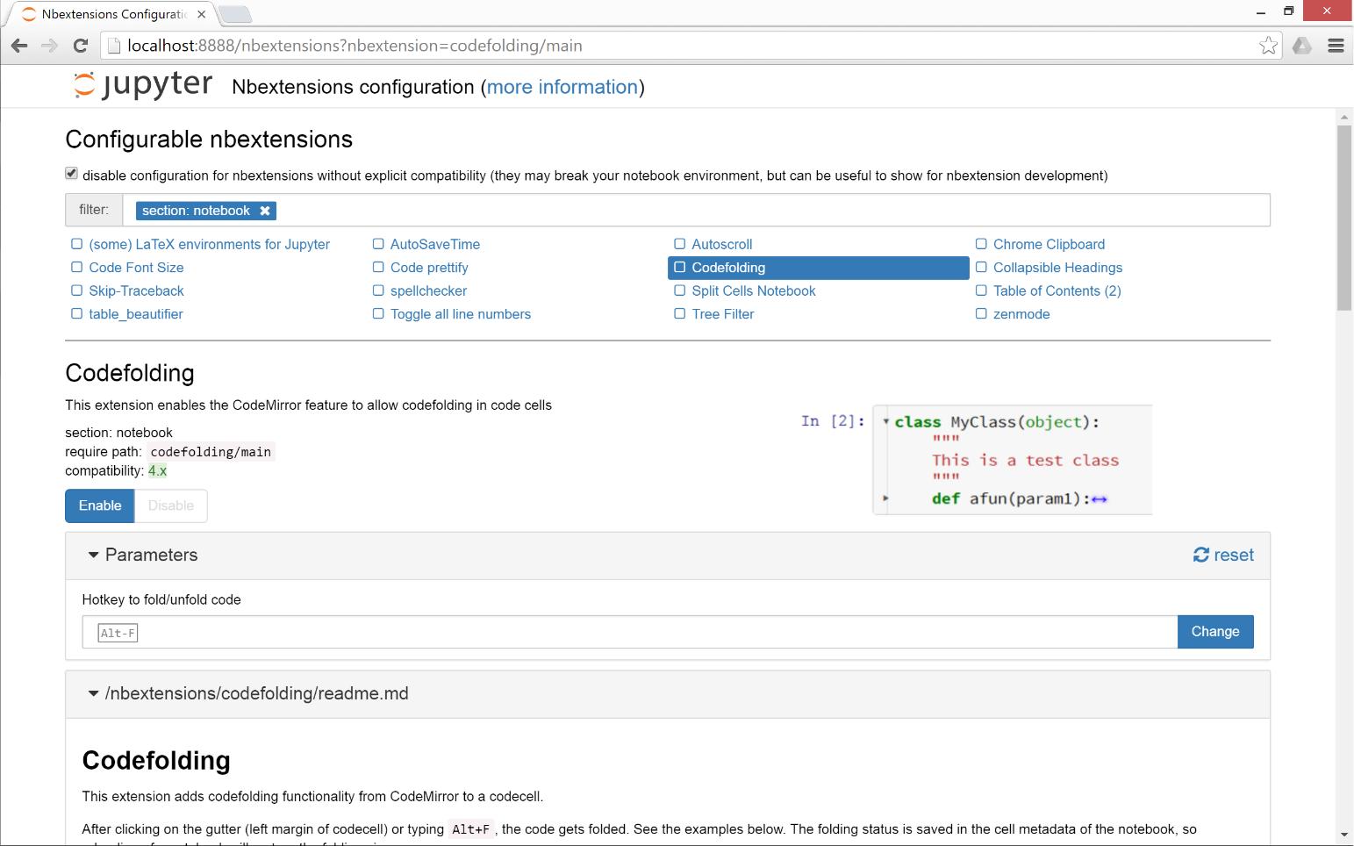](https://github.com/Jupyter-contrib/jupyter_nbextensions_configurator/blob/master/src/jupyter_nbextensions_configurator/static/nbextensions_configurator/icon.png)

### base_url

For most single-user notebook servers, the dashboard (the file-browser or 'tree' view) is at

http://localhost:8888/tree

So the base_url is the part between the host (http://localhost:8888) and tree, so in this case it's the default value of just /. If you have a non-default base url (such as with JupyterHub), you'll need to prepend it to the url. So, if your dashboard is at

http://localhost:8888/custom/base/url/tree

then you'll find the configurator UI page at

http://localhost:8888/custom/base/url/nbextensions

### tree tab

In addition to the main standalone page, the nbextensions configurator interface is also available as a tab on the dashboard:

[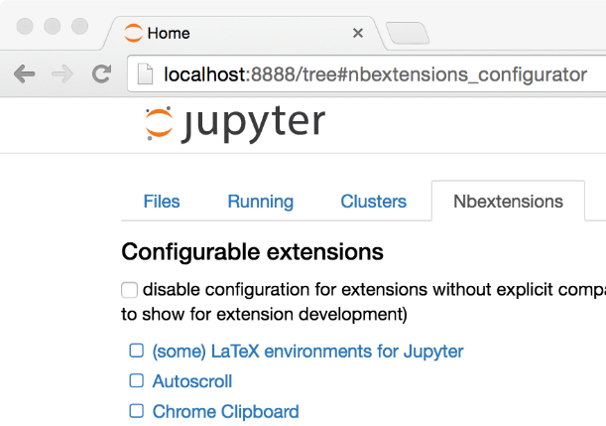](https://github.com/Jupyter-contrib/jupyter_nbextensions_configurator/blob/master/src/jupyter_nbextensions_configurator/static/nbextensions_configurator/tree_tab/icon.png)

The dashboard tab is provided via an nbextension called "Nbextensions dashboard tab", with requirejs urinbextensions_configurator/tree_tab/main. Since version [0.2.0](https://github.com/Jupyter-contrib/jupyter_nbextensions_configurator#020), this nbextension is enabled by default on enabling the jupyter_nbextensions_configurator serverextension, but it can be disabled as with any other nbextension if you don't want to use it.

### edit menu item

jupyter_nbextensions_configurator provides a second small nbextension, which simply adds an item to the notebook-view edit menu, which links to the configurator UI page:

[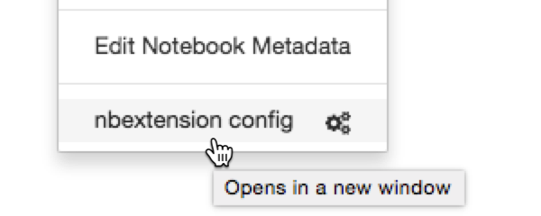](https://github.com/Jupyter-contrib/jupyter_nbextensions_configurator/blob/master/src/jupyter_nbextensions_configurator/static/nbextensions_configurator/config_menu/icon.png)

Similarly to the tree tab nbextension detailed above, since version [0.2.0](https://github.com/Jupyter-contrib/jupyter_nbextensions_configurator#020), the edit menu item nbextension is enabled by default when enabling the main jupyter_nbextensions_configurator serverextension, but can be disabled at any time in the same way as other nbextensions.

## YAML file format

You don't need to know about the yaml files in order simply to use jupyter_nbextensions_configurator. An nbextension is 'found' by the jupyter_nbextensions_configurator server extension when a special yaml file describing the nbextension and its options is found in the notebook server's nbextensions_path. The yaml file can have any name with the file extension .yaml or .yml, and describes the nbextension and its options to jupyter_nbextensions_configurator.

The case-sensitive keys in the yaml file are as follows:

* Type, (**required**) a case-sensitive identifier, must be IPython Notebook Extension or Jupyter Notebook Extension
* Main, (**required**) the main javascript file that is loaded, typically main.js
* Name, the name of the nbextension
* Section, which view the nbextension should be loaded in (defaults to notebook, but can alternatively be tree, edit, or to load in all views, common).
* Description, a short explanation of the nbextension
* Link, a URL for more documentation. If this is a relative url with a .md file extension (recommended!), the markdown readme is rendered in the configurator UI.
* Icon, a URL for a small icon for the configurator UI (rendered 120px high, should preferably end up 400px wide. Recall HDPI displays may benefit from a 2x resolution icon).
* Compatibility, Jupyter major version compatibility, e.g. 3.x or 4.x, 3.x 4.x, 3.x, 4.x, 5.x
* Parameters, an optional list of configuration parameters. Each item is a dictionary with (some of) the following keys
  + name, (**required**) the name used to store the configuration variable in the config json. It follows a json-like structure, so you can use . to separate sub-objects e.g. myextension.buttons_to_add.play.
  + description, a description of the configuration parameter
  + default, a default value used to populate the tag in the configurator UI, if no value is found in config. Note that this is more of a hint to the user than anything functional - since it's only set in the yaml file, the javascript implementing the nbextension in question might actually use a different default, depending on the implementation.
  + input_type, controls the type of html tag used to render the parameter in the configurator UI. Valid values include text, textarea, checkbox, [html5 input tags such as number, url, color, ...], plus a final type of list
  + list_element, a dictionary with the same default and input_type keys as a Parameters entry, used to render each element of the list for parameters with input_type list
  + finally, extras such as min, step and max may be used by number tags for validation
* tags, a list of string tags describing the nbextension, to allow for filtering

**Example:**

Type: Jupyter Notebook Extension

Name: Limit Output

Section: notebook

Description: This nbextension limits the number of characters that can be printed below a codecell

tags:

- usability

- limit

- output

Link: readme.md

Icon: icon.png

Main: main.js

Compatibility: 4.x

Parameters:

- name: limit_output

description: Number of characters to limit output to

input_type: number

default: 10000

step: 1

min: 0

- name: limit_output_message

description: Message to append when output is limited

input_type: text

default: '**OUTPUT MUTED**'

# APPENDIX 2 Spark Install Instructions - Windows

Instructions tested with Windows 10 64-bit. It is highly recommend that you use Mac OS X or Linux for this course, these instructions are only for people who cannot run Mac OS X or Linux on their computer.

## Install and Setup

Spark provides APIs in Scala, Java, Python (PySpark) and R. We use PySpark and Jupyter, previously known as IPython Notebook, as the development environment. There are many articles online that talk about Jupyter and what a great tool it is, so we won’t introduce it in details here.

This Guide Assumes you already have Anaconda and Gnu On Windows installed. See <https://mas-dse.github.io/startup/anaconda-windows-install/>

1. Go to [http://www.java.com](http://www.java.com/) and install Java 7+.

2. Get Spark pre-built package from the [downloads page](http://spark.apache.org/downloads.html) of the Spark project website.

3. Open PowerShell by pressing ⊞ Win-R, typing “powershell” in Run dialog box and clicking “OK”. Change your working directory to where you downloaded the Spark package.

4. Type the commands in red to uncompress the Spark download. Alternatively, you can use any other software of your preference to uncompress.

> **gzip -d spark-2.1.0-bin-hadoop2.7.tgz**  
> **tar xvf spark-2.1.0-bin-hadoop2.7.tar**

5. Type the commands in red to move Spark to the c:\opt\spark\ directory.

> **mkdir C:\opt\**  
> **move spark-2.1.0-bin-hadoop2.7 C:\opt\spark\**

6. Type the commands in red to download winutils.exe for Spark.

> **cd C:\opt\spark\bin\**  
> **curl -k -L -o winutils.exe https://github.com/steveloughran/winutils/blob/master/hadoop-2.6.0/bin/winutils.exe?raw=true**

7. Create an environment variable with variable name = SPARK_HOME and variable value = C:/opt/spark. This link provides a good description of [how to set environment variable in windows](http://www.forbeslindesay.co.uk/post/42833119552/permanently-set-environment-variables-on-windows)

8. Type the commands in red to create a temporary directory.

> **mkdir ~/Documents/jupyter-temp/**  
> **cd ~/Documents/jupyter-temp/**

9. Type the commands in red to install, configure and run Jupyter Notebook. Jupyter Notebook will launch using your default web browser.

> **conda install jupyter -y**  
> **ipython kernelspec install-self**  
> **jupyter notebook**

## First Spark Application

In our first Spark application, we will run a Monte Carlo experiment to find an estimate for $\pi$.

Here is how we are going to do it. The figure bellow shows a circle with radius $r = 1$ inscribed within a 2×2 square. The ratio between the area of the circle and the area of the square is $\frac{\pi}{4}$. If we sample enough points in the square, we will have approximately $\rho = \frac{\pi}{4}$ of these points that lie inside the circle. So we can estimate $\pi$ as $4 \rho$.

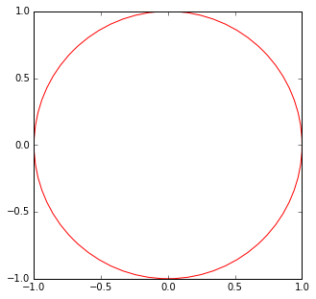

1. Create a new Notebook by selecting **Python 2** from the **New** drop down list at the right of the page.

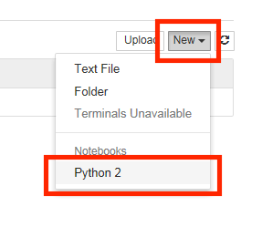

2. First we will create the Spark Context. Copy and paste the red text into the first cell then click the  (run cell) button:

**import os**  
**import sys**  
  
**import findspark**  
**findspark.init()**  
  
**from pyspark import SparkContext**  
  
**sc = SparkContext(master="local[4]")**

3. Next, we draw a sufficient amount of points inside the square. Copy and paste the red text into the next cell then click the  (run cell) button:

**import numpy as np**  
  
**TOTAL = 1000000**  
**dots = sc.parallelize([2.0 * np.random.random(2) - 1.0 for i in range(TOTAL)]).cache()**  
**print("Number of random points:", dots.count())**  
  
**stats = dots.stats()**  
**print('Mean:', stats.mean())**  
**print('stdev:', stats.stdev())**

Output:

('Number of random points:', 1000000)  
('Mean:', array([-0.0004401 , 0.00052725]))  
('stdev:', array([ 0.57720696, 0.57773085]))

4. We can sample a small fraction of these points and visualize them. Copy and paste the red text into the next cell then click the  (run cell) button:

**%matplotlib inline**  
**from operator import itemgetter**  
**from matplotlib import pyplot as plt**  
  
**plt.figure(figsize = (10, 5))**  
  
**# Plot 1**  
**plt.subplot(1, 2, 1)**  
**plt.xlim((-1.0, 1.0))**  
**plt.ylim((-1.0, 1.0))**  
  
**sample = dots.sample(False, 0.01)**  
**X = sample.map(itemgetter(0)).collect()**  
**Y = sample.map(itemgetter(1)).collect()**  
**plt.scatter(X, Y)**  
  
**# Plot 2**  
**plt.subplot(1, 2, 2)**  
**plt.xlim((-1.0, 1.0))**  
**plt.ylim((-1.0, 1.0))**  
  
**inCircle = lambda v: np.linalg.norm(v) <= 1.0**  
**dotsIn = sample.filter(inCircle).cache()**  
**dotsOut = sample.filter(lambda v: not inCircle(v)).cache()**  
  
**# inside circle**  
**Xin = dotsIn.map(itemgetter(0)).collect()**  
**Yin = dotsIn.map(itemgetter(1)).collect()**  
**plt.scatter(Xin, Yin, color = 'r')**  
  
**# outside circle**  
**Xout = dotsOut.map(itemgetter(0)).collect()**  
**Yout = dotsOut.map(itemgetter(1)).collect()**  
**plt.scatter(Xout, Yout)**

Output:

﻿<matplotlib.collections.PathCollection at 0x17a78780>

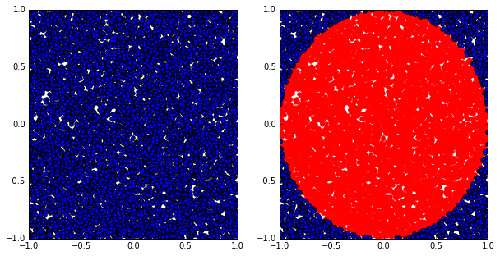

5. Finally, let’s compute the estimated value of $\pi$. Copy and paste the red text into the next cell then click the  (run cell) button:

**pi = 4.0 * (dots.filter(inCircle).count() / float(TOTAL))**  
**print("The estimation of \pi is:", pi)**

Output:

('The estimation of \\pi is:', 3.142204)

#### Next Steps

* [Spark Programming Guide](http://spark.apache.org/docs/latest/programming-guide.html)
* [Example Spark Programs](http://spark.apache.org/examples.html)

#### References

* [Spark official documents](http://spark.apache.org/docs/latest/)
* Example Python Spark programs [on the Spark Github repository](https://github.com/apache/spark/tree/master/examples/src/main/python)

# APPENDIX 3 Gow - The lightweight alternative to Cygwin

## Introduction

Gow (Gnu On Windows) is the lightweight alternative to Cygwin. It uses a convenient [NSIS installer](http://bit.ly/cop1wN)that installs over 100 extremely useful [open source UNIX applications](https://github.com/bmatzelle/gow/wiki/executables_list) compiled as native win32 binaries. It is designed to be as small as possible, about 18 MB, as opposed to Cygwin which can run well over 100 MB depending upon options.

Here are a couple quotes from happy Gow users:

"Gow is one of the few things that makes Windows bearable/usable"

"I use Gow constantly. It's awesome."

"I just wanted to let you know that the GOW Suite is simply great - it is far lighter than the Cygwin tool, and is extremely useful. "

## Features and Benefits

* *Ultra light*: Small, light subset (about 18 MB) of very [useful UNIX binaries](https://github.com/bmatzelle/gow/wiki/executables_list) that do not have decent installers (until now!).
* *Shell window from any directory*: Adds a Windows Explorer shell window ([screenshot](http://bit.ly/9Pk1us)) so that you can right-click on any directory and open a command (cmd.exe) window from that directory.
* *Simple install/remove*: Easy to install and remove, all files contained in a single directory in a standard C:\Program Files path.
* *Included in PATH*: All binaries are conveniently installed into the Windows PATH so they are accessible from a command-line window.
* *Stable binaries*: All commands are stable and tested.

## Win32 Utilities Overview

Below are just a few of the [100+ applications](https://github.com/bmatzelle/gow/wiki/executables_list) found in Gow.

* *Shell scripting*: bash, zsh
* *Compression*: gzip, zip, bzip2, compress
* *SSH*: putty, psftp, pscp, pageant, plink
* *Download/upload*: cURL, wget
* *FTP*: NcFTP
* *Editing*: vim, nano
* *Text search/view*: grep, agrep, less, cat, tail, head
* *File system*: mv, cp, du, ls, pwd, rmdir, whereis
* *Development*: make, diff, diff3, sleep, cvs, dos2unix, unix2dos

1. Find pyspark to make it importable.